30 Day Servo Project Build, Shane Welcher (here)

Create a new program, here we are using a Controllogix 1756-A7 seven slot rack with the processor in slot 1 and firmware rev. 34. We will use state logic with state transition. Create the task structure

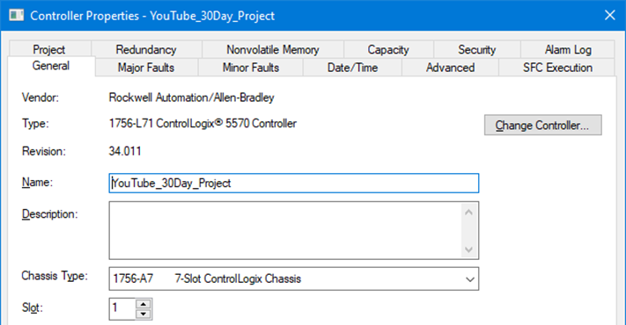
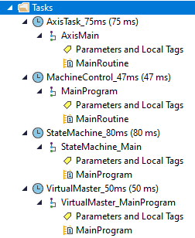

shown above at right confirming all the settings shown below, key items are circled in first group.

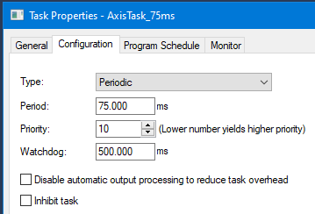
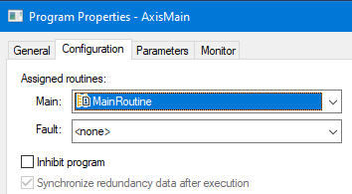

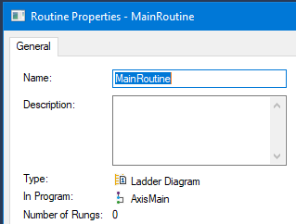
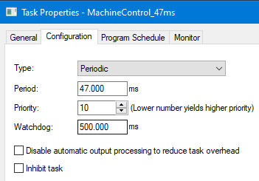

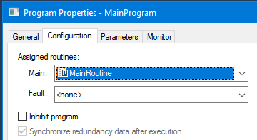
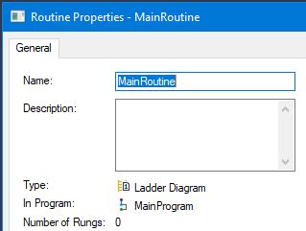
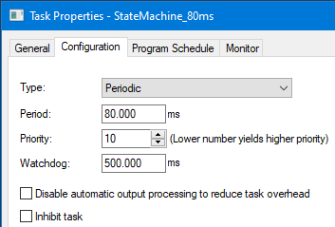
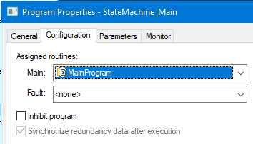

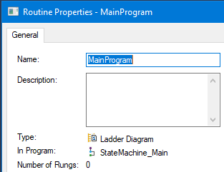
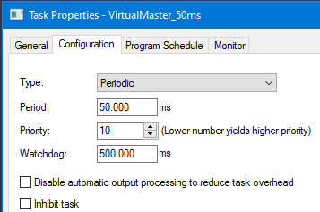

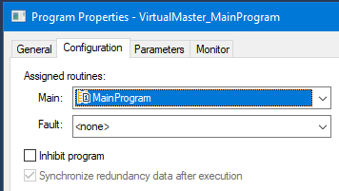
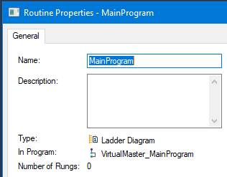
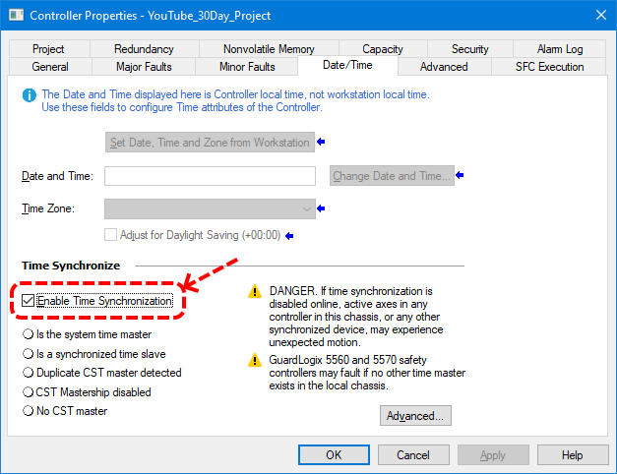

It is critically important to enable time synchronization in the controller properties as shown above.

The below screens are being created with FactoryTalk View Site Edition Network Distributed.

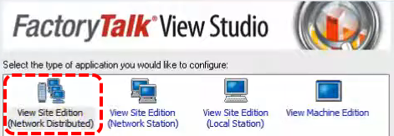

We will not be using Primary/Secondary, this will be just a Primary Solution.

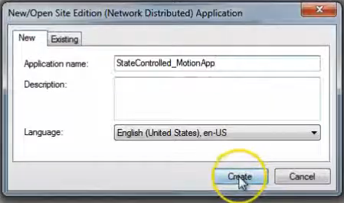

Now we want to setup data server, RS-Lynx, alarming, shortcuts, users, and security.

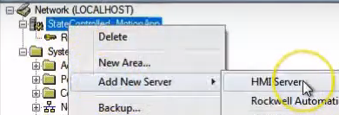

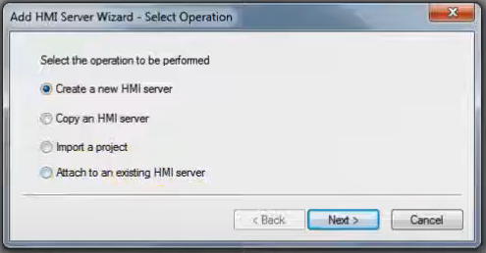

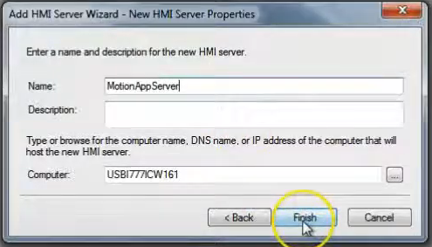

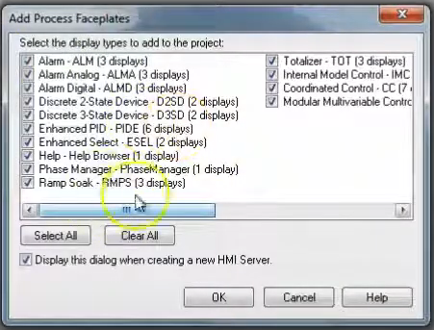

Add all. Then add a new area.

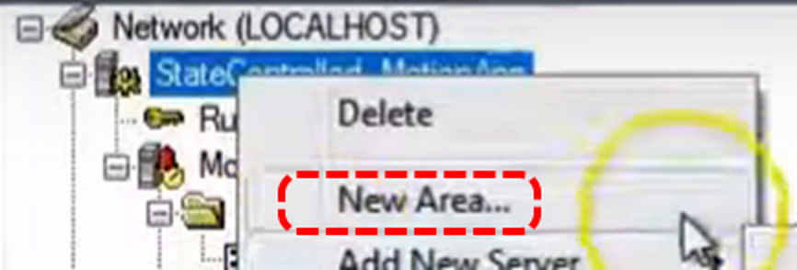

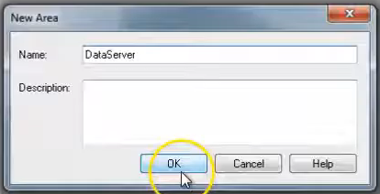

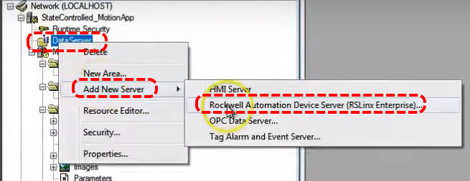

Under Data Server add RS Lynx Enterprise.

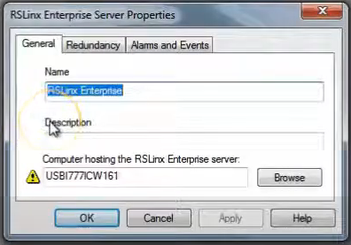

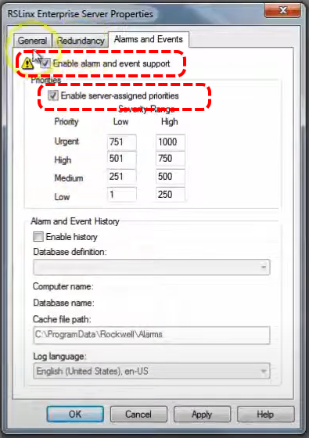

We will not be using Redundancy but will be using Alarms but we will not enable history because we do not have a database.

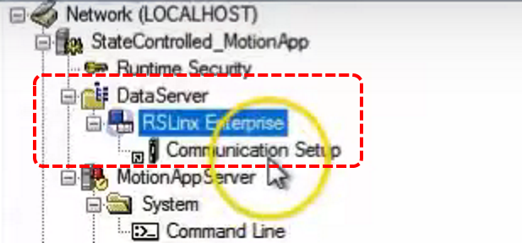

Open the Communications Setup branch. Click Add, give it a name, in this case YouTube. Select the chassis you are using. With the two selected click Apply, dialog appears to create the shortcut.

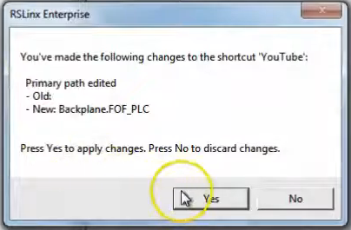

Our application is using Alarms and Events so we must enable it in the Communications screen.

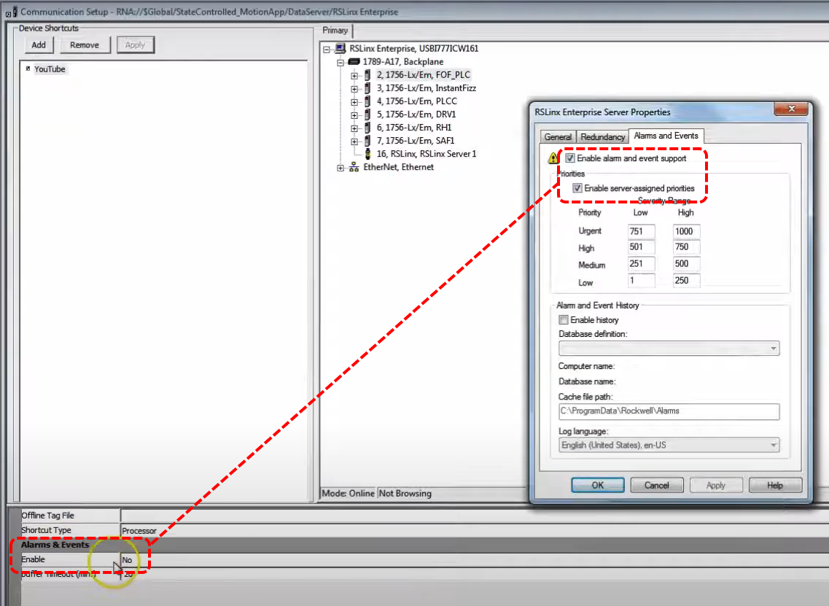

Once you enable Alarms & Events you have to click Apply again, make sure shortcut name and chassis are still selected.

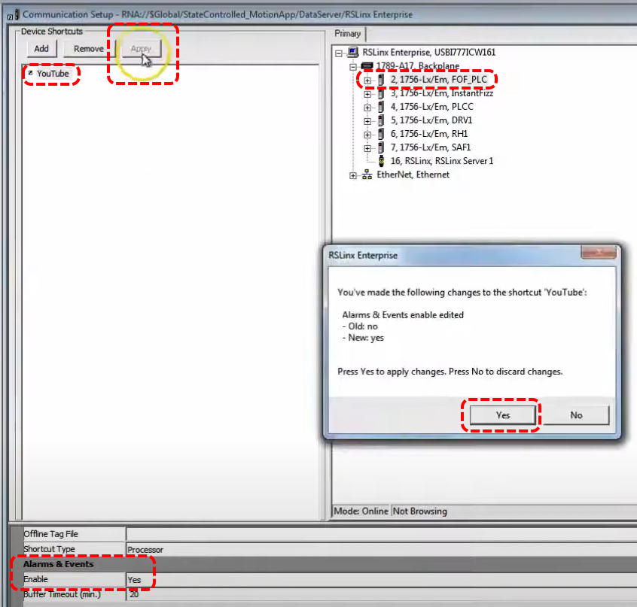

Once that is done you must go to the bottom right corner and click Verify. Then click OK to close.

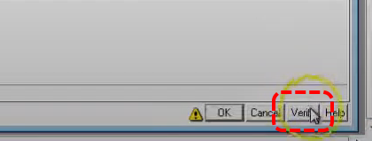
Now open the Runtime Security tab. We will configure an Operator and an Administrator.

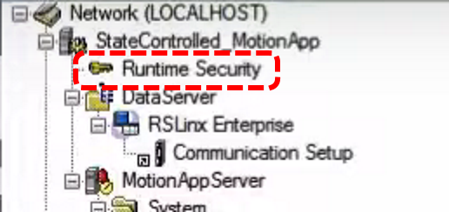

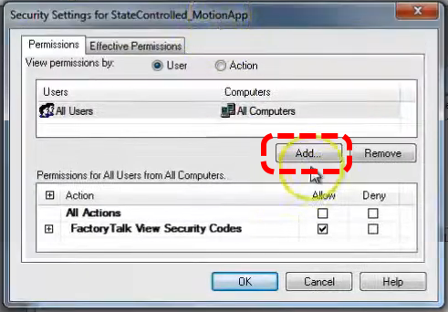

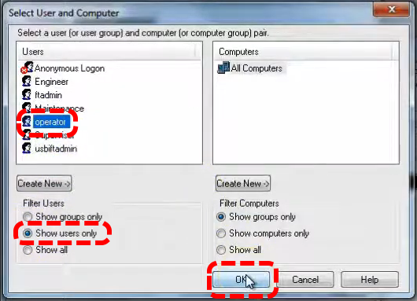
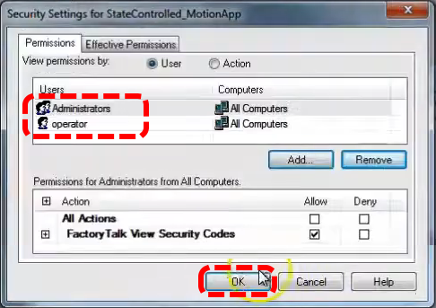

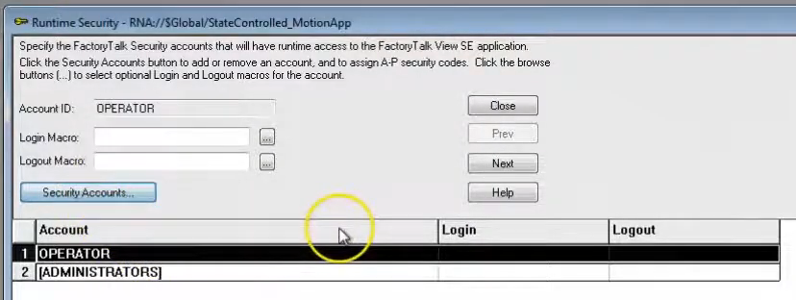

Add and adjust users is pretty much the same as ME version.

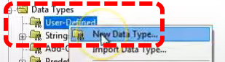

Now we will set up our UDT in the PLC application.

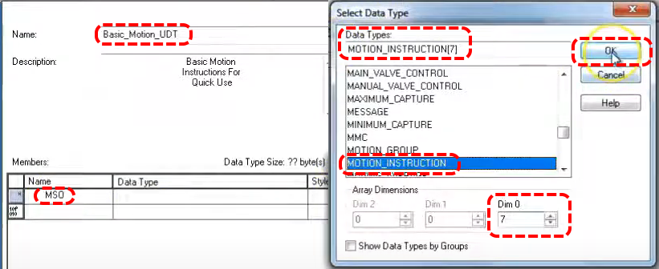

We have given our UDT the name Basic_Motion_UDT. We are adding the first member, it is the MSO motion instruction Motion Servo On. We think our application will have 5 axis so we select aa array dimension of 7 so we have spares. We have to select Data Type MOTION_INSTRUCTION.

Add the motion commands shown below.

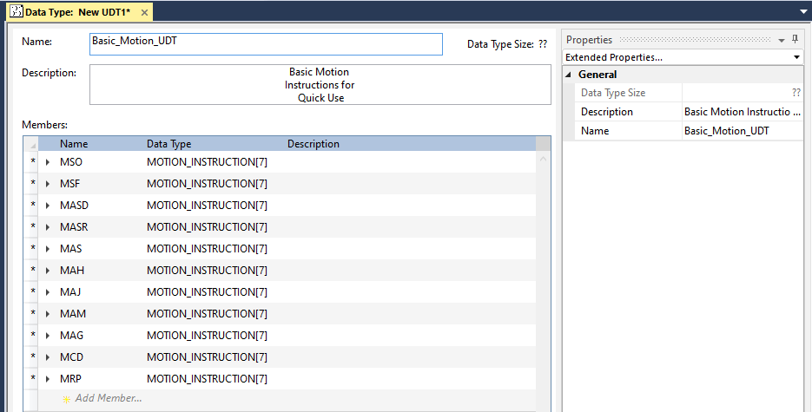

In this activity we will make all virtual axis since we are running on an emulator.

Create the below motion group then add the virtual axis.

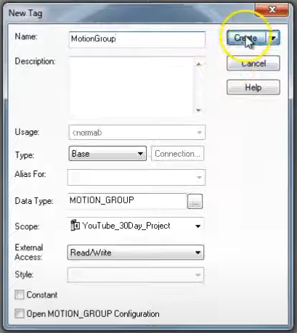
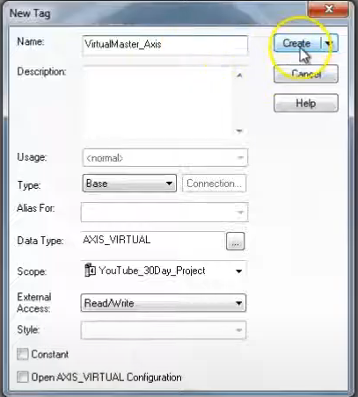
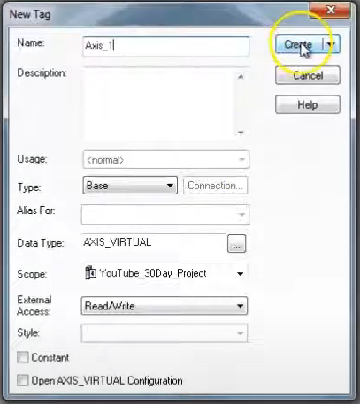
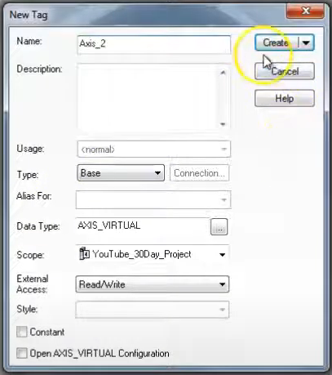

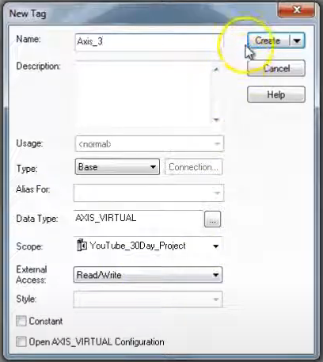
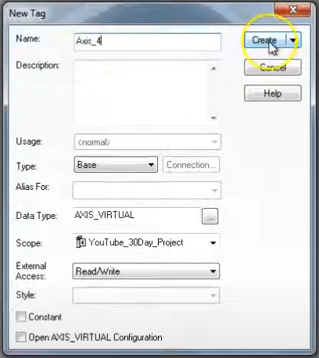

Open VirtualMaster_Axis, on the Conversion tab leave Position Mode at Linear and 8000. Homing should be Active and 0. Dynamics tab per below, use Calculate button, 25,000 for last two.

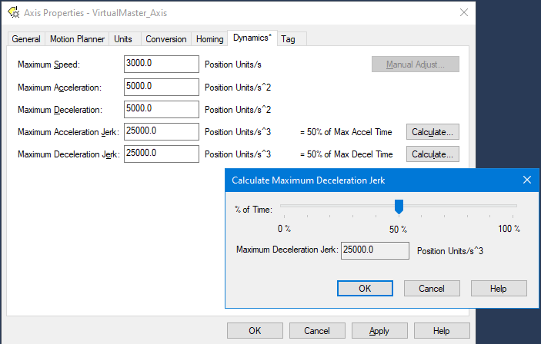

USE THESE SAME SETTINGS FOR ALL AXIS!
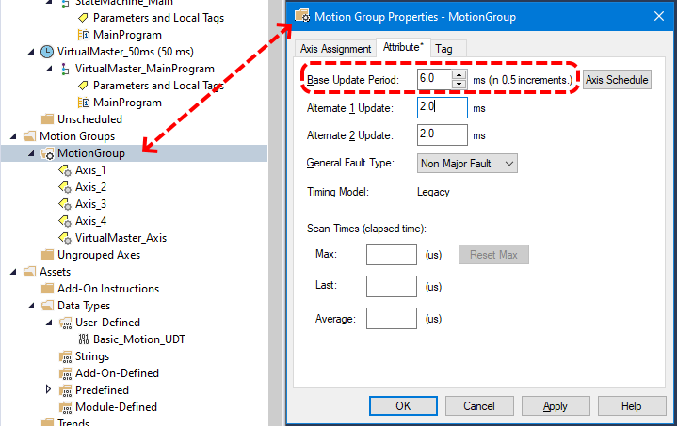

Under the Attribute tab of our motion group properties we want to set the Base Update Rate. We will allocate 1 ms for each axis (real or virtual) and another 1 ms for each configured drive in the IO Configuration section. Here we are using 6 ms to give our application a little slack. This number represents the periodic rate you are receiving information from your servos. In terms of processor allocation motion comes before IO and logic. For this reason we want as low as possible a base update rate. If your firmware version has Auto Tag Update it should be enabled. Set General Fault Type to your preference. Course Rate Update (aka Base Update Period) makes use of Enable Time Synchronization being enabled in the controller properties. In our case we have all axis assigned.

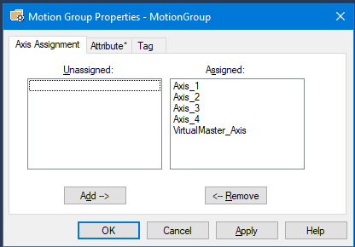

Now we are going to add routines for each axis, we will add routines and change the name of the original to better indicate. Note that each program added gets set to

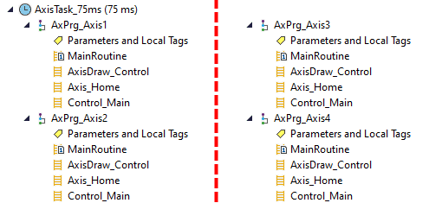

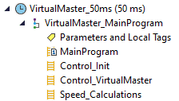

Now we will add other routines to the VirtualMaster_MainProgram group.

Now, in the MainProgram routine of VirtualMaster_MainProgram, add the JSR ladder for each sub.

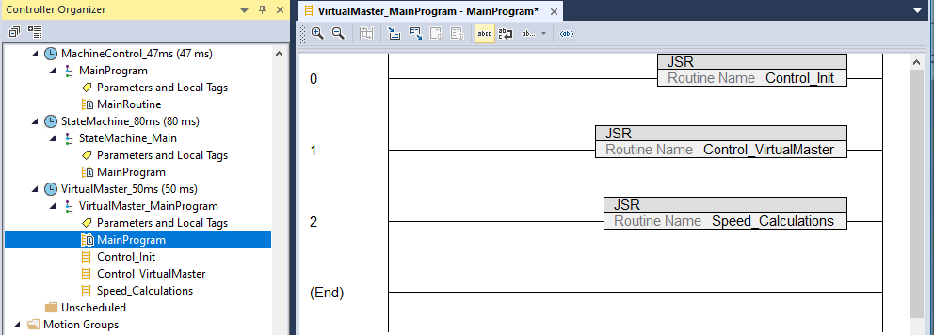

Add similar code for the AxPrg_Axis# routines.

Add four new routines to the StateMachine_80ms task; MachineState_Control (ld), Machine_SSL (st), Next_State (st, for HMI), Previous_State (st, for HMI). Add JSR code in Main.

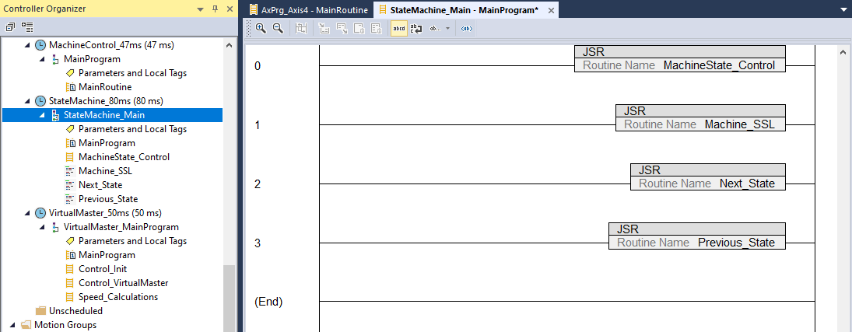

Now we will add our state tag database.

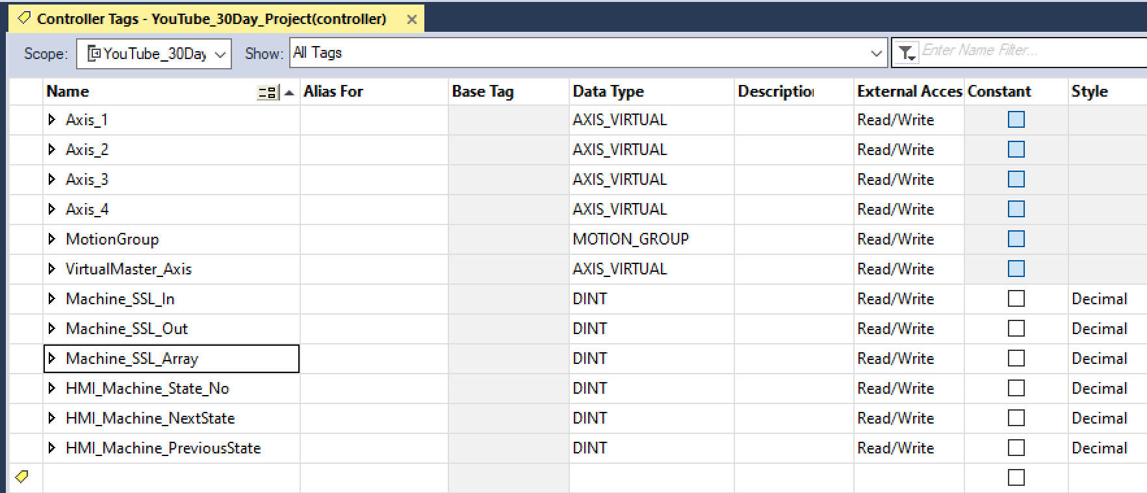

Now we add the structured text for Next_State in StateMachine. Take it up to case 31 which loops back to zero. Each case directs back to the previous case, case 0 stays at 0.

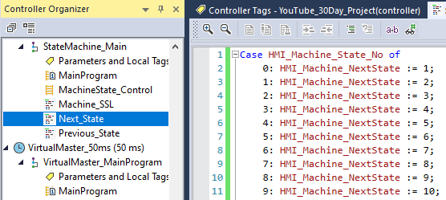
Now do the same (with modifications) for Previous_State.

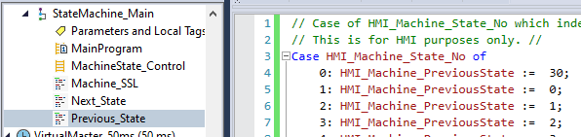

Now we will work on axis routines. In this application all drives will be following the virtual drive. Begin by adding fault monitoring code in AxPrg_Axis1:Control_Main.

First we want to check for faults in axis 1, we will access it’s collection of parameters and associate Axis_1.AxisFault with a new local parameter called AxisFault. Note that a value other than 0 indicates a fault. If this is the case we will set a fault solenoid.

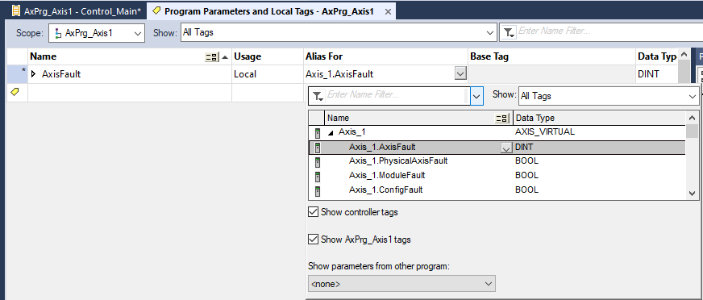

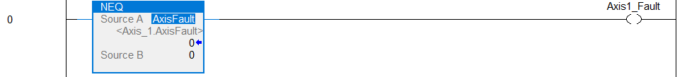

Next we examine a series of other fault parameters all associated with Axis_1. If none are in fault we set a local parameter Axis1_OkStatusBit. Note that we associate (alias) the axis tags with local vars.

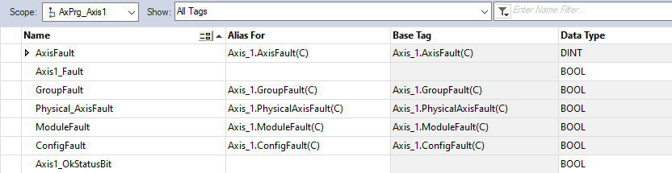

Next we process an HMI request for axis 1 reset. We will use the functions Motion Axis Shutdown Reset or Motion Axis Fault Reset depending on the state of tag Axis_1.ShutdownStatus (is the axis currently shutdown or not).

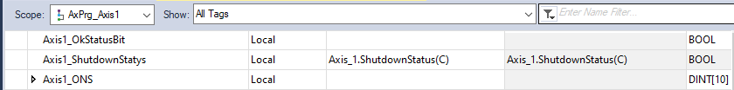

Now we want to access the motion command arrays we created in a UDT. We declare a local variable Axis1_ServoControls and give it data type of Basic_Motion_UDT as shown below.

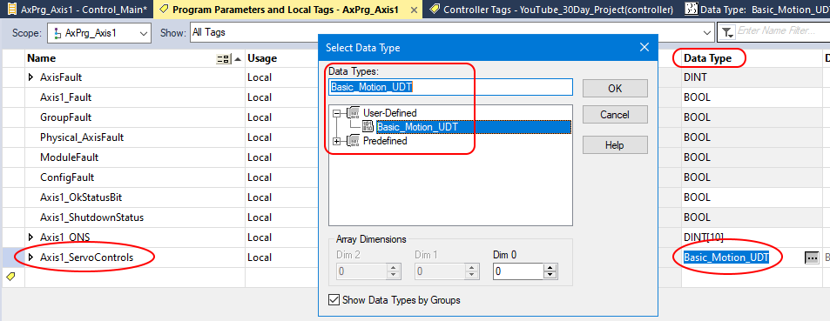

Now we have to add the motion command MAFR to our UDT.

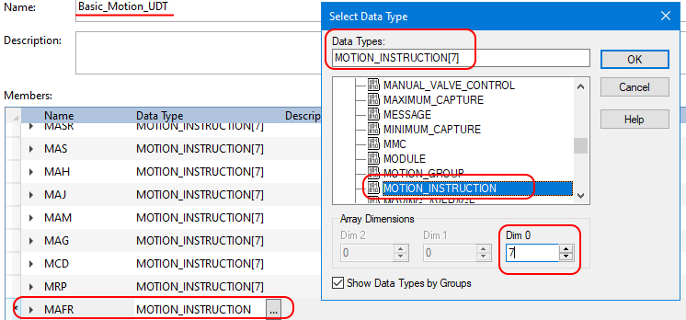

Completed fault status check below. The reason we have created these tags at the local level (and used aliases) is we want to be able to copy/paste into other modules and use recipe features. It is very quick to import/export and modify alias tag names. FW levels in the 30s have other methods.
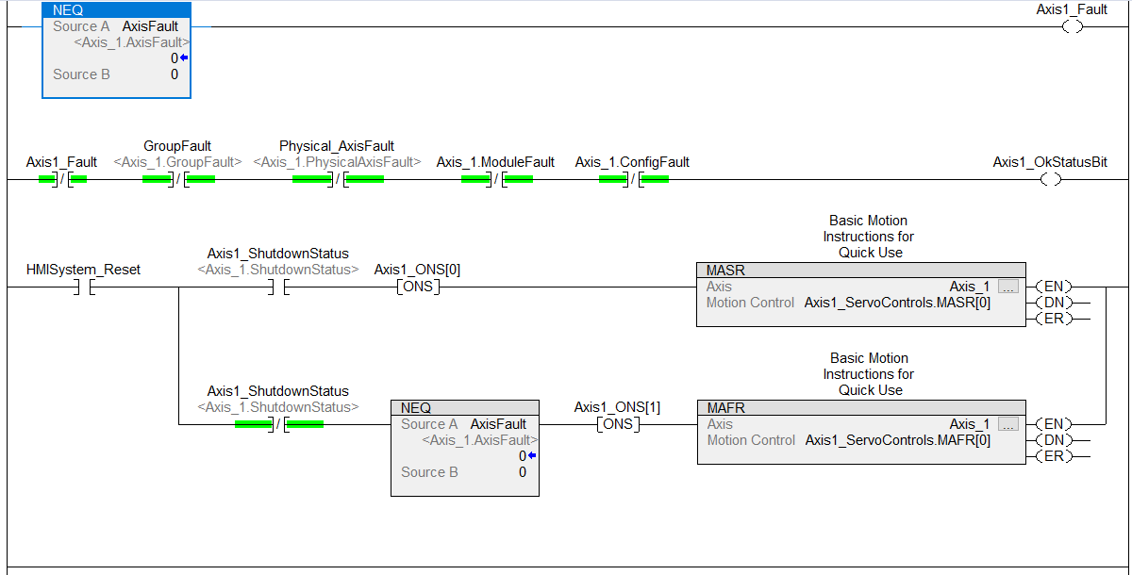
An actual servo system will have a more in depth status and fault checking scheme.

Note the above code does have two global tags; Axis1_OkStatusBit and HMISystem_Reset.

Now we want to export this routine from AxPrg_Axis1 and import it into AxPrg_Axis2. To export right click on the routine Control_Main. Next right click AxPrg_Axis2 and select Import.

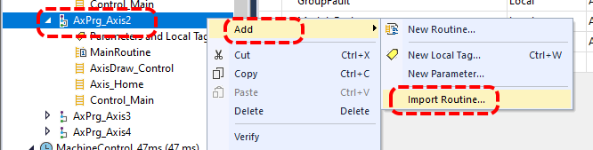

When window opens go to tags on the left hand pane. Everything in the Final Name column that says Axis1 we want to change to Axis2 (same goes for Axis_1 and Axis_2). Use the find & replace button. Check when done then click OK.

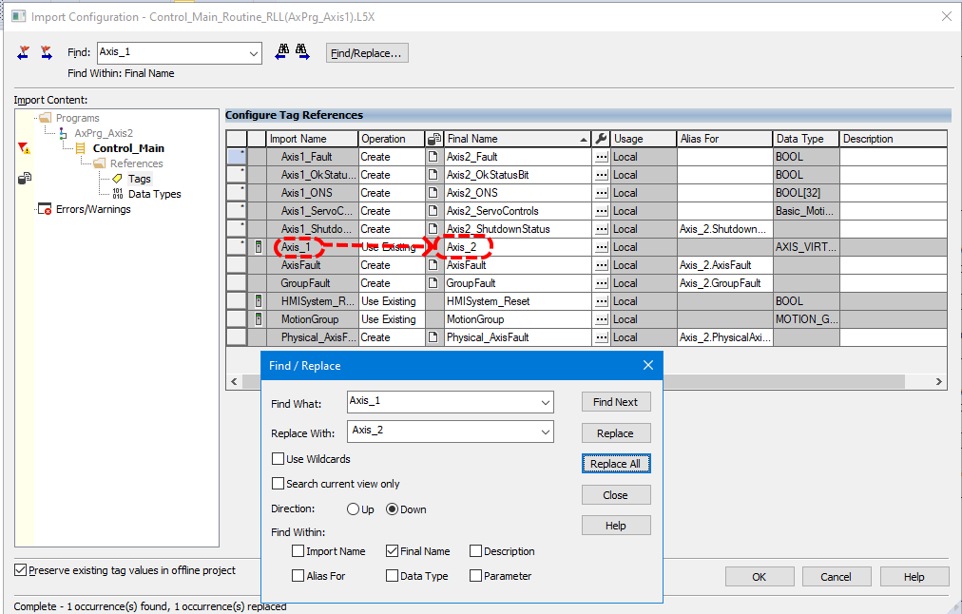

The code has been added to AxPrg_Axis2 with the parameter names changed.

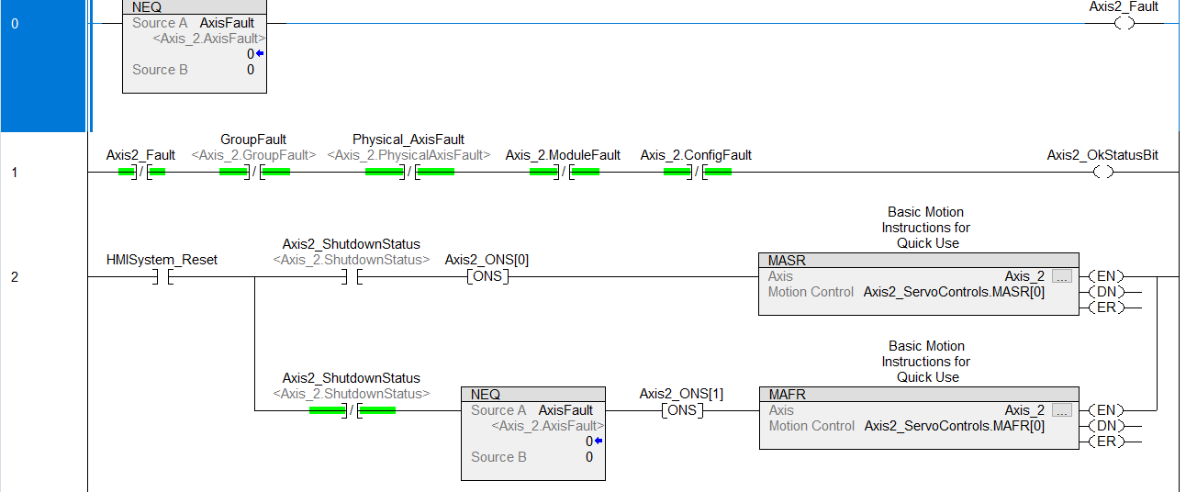

Repeat for axis 3 and 4.

Next we work on the Home code. Note that virtual axis turn themselves on when you home them, actual servos have a command to turn them on. We check the axis parameter .ServoActionStatus because if the axis is on it has already been homed and we do not want to home it again. Axis1_HomeStatus is controller scope and meant to be a kind of rool-up or indicator that the axis is being homed.

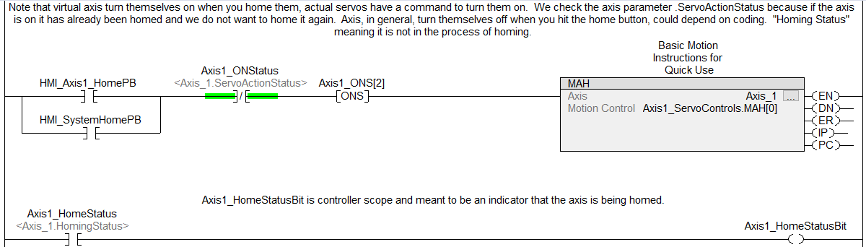

Now export the homing routine and import it into the other modules. Better to delete the existing Axis_Home module and import, then change the names. Writing over causes some parameter mix ups.

Moving on to coding the Draw_Control now. We will be gearing axis, the ratio of the gearing is actually the draw control. Anytime draw control changes the MAG command will recalculate the gearing. Method is: if an input to the draw control is not equal to the last value then we set a bool called Axis1_UpdateDraw which, on the next cycle, will enable the MAG block to recalculate the ratio. If an error is generated by the MAG [MAG[#].ER] command a fault is declared.

Begin by adding the below code to MachineControl_47ms|MainProgram.MainRoutine. Both parameters are controller scope.

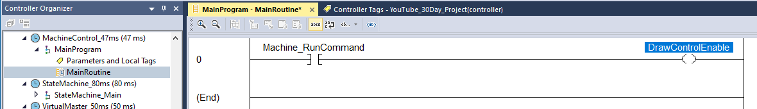
This block is kind of the start stop.

Now we will program the master jog into VirtualMaster_50ms - VirtualMaster_MainProgram - Control_VirtualMaster.

Setting Machine_RunCommand will set DrawControlEnable in MachineControl_47ms - MainProgram - MainRoutine.

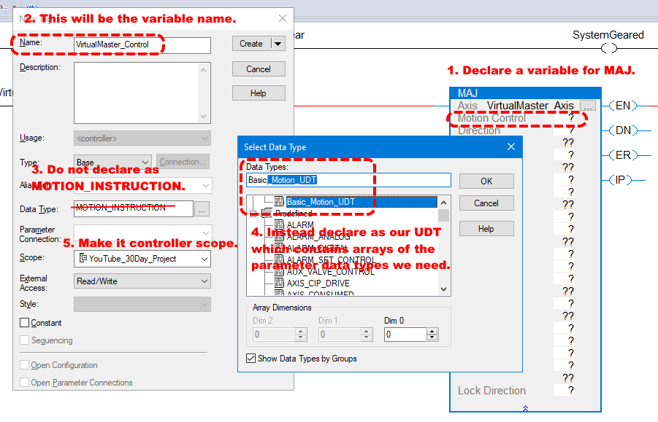
Above are the first steps in declaring our MAJ function.

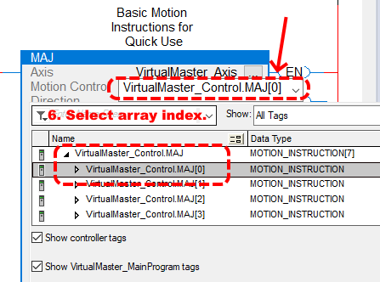

After we OK the above dialog we can come back in and select the array index we wish to use.

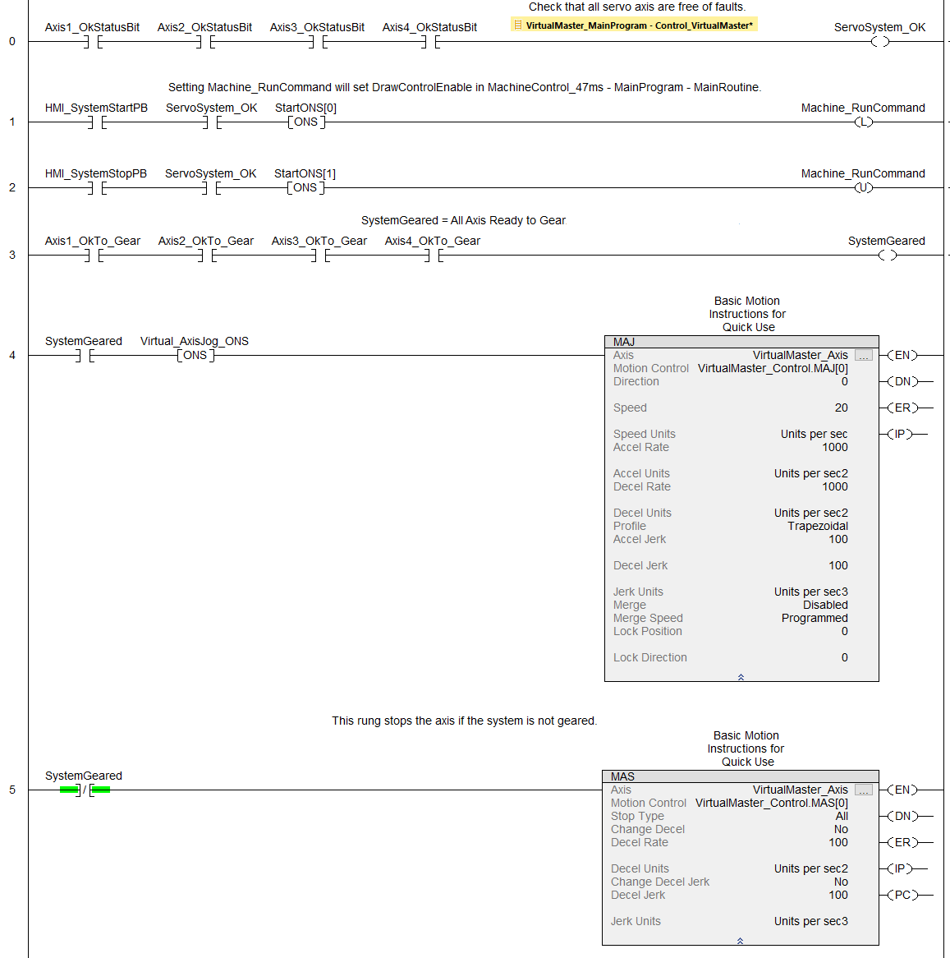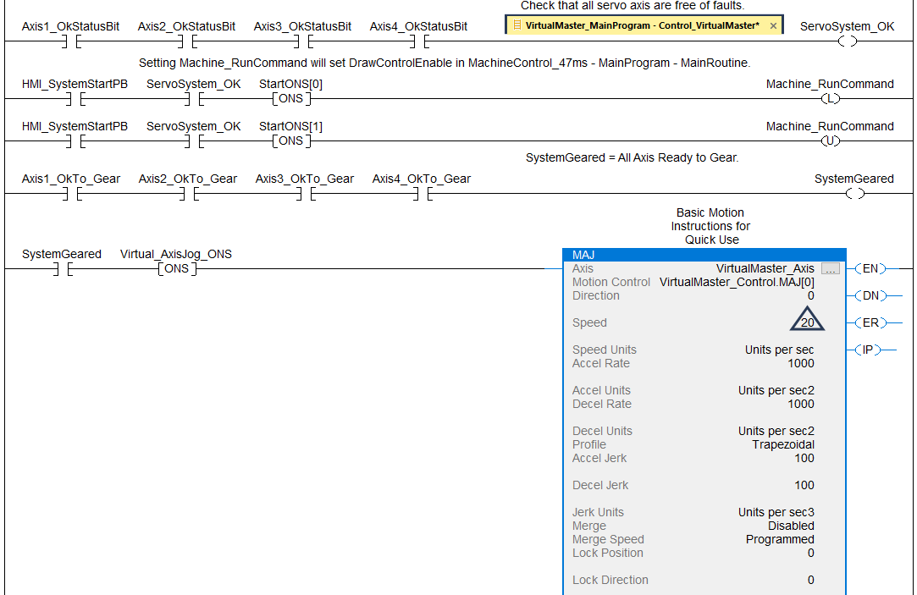
If running on an emulator now you can download and test run.

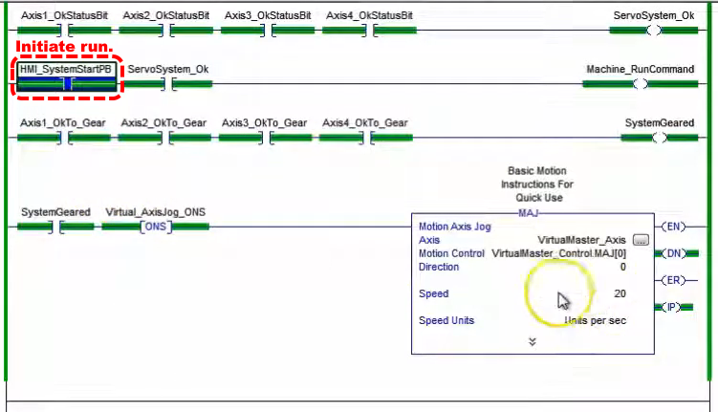
We can check the AxisDraw_Control code to see the axis running.
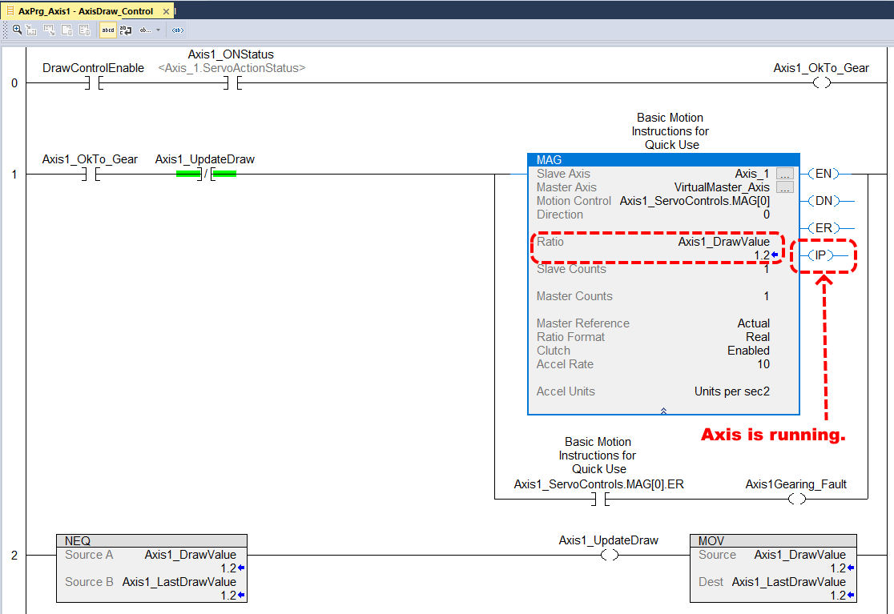

Now let’s look at the effect of the gearing. We can see the ratio is set at 1.2. We can see Axis_2 is turning at a velocity of 24, this is 1.2 times our commanded speed for the VirtualMaster of 20 (blue triangle a few screens up).

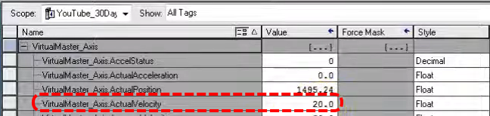

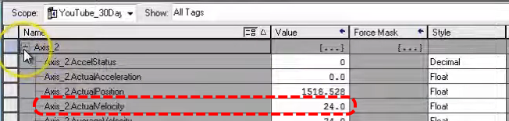

Now let’s add a Motion Axis Stop to VirtualMaster_MainProgram.

Next we will work on the state machine and transitions through the program. We will use indirect addressing. We have to create a move instruction which access an array.

Start with two move instructions, each on their own rung. On the top one for the select the tags we have already made, Machine_SSL_Array[0] which is a DINT[50] array.

Now create variable Machine_State_No as DINT with controller scope.

Now create Machine_SSL_State_No as an alias for Machine_State_No, DINT, controller scope.

Now Machine_SSL_State_No becomes the index into Machine_SSL_Array in the top move statement.

The bottom move statement populates the parameter displayed in the HMI, HMI_Machine_State_No.

The top move statement has destination Machine_SSL_Out.

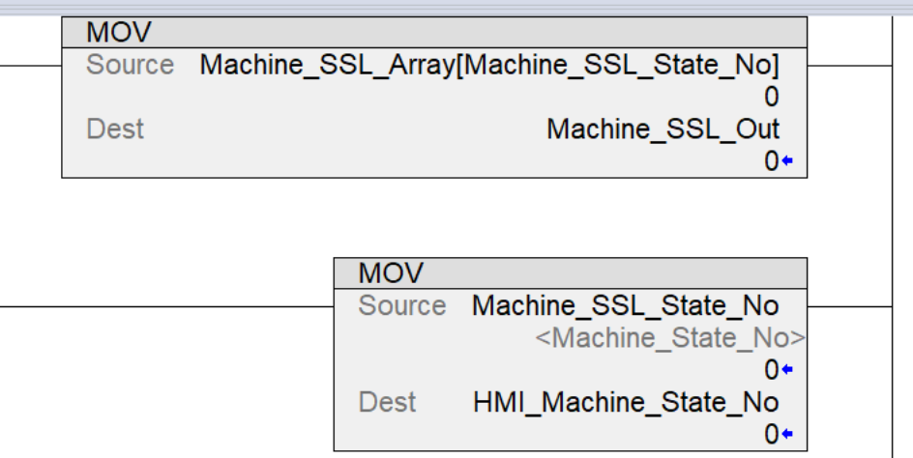

Now adding some outputs.
SSL_In1_Estop, alias for Machine_SSL_In.0, Bool, controller scope.
SSL_In_Not_Ready, alias for Machine_SSL_In.1, Bool, controller scope.
SSL_In1_SystemStop, alias for Machine_SSL_In.2, Bool, controller scope.
SSL_In1_SystemReady, alias for Machine_SSL_In.3, Bool, controller scope.
SSL_In1_SystemStart, alias for Machine_SSL_In.4, Bool, controller scope.
SSL_In1_SystemRunning, alias for Machine_SSL_In.5, Bool, controller scope.

Now we’ll add some code to shut the machine down if the axis goes into fault. We’ll also add code to shut down if the gearing faults.

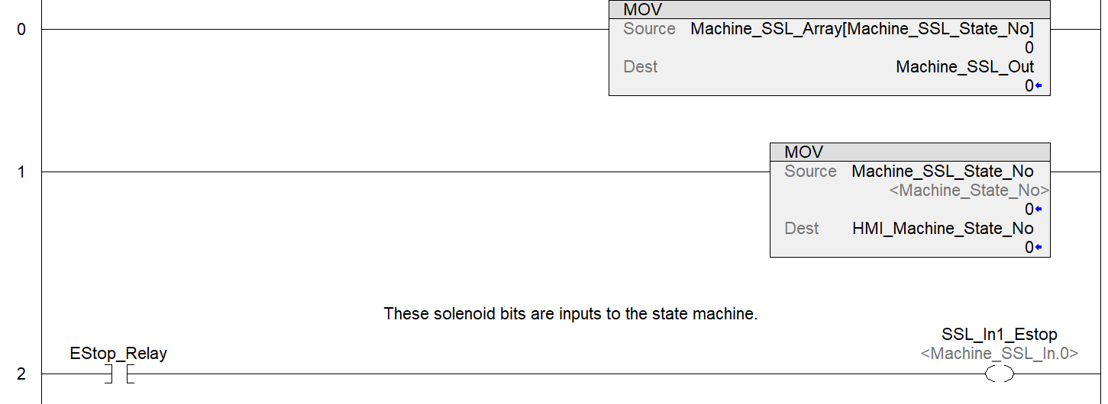

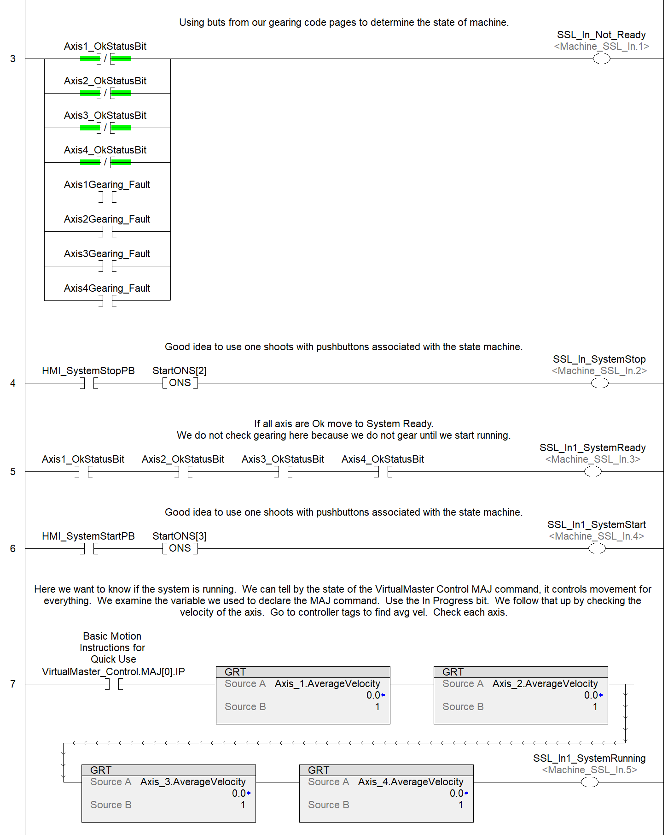

Now we will code Machine_SSL in structured text (state 2 currently not used).
“In1” seen in this code refers to inputs to the state machine.
//state control
//===============================
//0: E-Stop / Safe Device State
//1: Stopped & Not Ready
//2: Not Used
//3: Stopped & Ready
//4: System Start
//5: Wait on Stop

Case Machine_State_No of
/************************************************************************************/
/* Machine State 0 - Emergency Stop */
/************************************************************************************/
0: If NOT SSL_In1_Estop AND SSL_In_Not_Ready then Machine_State_No := 1;
elsif
NOT SSL_In1_Estop AND SSL_In1_SystemReady then Machine_State_No := 3;
end_if

/************************************************************************************/
/* Machine State 1 - Stopped & Not Ready */
/************************************************************************************/
1: If SSL_In1_Estop then
Machine_State_No := 0;
elsif
NOT SSL_In1_SystemStop AND SSL_In1_SystemReady then
Machine_State_No := 3;
end_if

/************************************************************************************/
/* Machine State 3 - Stopped & Ready */
/************************************************************************************/
3: If NOT SSL_In1_Estop then Machine_State_No := 0;
elsif SSL_In1_SystemStop OR SSL_In_Not_Ready then Machine_State_No := 1;
elsif SSL_In1_SystemStart AND SSL_In1_SystemReady then Machine_State_No := 4;
end_if

/************************************************************************************/
/* Machine State 4 - System Start */
/************************************************************************************/
4: If NOT SSL_In1_Estop then Machine_State_No := 0;
elsif SSL_In1_SystemStop OR SSL_In_Not_Ready then Machine_State_No := 1;
elsif SSL_In1_SystemRunning then Machine_State_No := 5;
end_if

/************************************************************************************/
/* Machine State 5 - Wait on Stop */
/************************************************************************************/
5: If SSL_In1_Estop then Machine_State_No := 0;
elsif SSL_In1_SystemStop OR SSL_In_Not_Ready then Machine_State_No := 1;
end_if
===========================================================================

Next we will populate the Machine_SSL_Array[Machine_SSL_State_No] array. Keep in mind that Machine_SSL_State_No is populated by the state machine ST code, as state changes we will see Machine_SSL_Array[]’s value change.

We want to demonstrate how to use this array. Machine_SSL_Array[Machine_SSL_State_No] offers a way for the state machine to take various actions based on various conditions automatically. Machine_SSL_Array[ ] is a 50 member DINT array, so each member has it’s own 32-bit DINT which we can preload with values and we can program certain actions for. For example, say we load Machine_SSL_Array[4].5 with a 1. Look what setting bit 5 to 1 does, it makes the value of Machine_SSL_Array[4] equal to 32 (2^5).

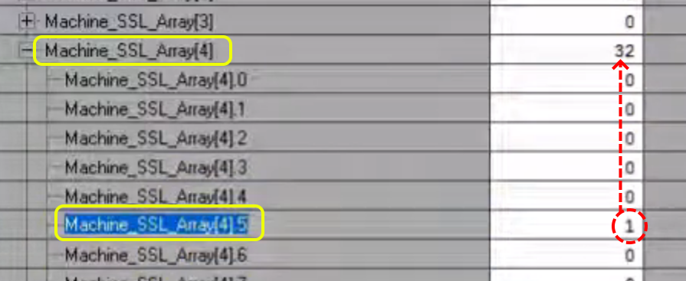

And we can see that value in the code because we are in state 4.

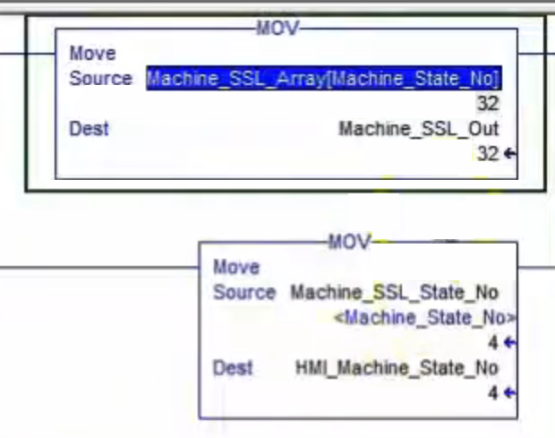
Now we can ask what output is associated with “32”? We will look at Machine_SSL_Out.

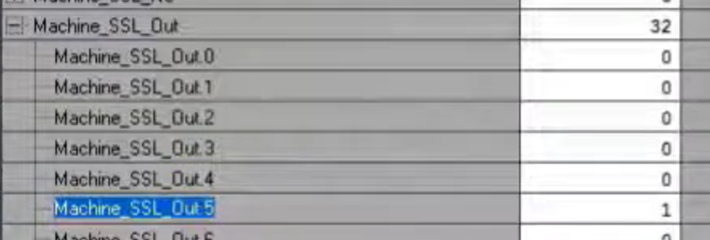

We add another value to Machine_SSL_Array[3].4 which makes Machine_SSL_Out = 16.

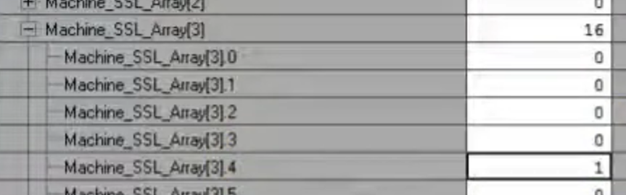

We can use these values in our code. In this case we will create a stop feature using nit Machine_SSL_Array[3].4 as an alias.

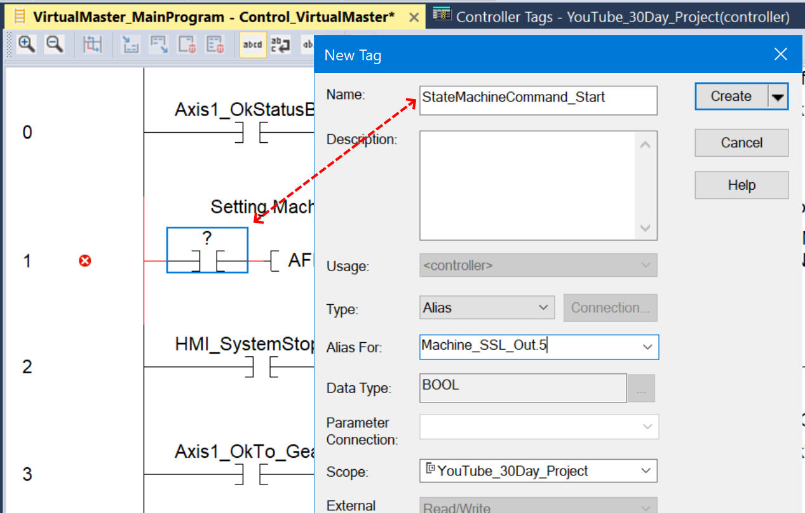
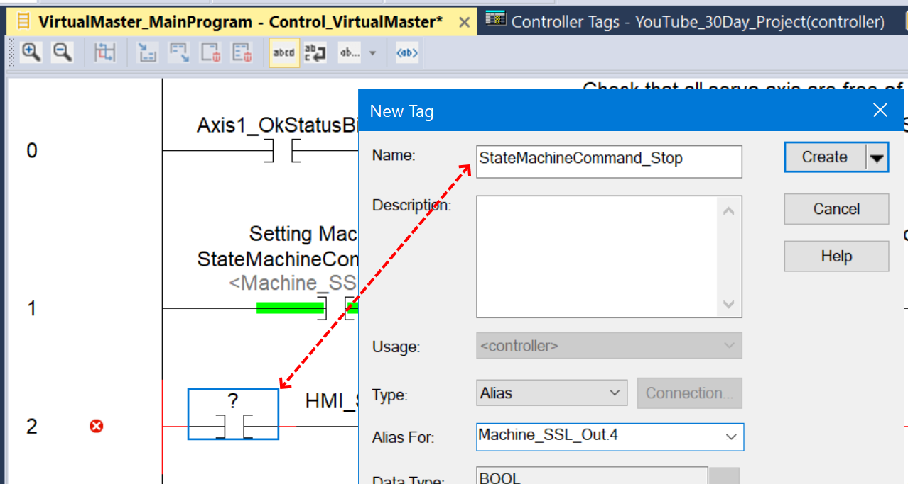

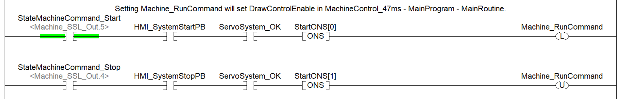
“Out” as we see here, refers to output of the state machine.

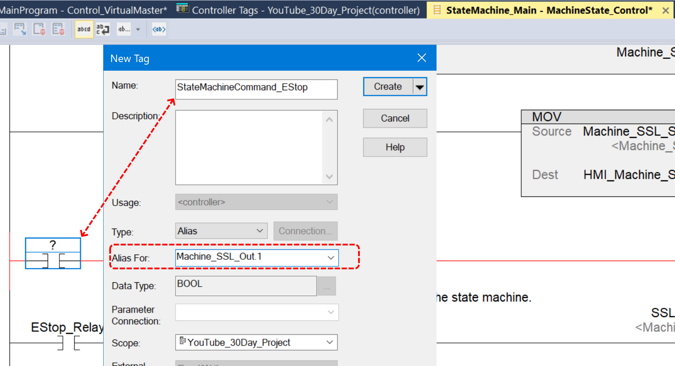

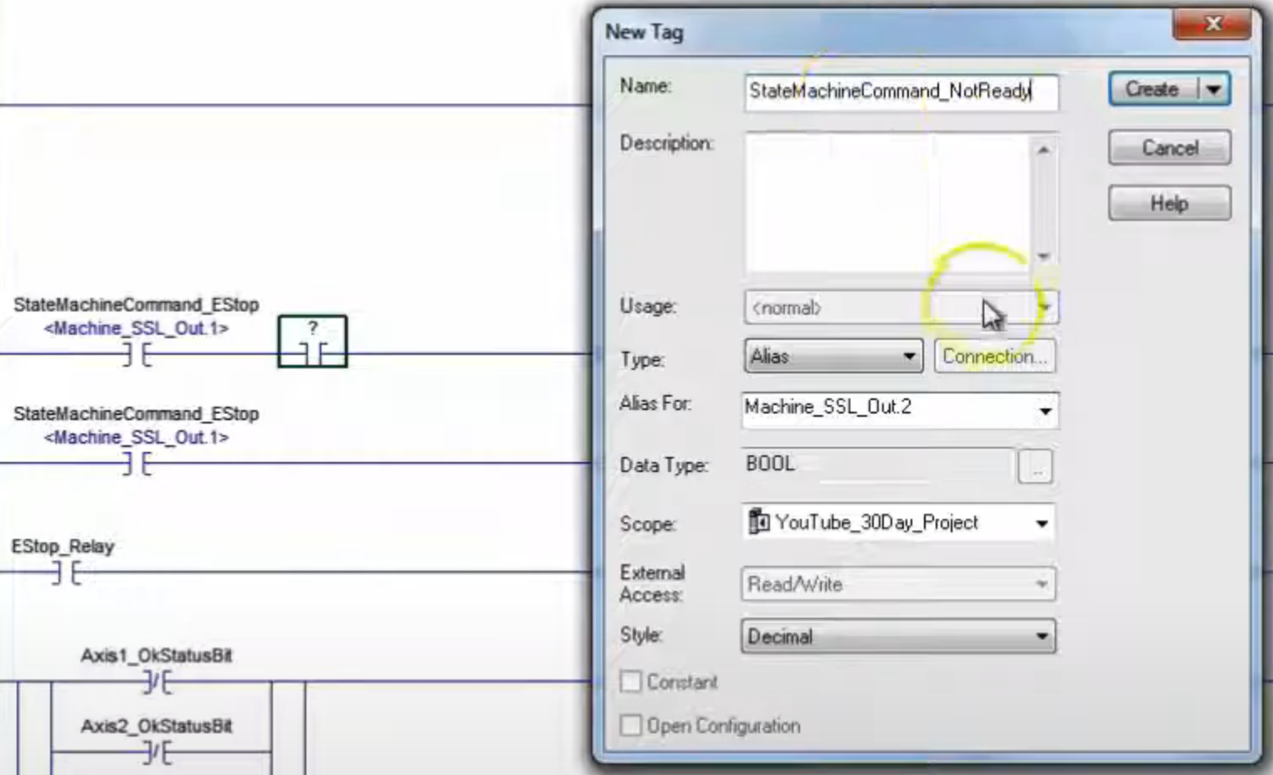

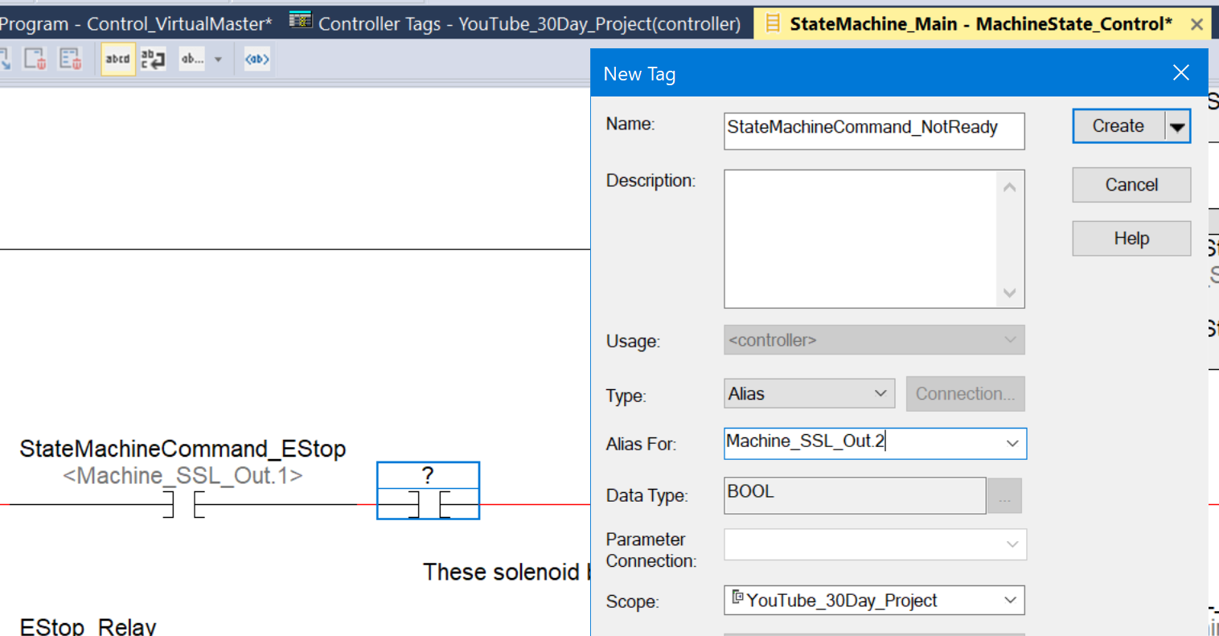

The above edit, creating StateMachineCommand_NotReady, will toggle when run.

Now we want to put in the Ready … we will make array element Machine_SSL_Array[3].3 the ready bit.
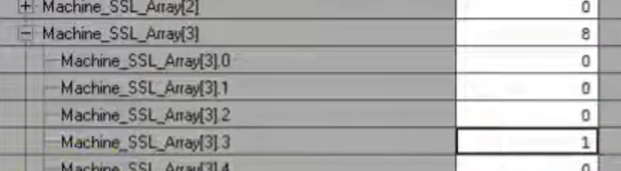

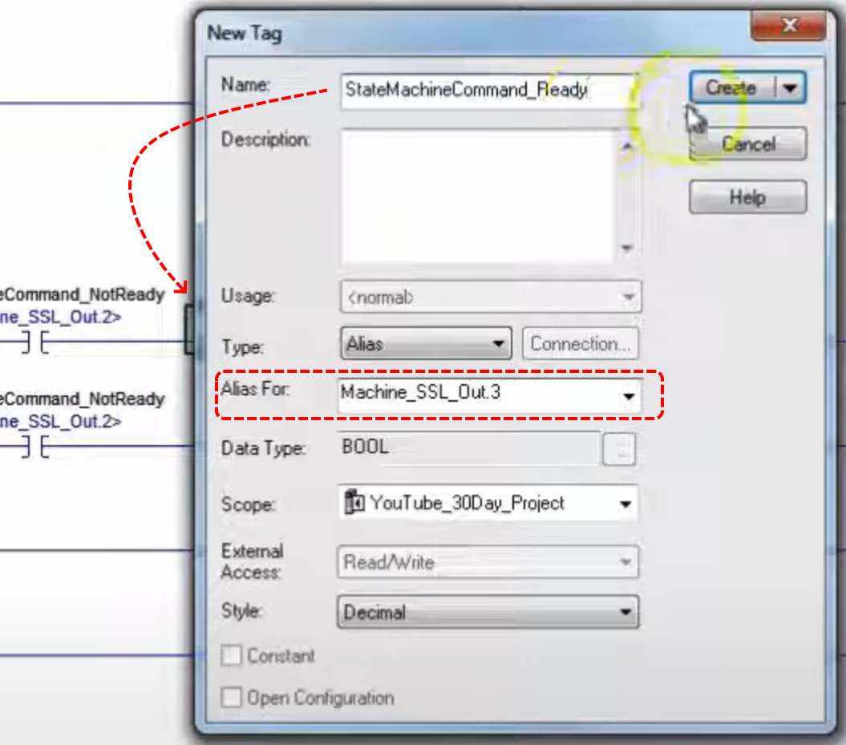

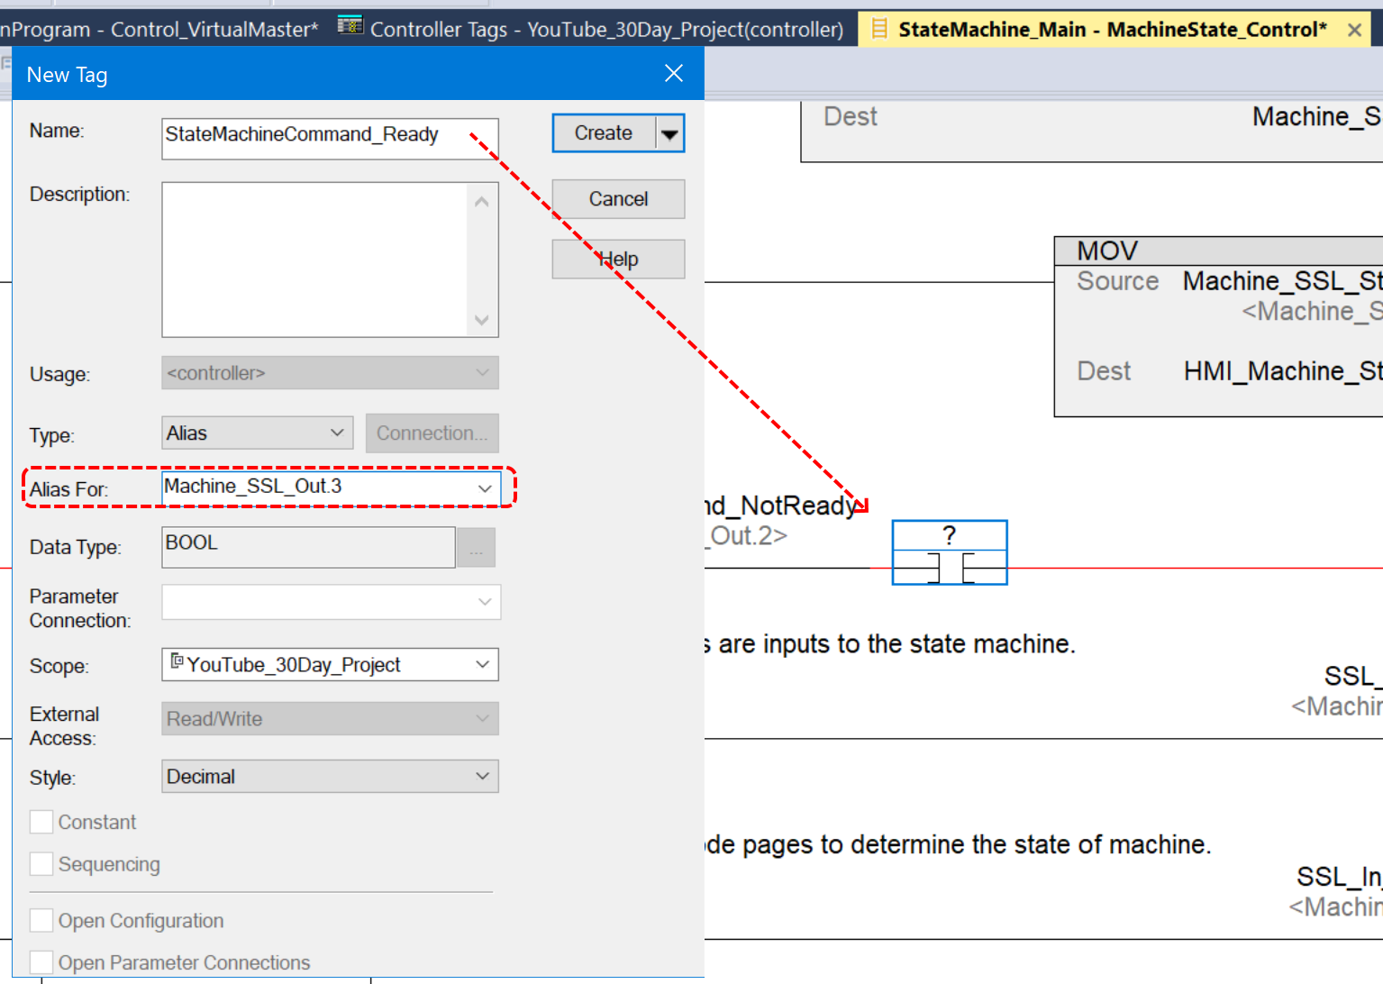

Now take the “NOP” rung to the bottom.

We need array position Machine_SSL_Array[4].5 set to one… we need a none zero value corresponding to Machine_SSL_Array[4].5.

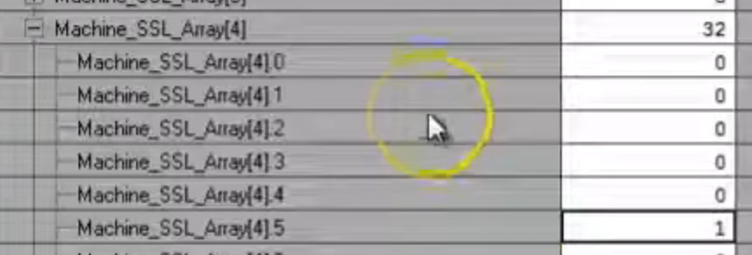

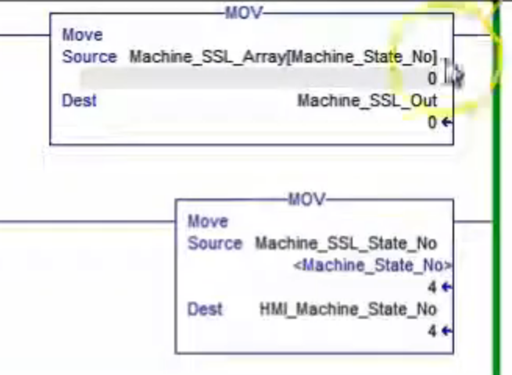

Back to HMI. Client Keys are a way to map a key combination which will shut down a screen of system (?). Name our client keys “cliKeys”.
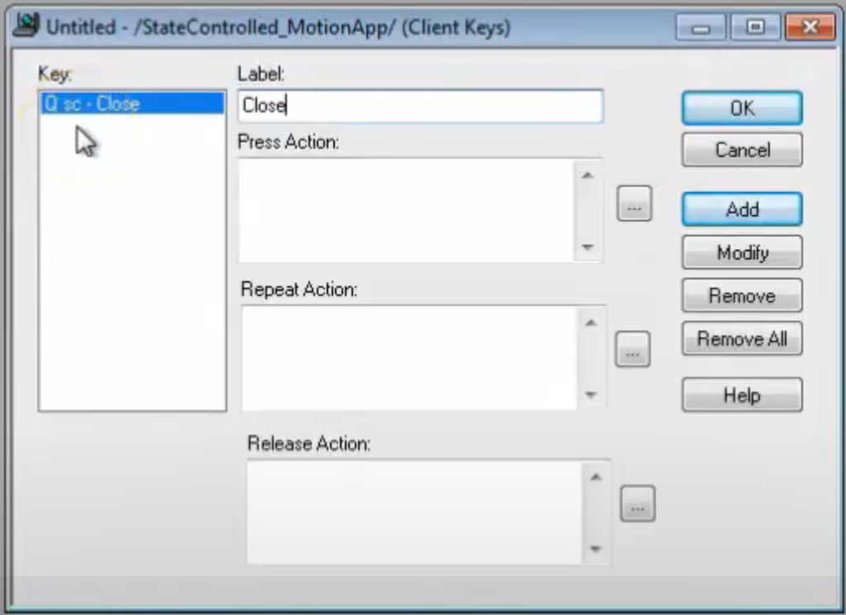
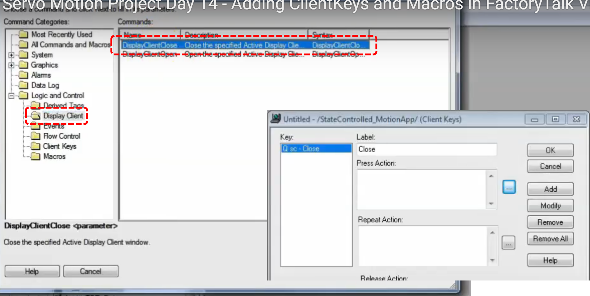

Now we have our client keys, next we set up our macro.

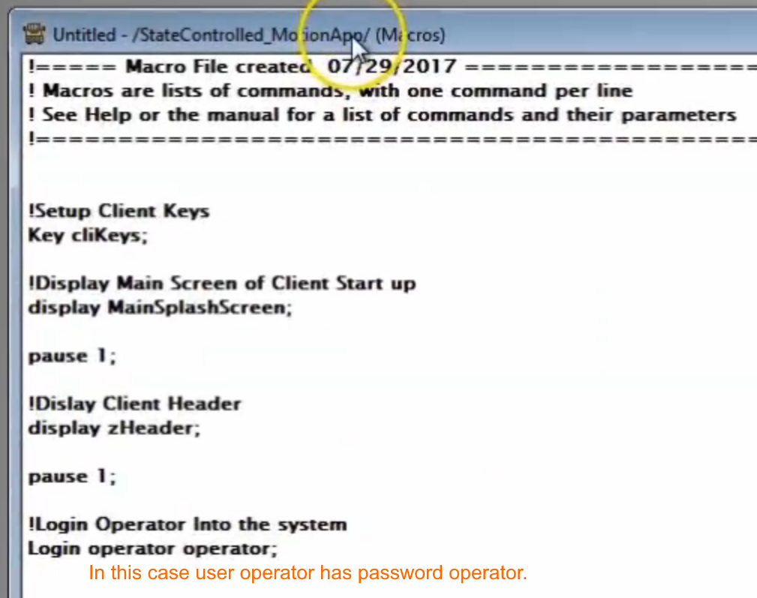

Our Header Screen
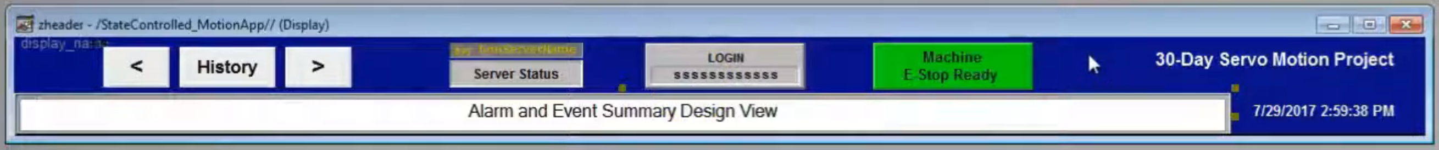
We also added some Alarm & Events items.

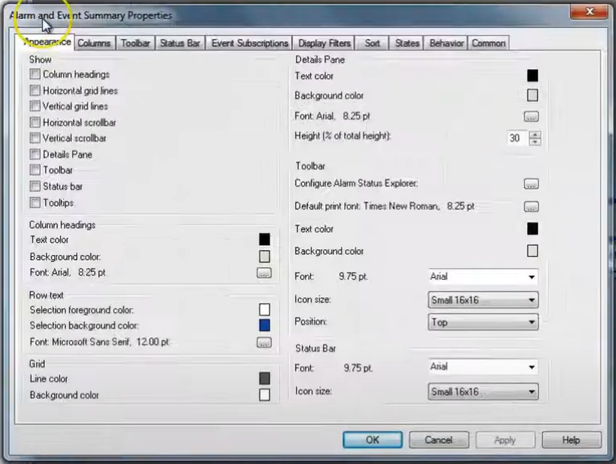

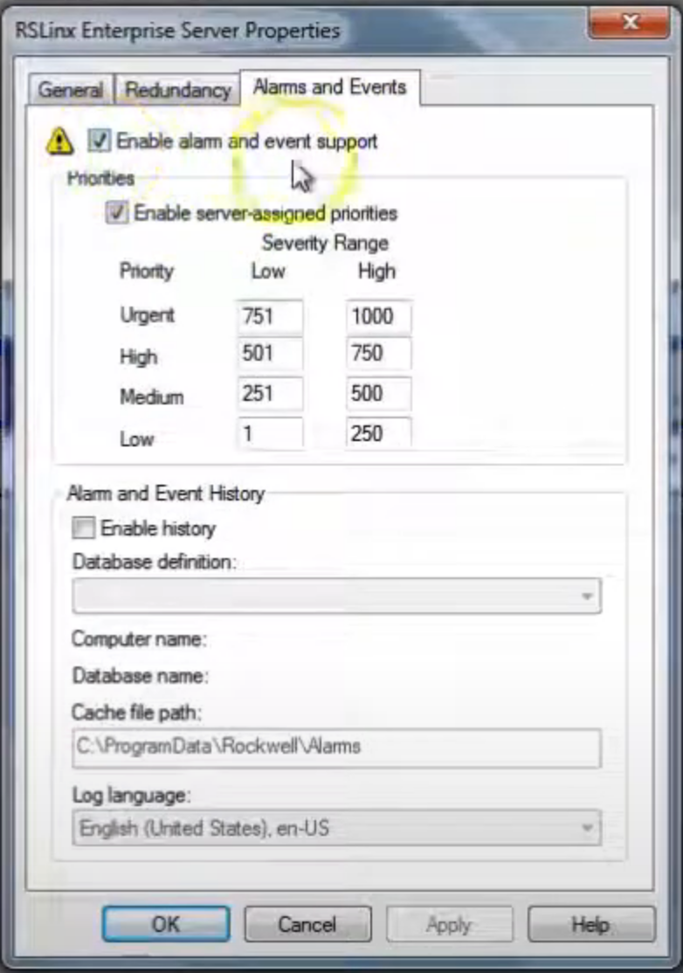

Enabling server side priorities and other RSLynx based alarm & events.

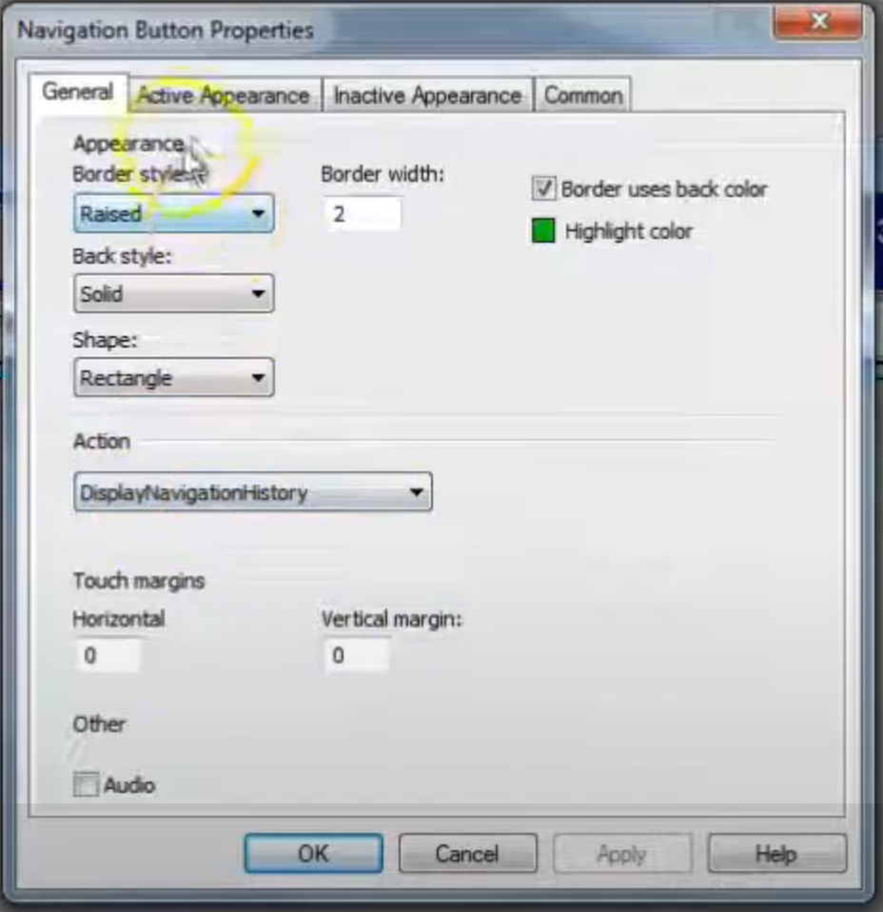

Set up navigation screen items.

Using next screen / prior screen.

Now we are incorporating the below screen. It came from RW knowledgebase and has VBA code behind it. We will examine the code.

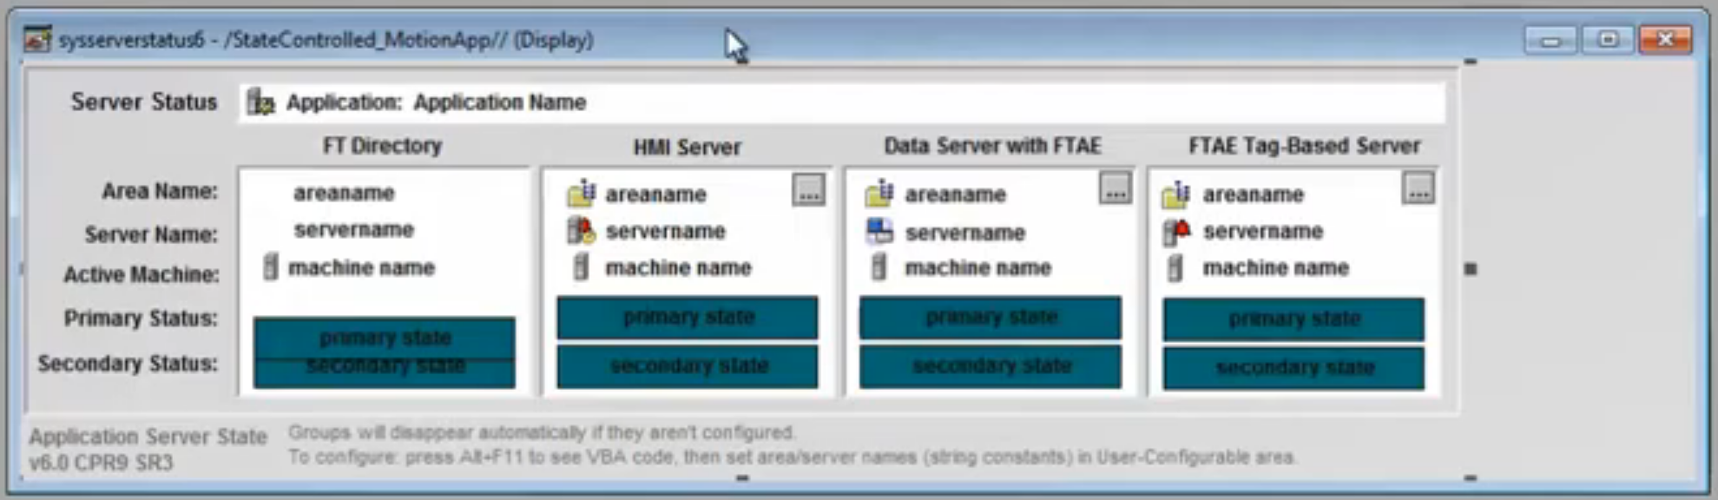

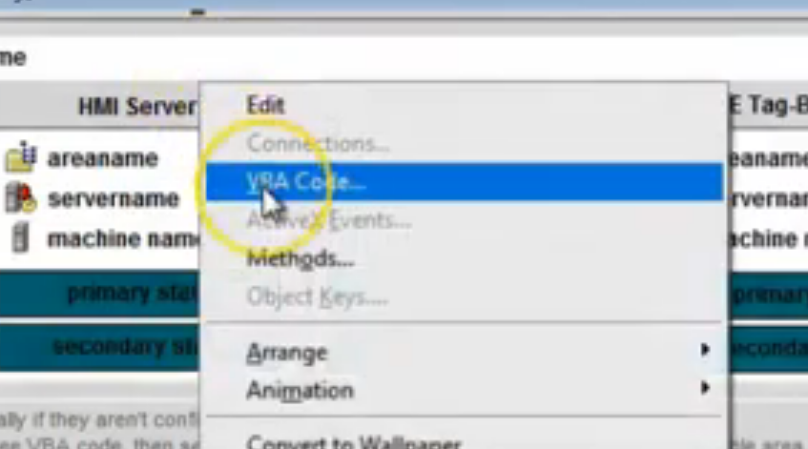

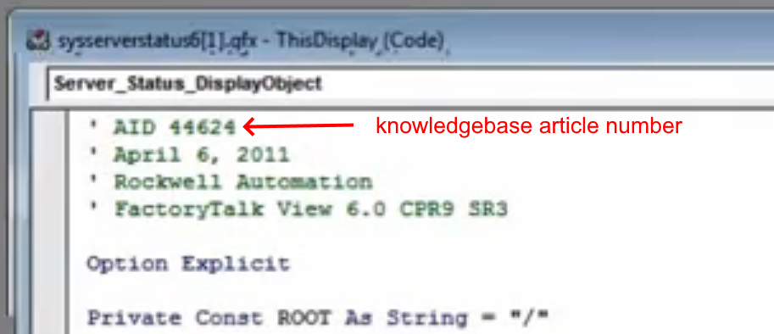

This is kind of an application template.
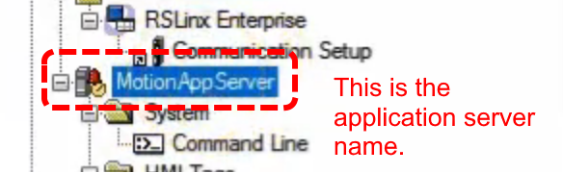
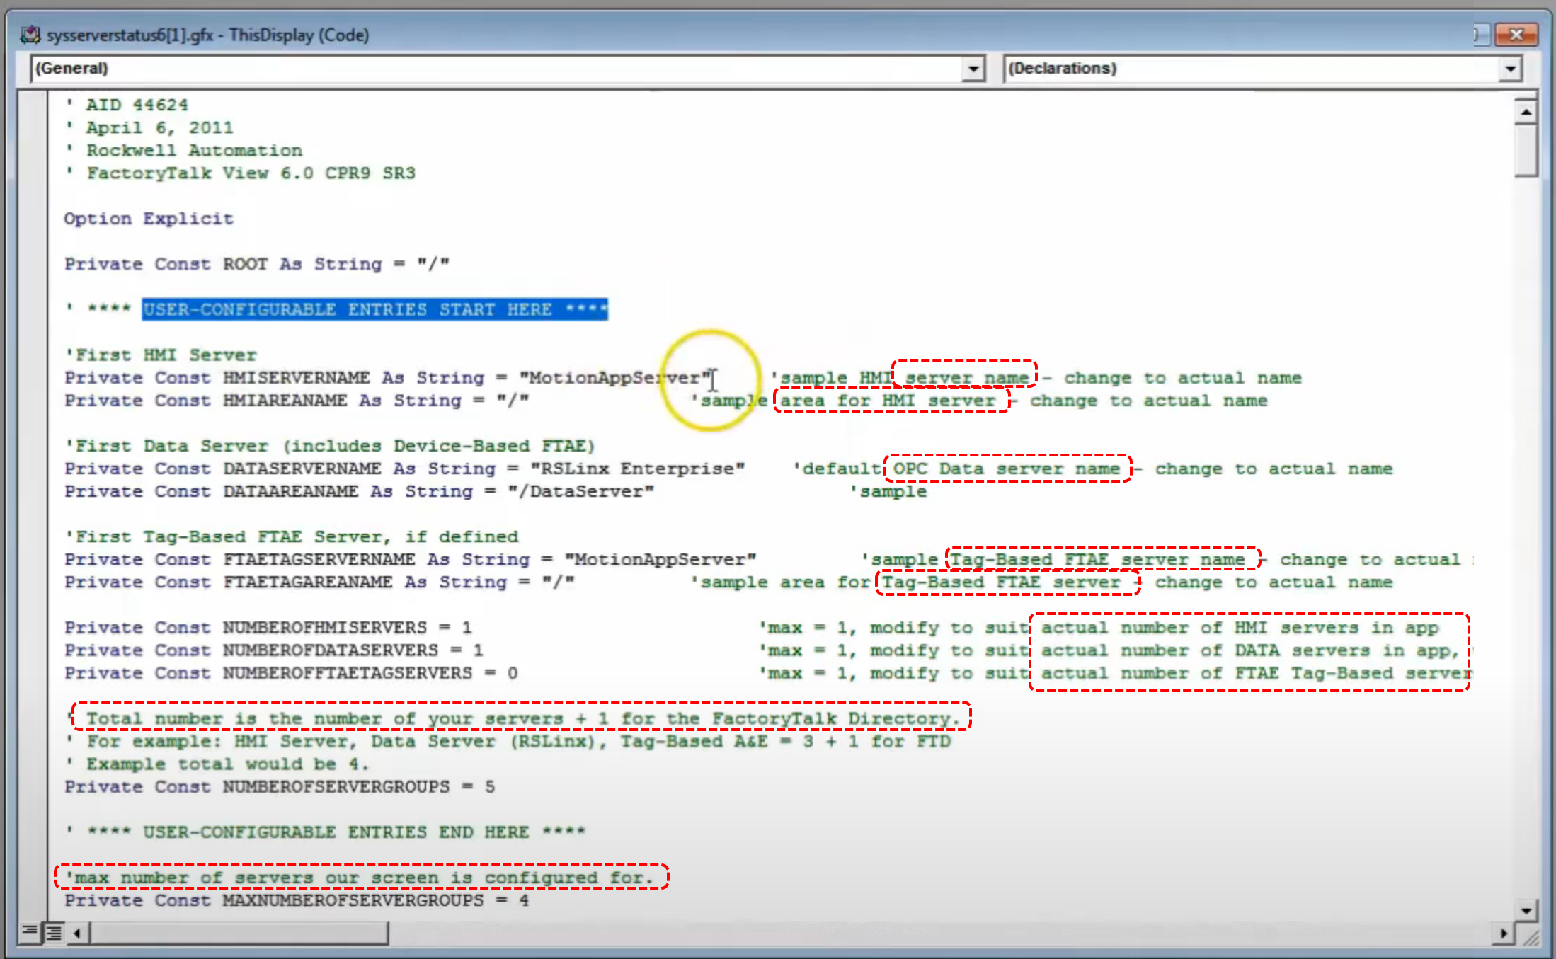
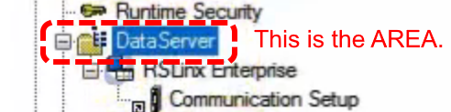

If using a second server you must fill in the below information as well.
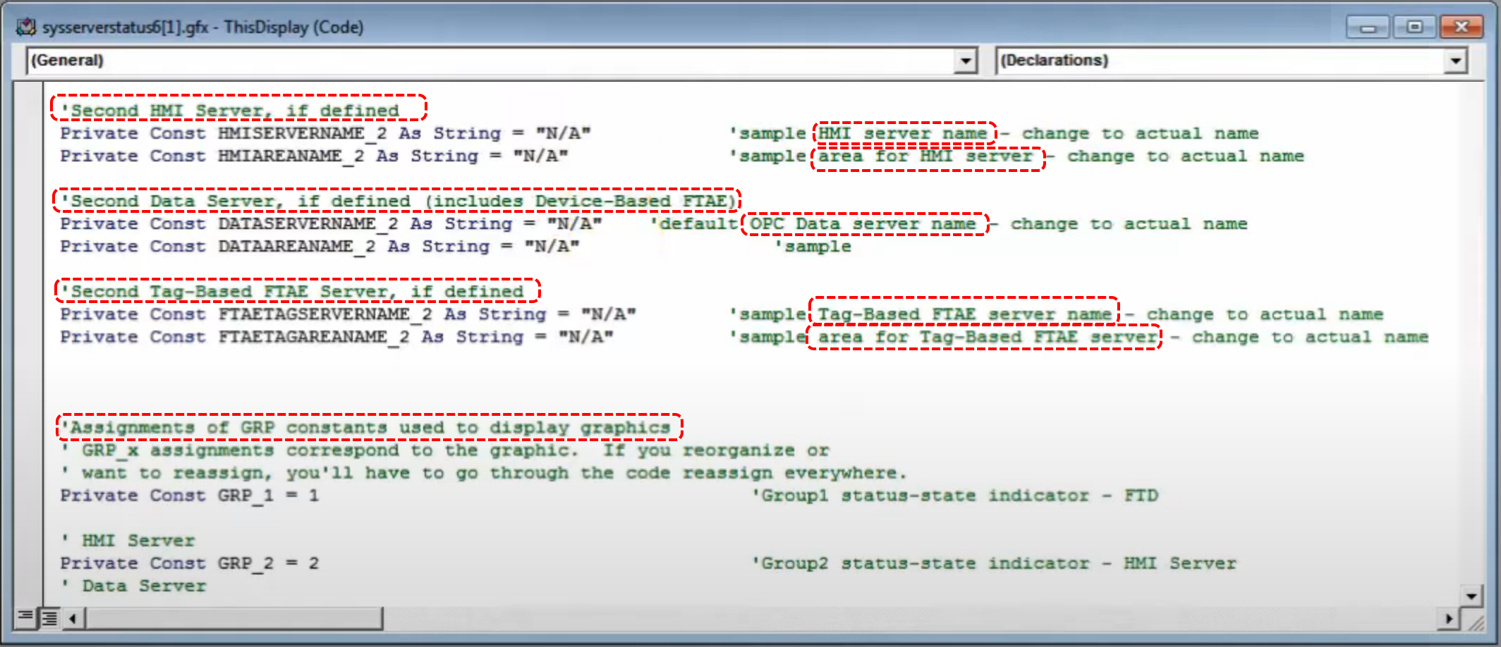

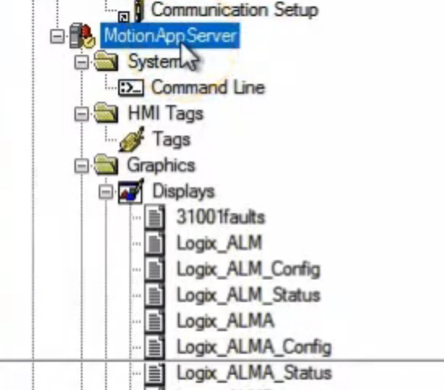
“MotionAppServer” is the HMI system we are creating our application under. This has to do with the “/” characters asked for in the application setup data above (such as HMIAREANAME”.

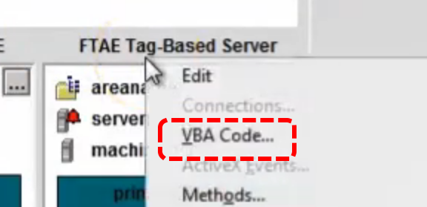

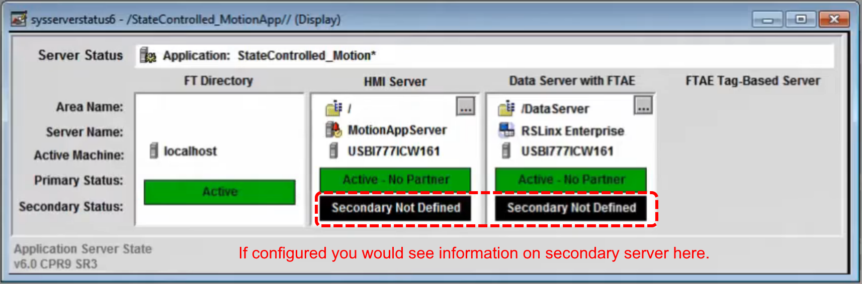

Often times you can use the Rockwell sample VBA program more or less as is and not be missing any functionality you need.

The purpose of the above screen is to allow you to check the full health of the system without going into shutdown and bringing up various other info centers.

Now we will add a small button to our navigation screen. Note how the list of actions comes up.

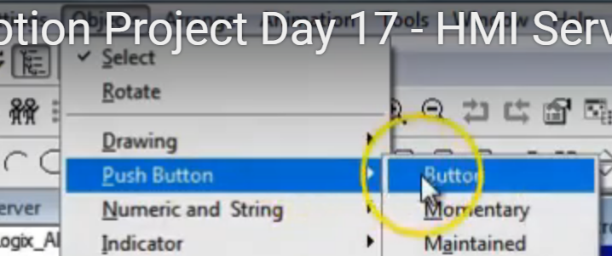

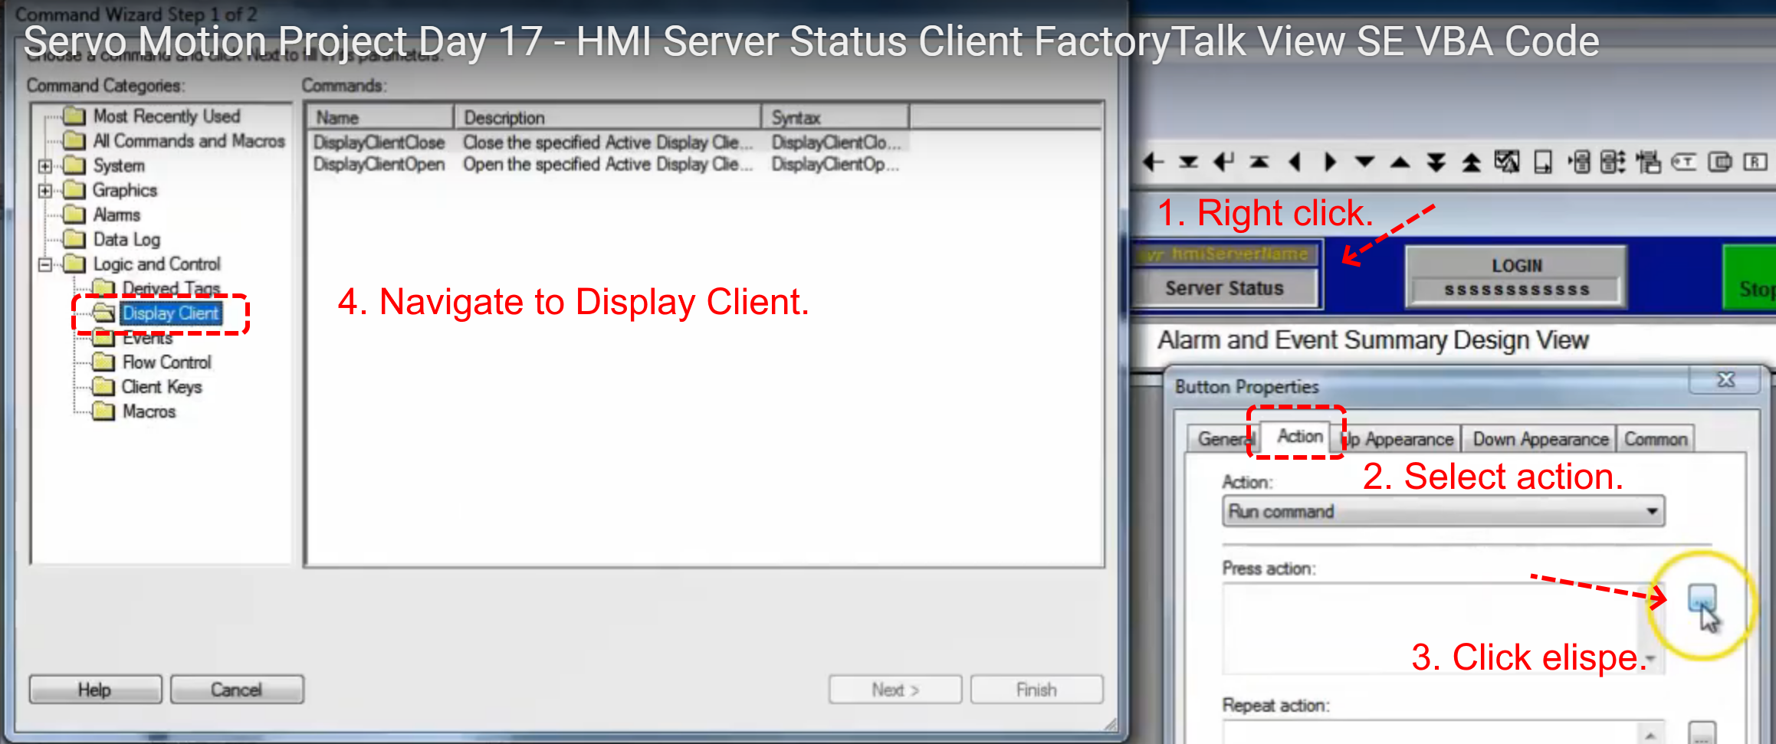

We will use the below item.
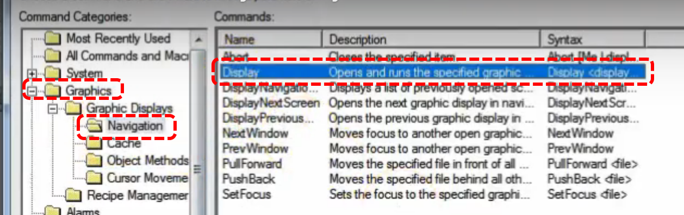

Follow this process… Click the elispe.
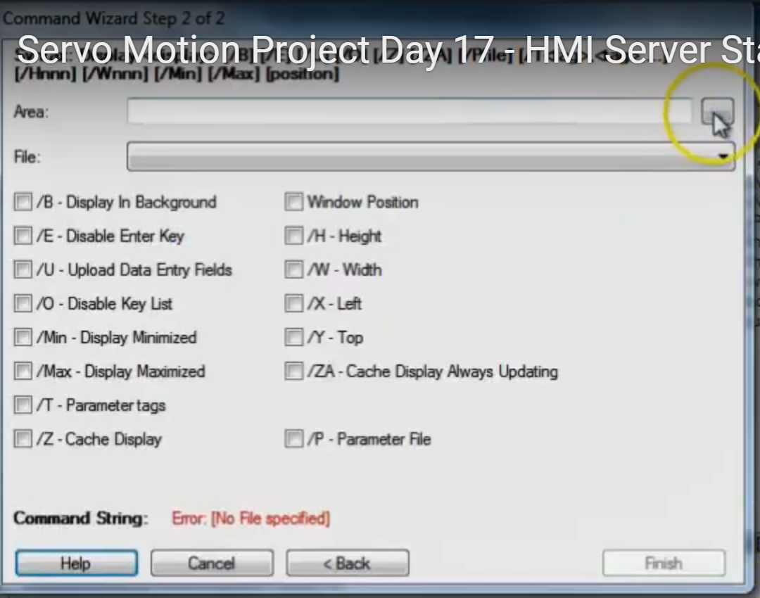
Ensure AREA is selected to server level.
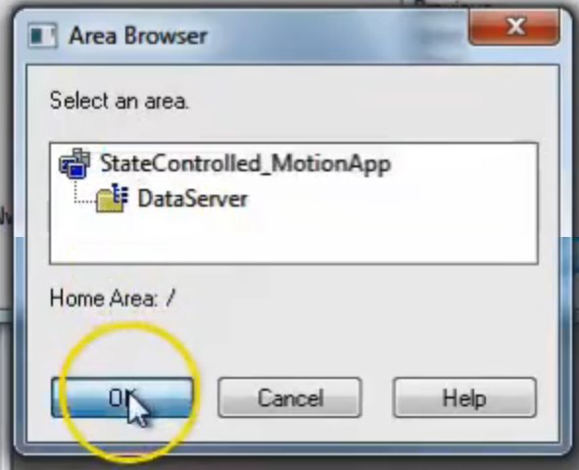

From the dropdown select the screen you want to bring up then click finish on that dialog.
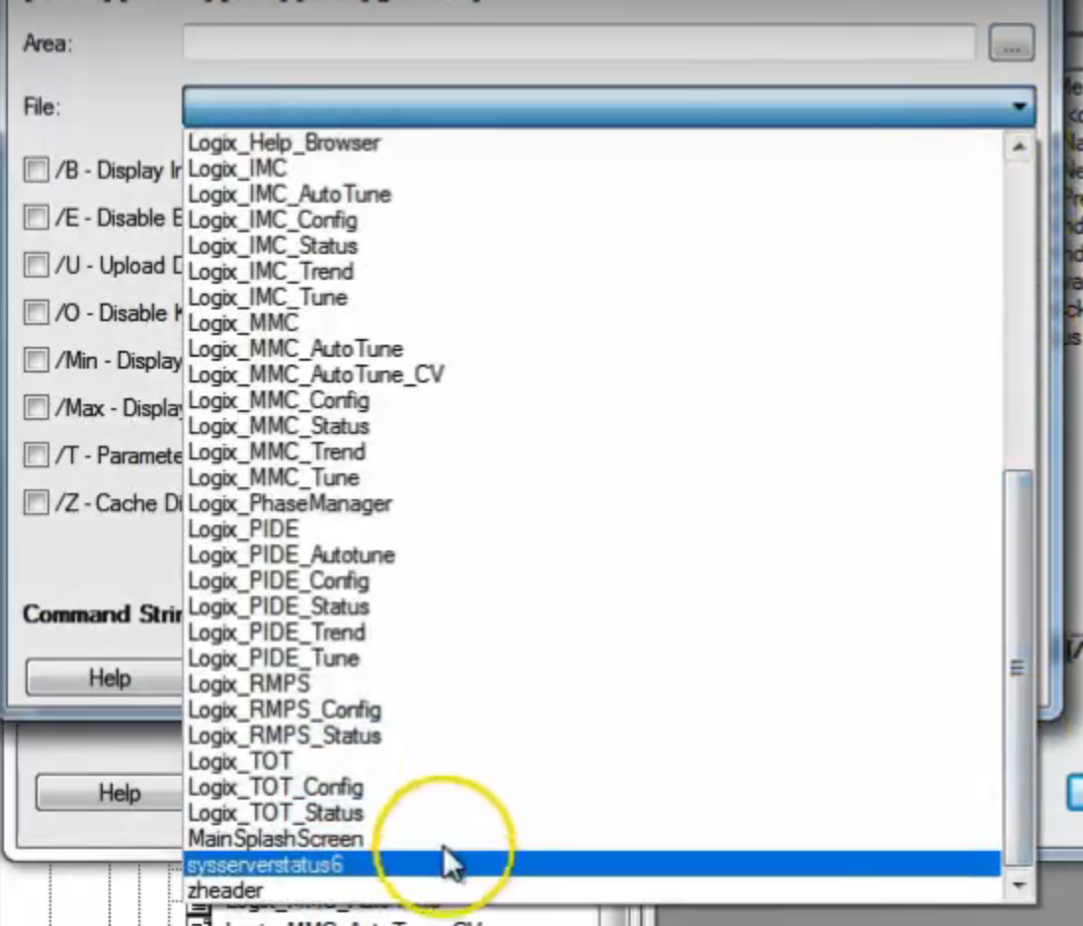
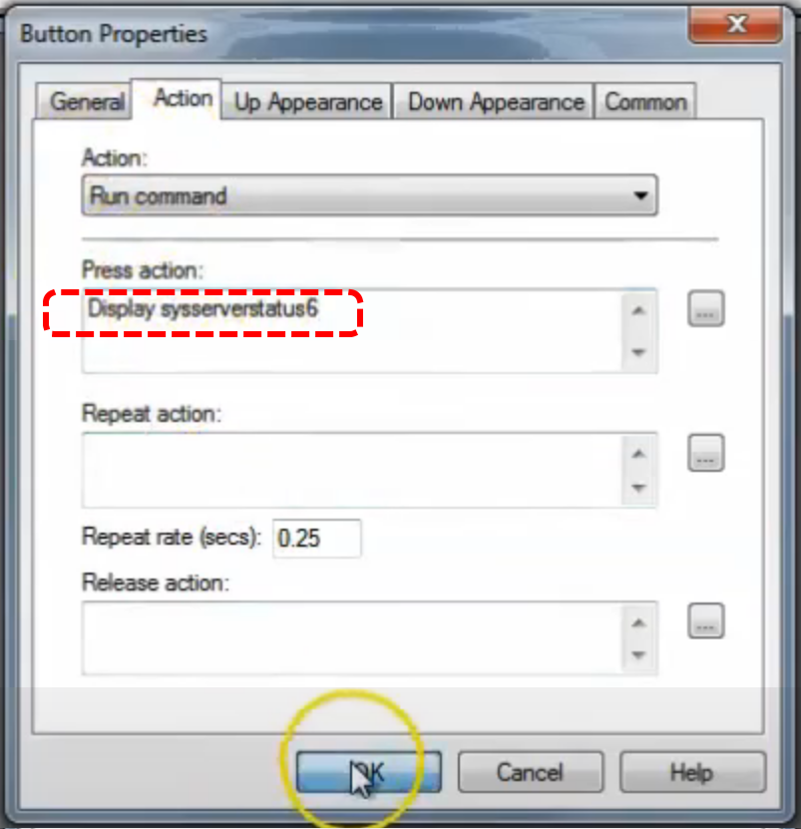

Click OK to finish.

Next we will add a footer screen.Now we will build the client and see what we have so far. Double click on Macros | Client Start to examine the macro.

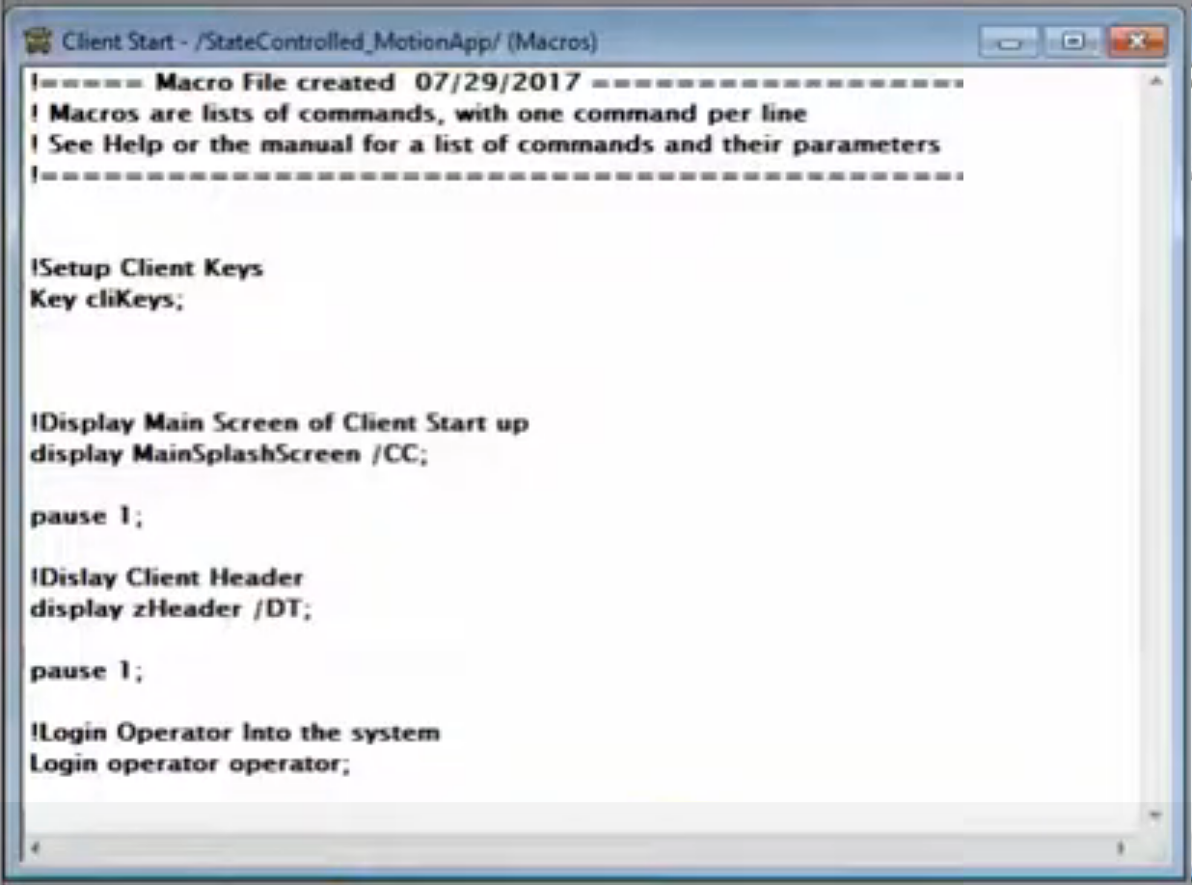
Macro looks good. Now build by pressing the menu bar icon:

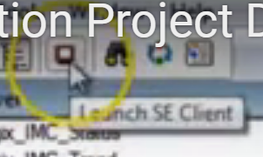

In the dialog click on NEW.
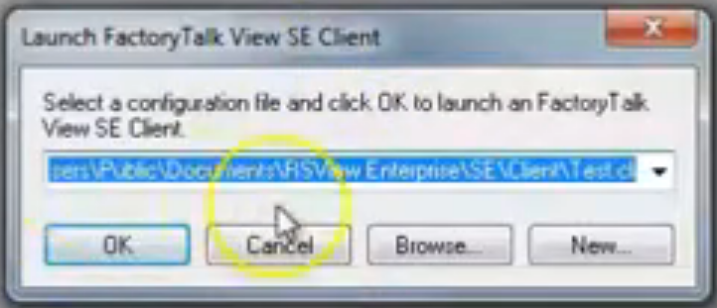

Click New again…

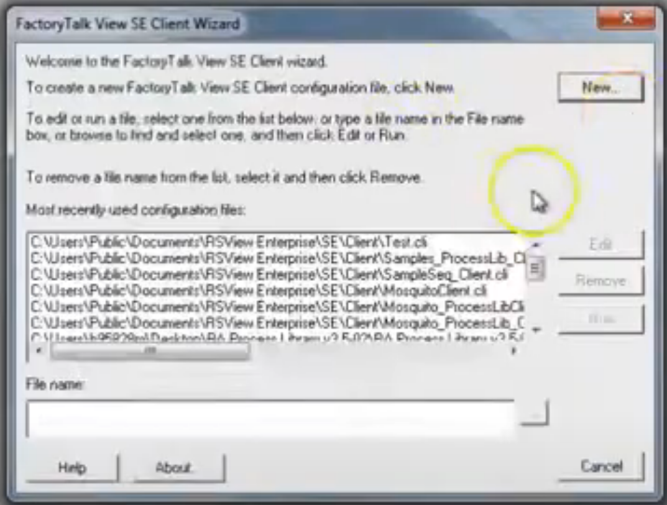
This is the New Client dialog. Type in a name for the new configuration file. Then click Next.
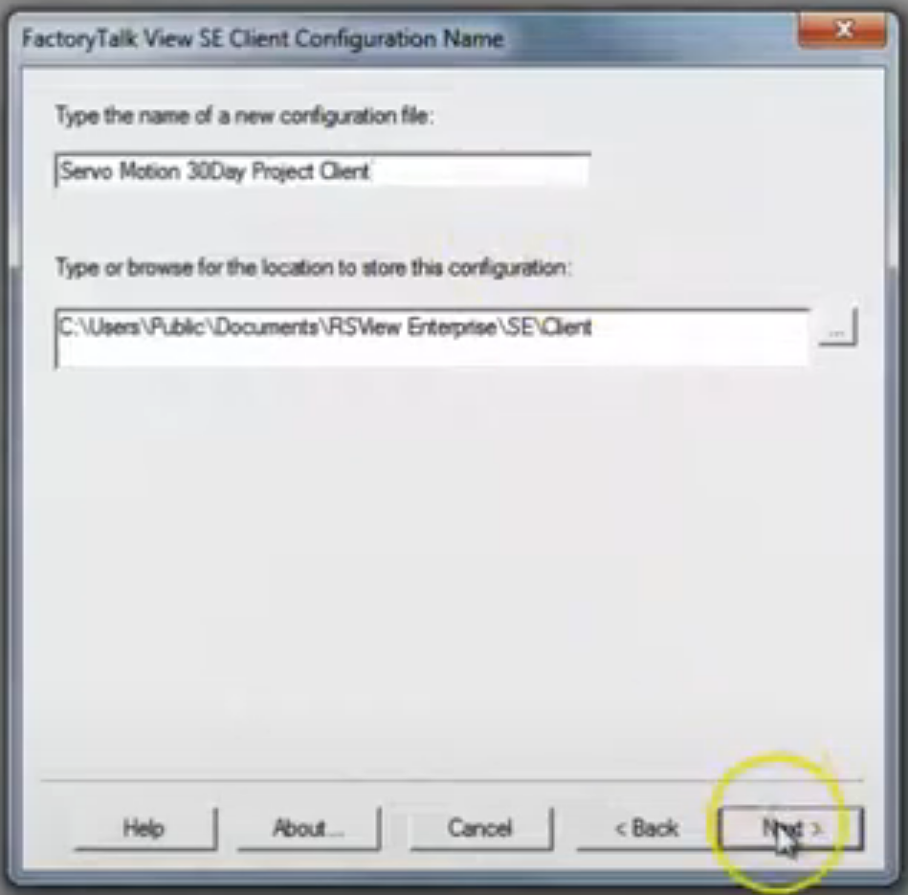

Check the network model, we are using Network Distributed.
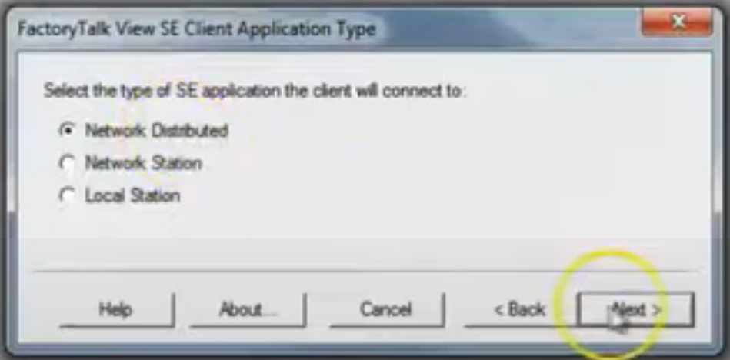

Next we are specifying which server we want the client to attach to, in our case the StateControl_MotionApp. Click Next.

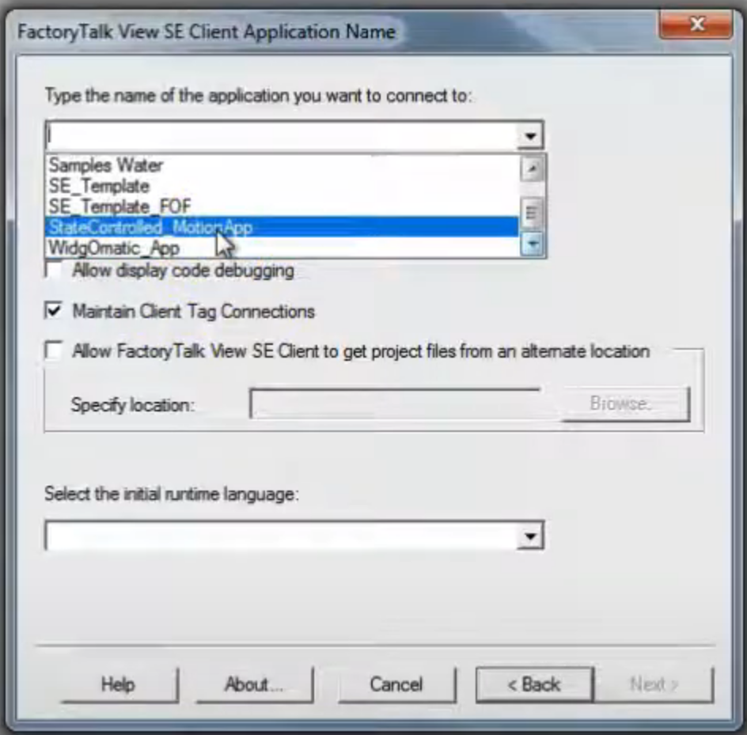

Click the ellipse on the AREA entry. You want to select StateControlled_MotionApp, it has the data server under it. If you select Data Server there is nothing under it so the application will not work.

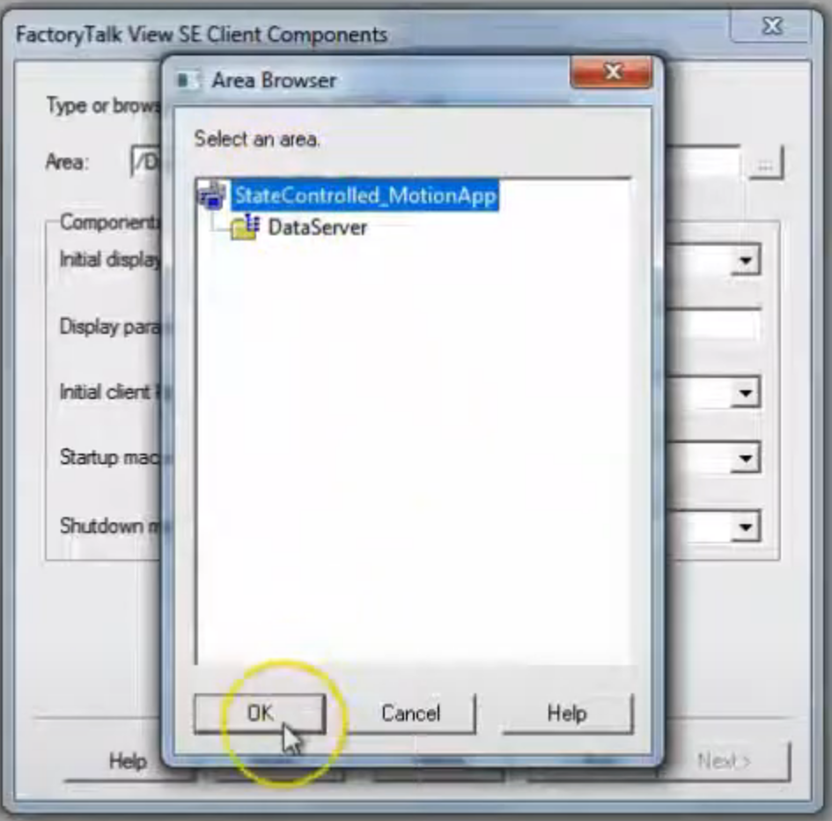

The forward slash represents our choice (defined in VBA app). Also fill in client key and startup macro. Others are optional.

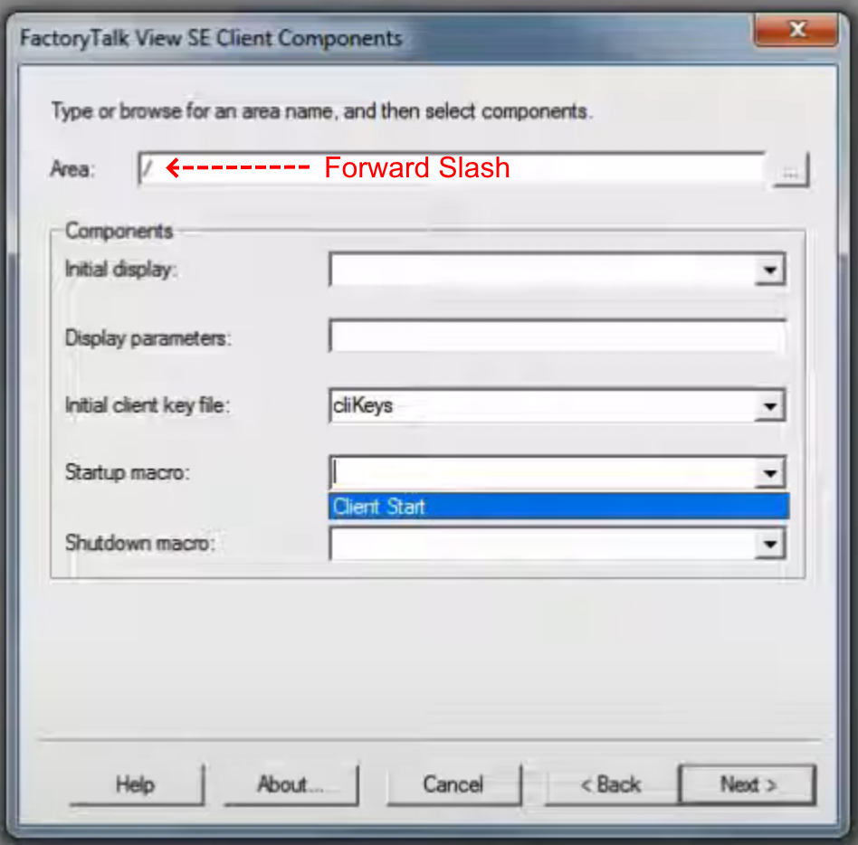

Click Next. Now uncheck Title Bar option. May want maximize as well. We’ll use diagnostics for now.

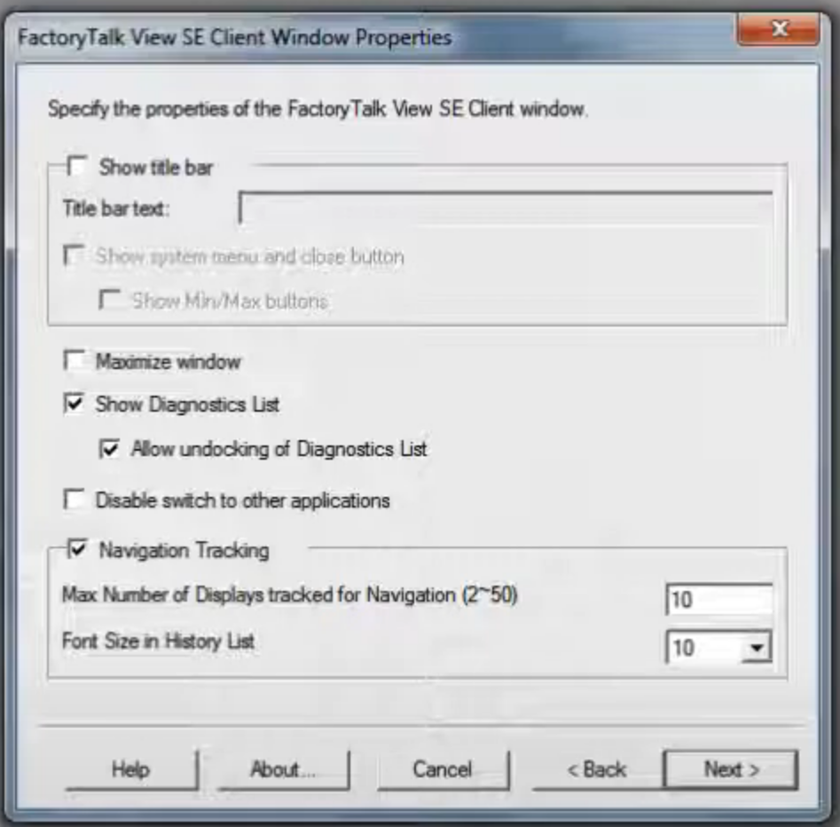

We won’t use Enable Auto Logout.

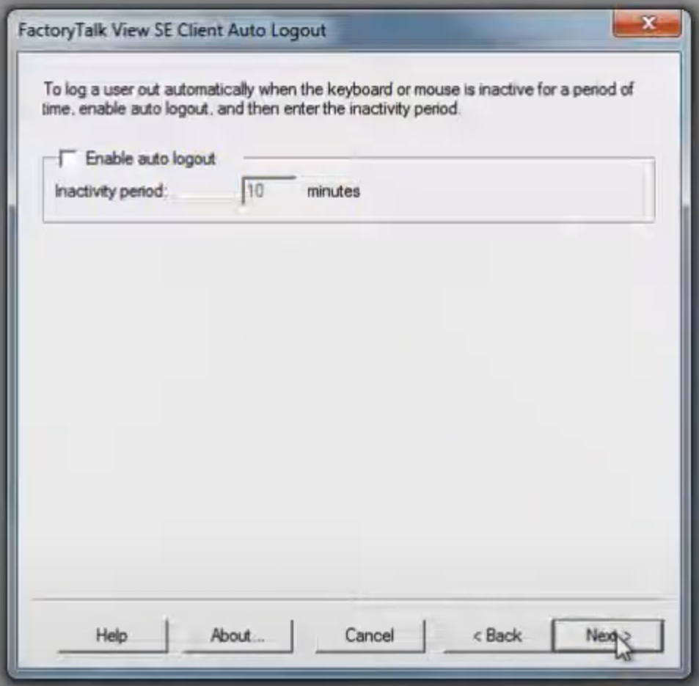

In this dialog we can click Finish.

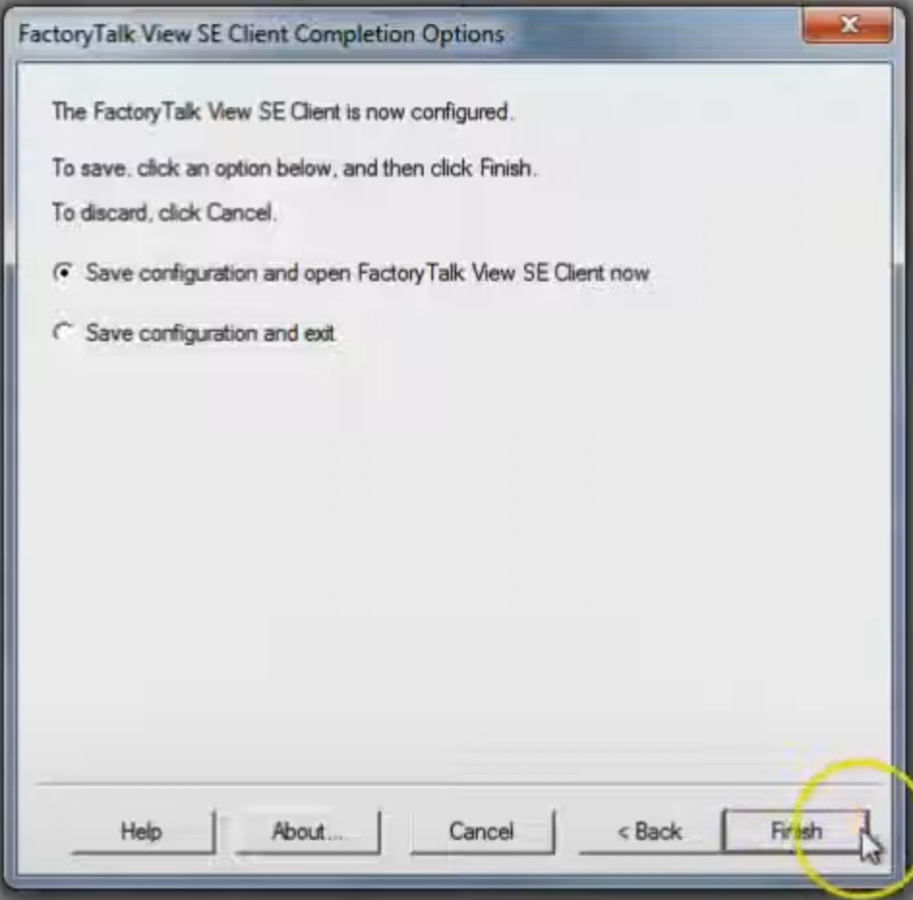

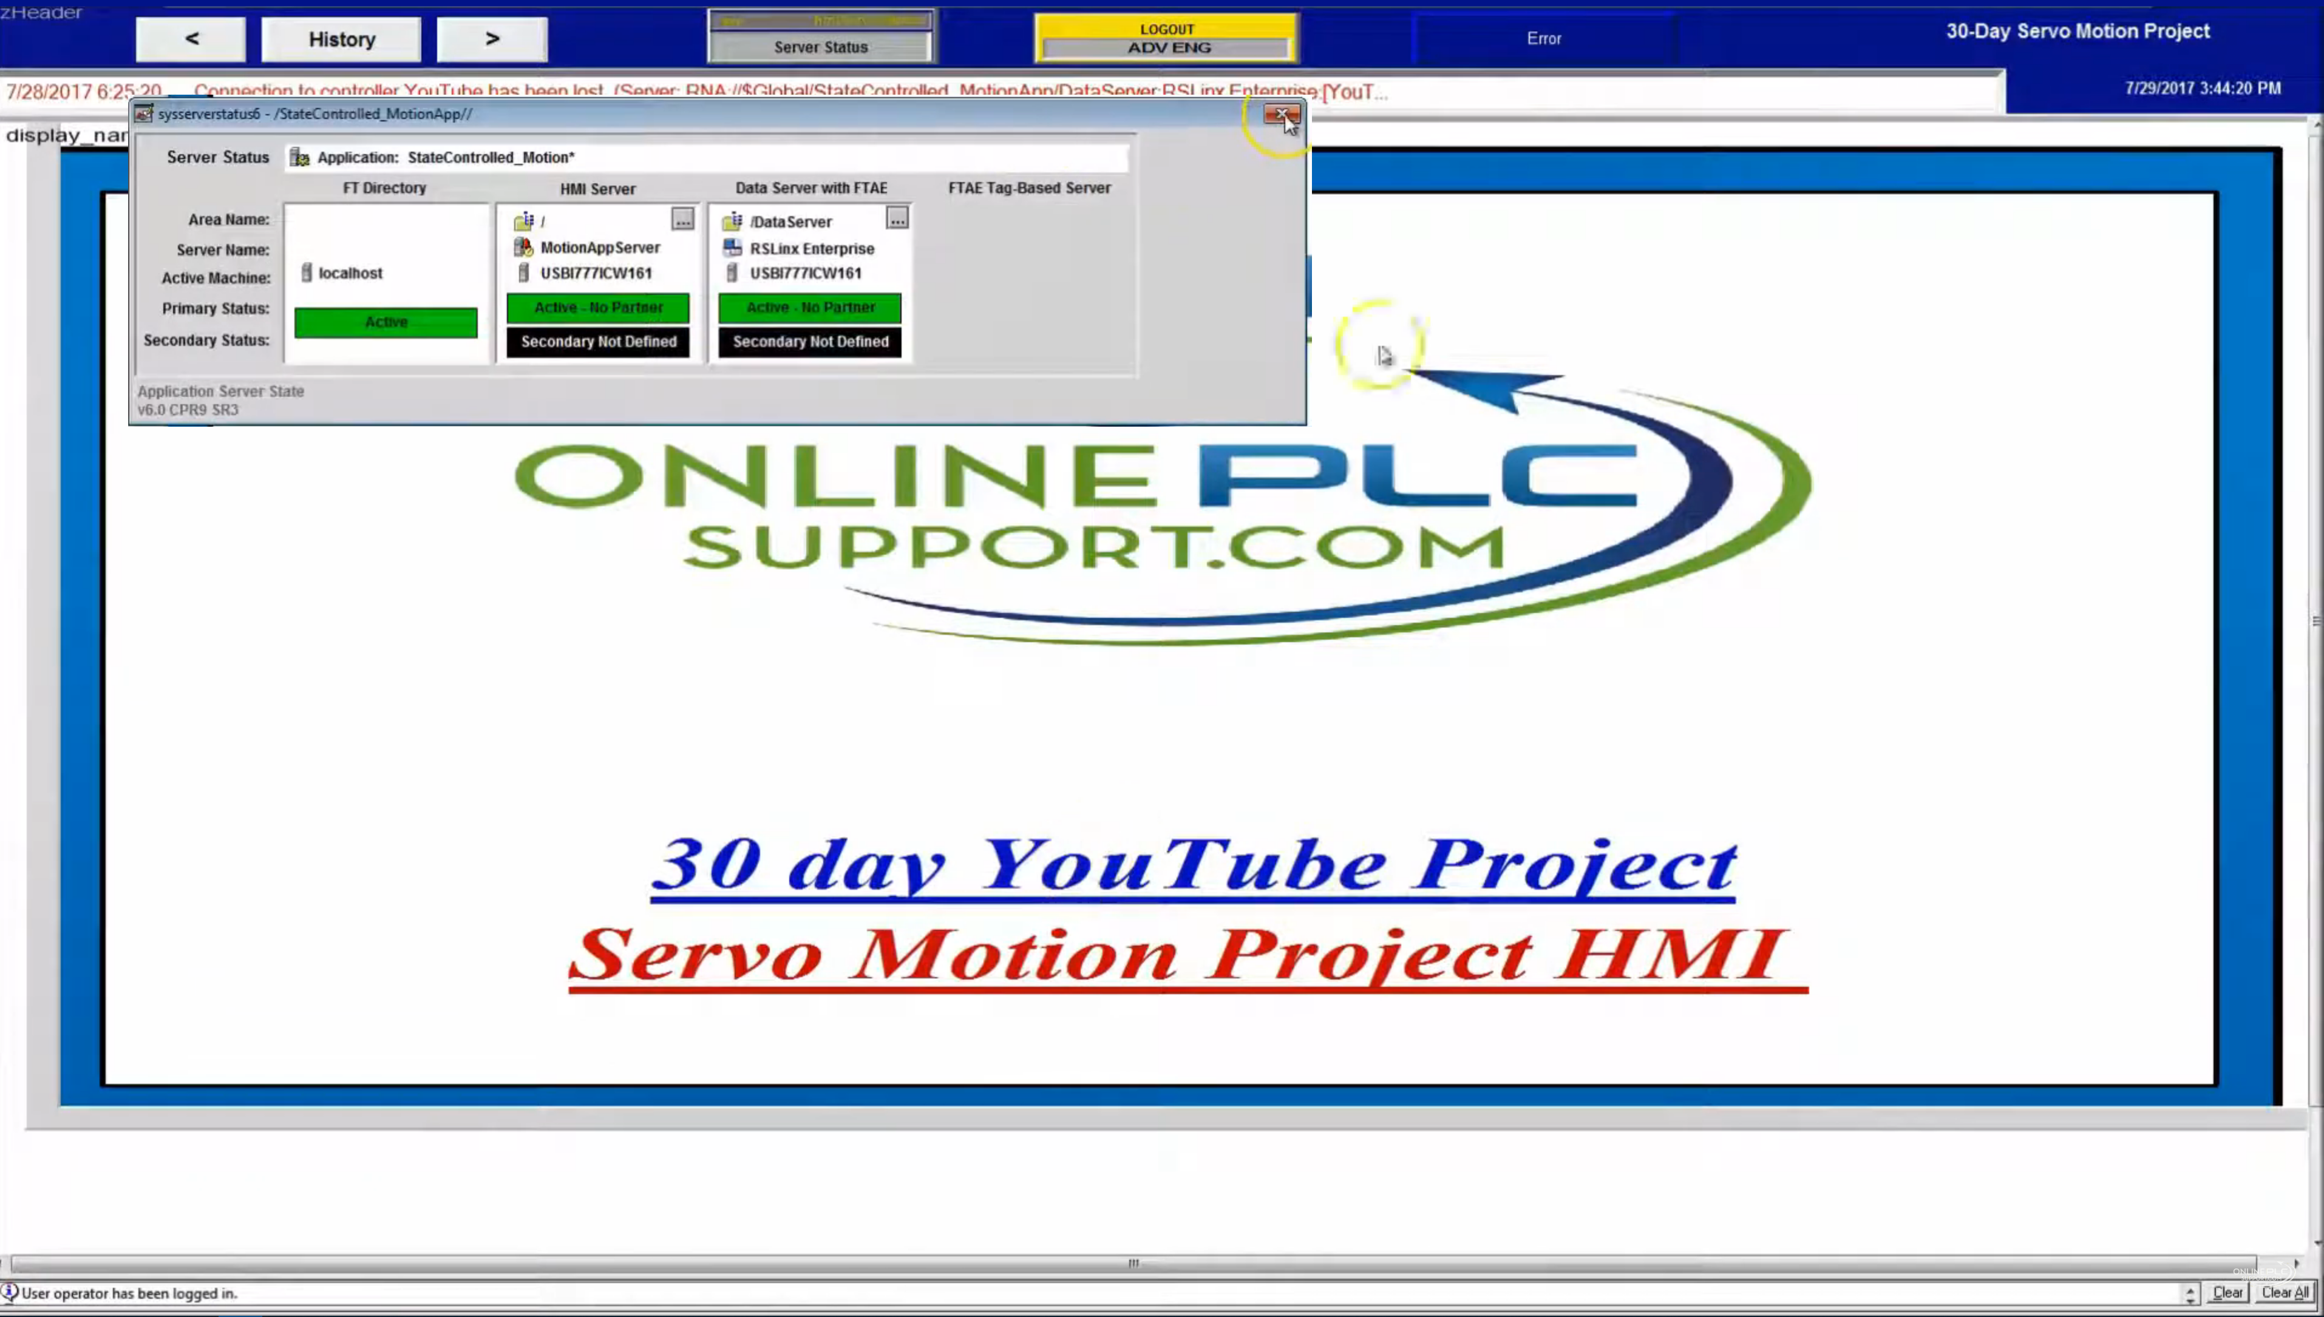

Client keys CTRL + SHIFT + Q will shut down the application.

Now we want to build a shortcut for our application.
Open the Communications Setup menu item.

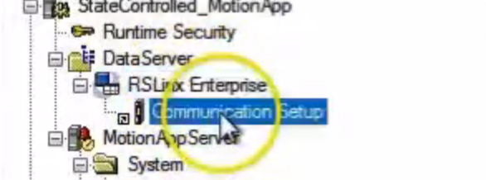

We had configured YouTube earlier.

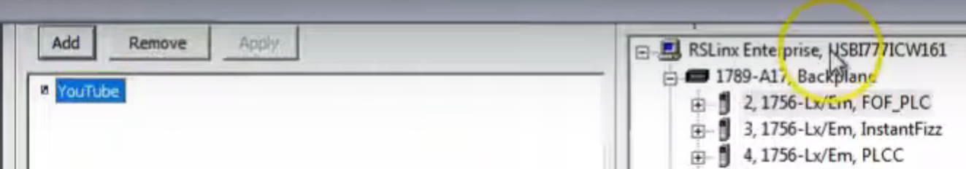

On the PLC side we are using an emulator.

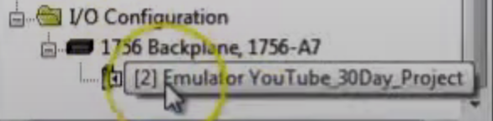

Click Verify in the bottom right corner then click OK.
Double click the “Machine Stopped and Reday” button to bring up the button properties, go to the Connections tab.

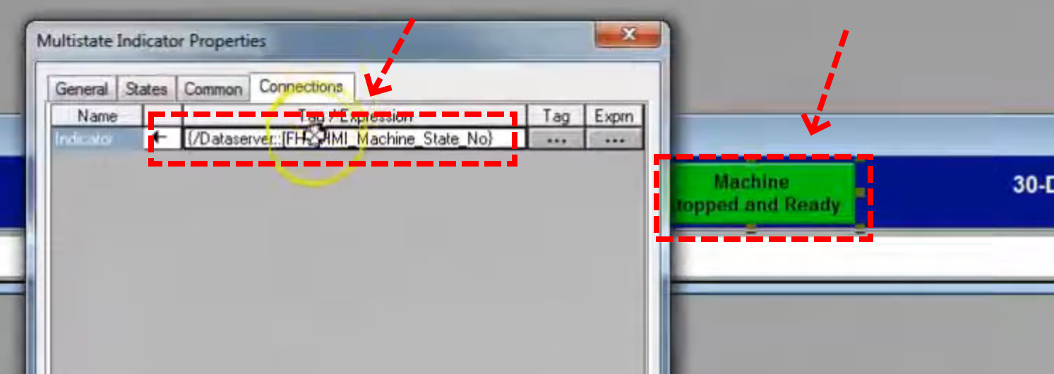
Change the string to what is shown below.
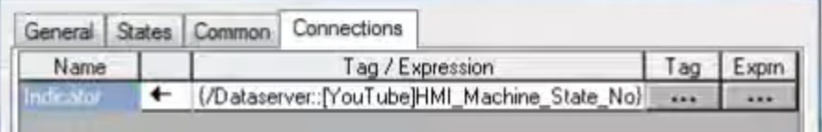

Click Apply and OK. Save and close the navigation window. Click the Launch Client button.

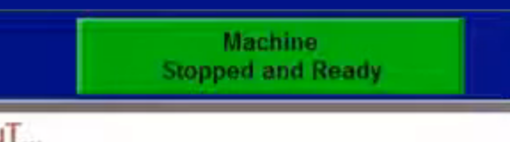
Button is working (making comms), displays the state we are in. When we start the PLC app and change the state we see the button properly picks that up.

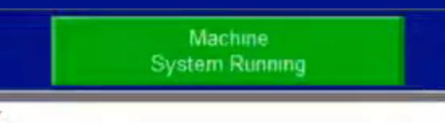
Now we’ll make a new screen.
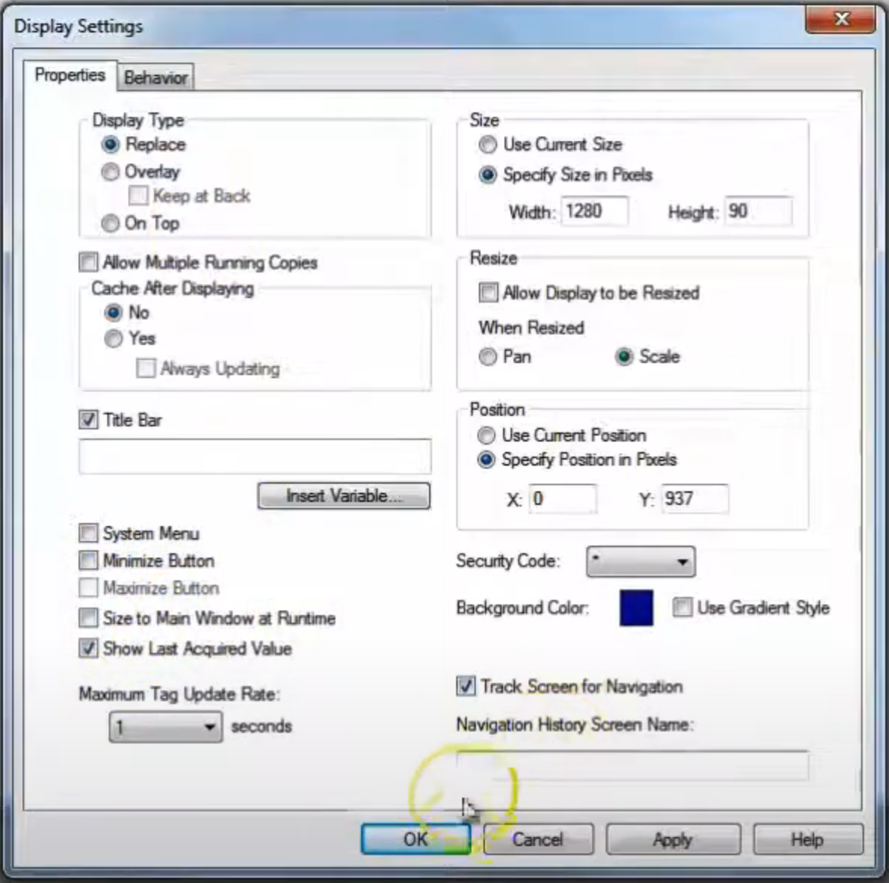
Name and close the screen.
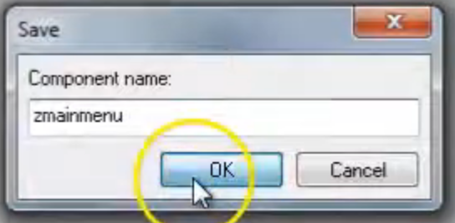
Modify the macro to add display zmainmenu on the bottom.

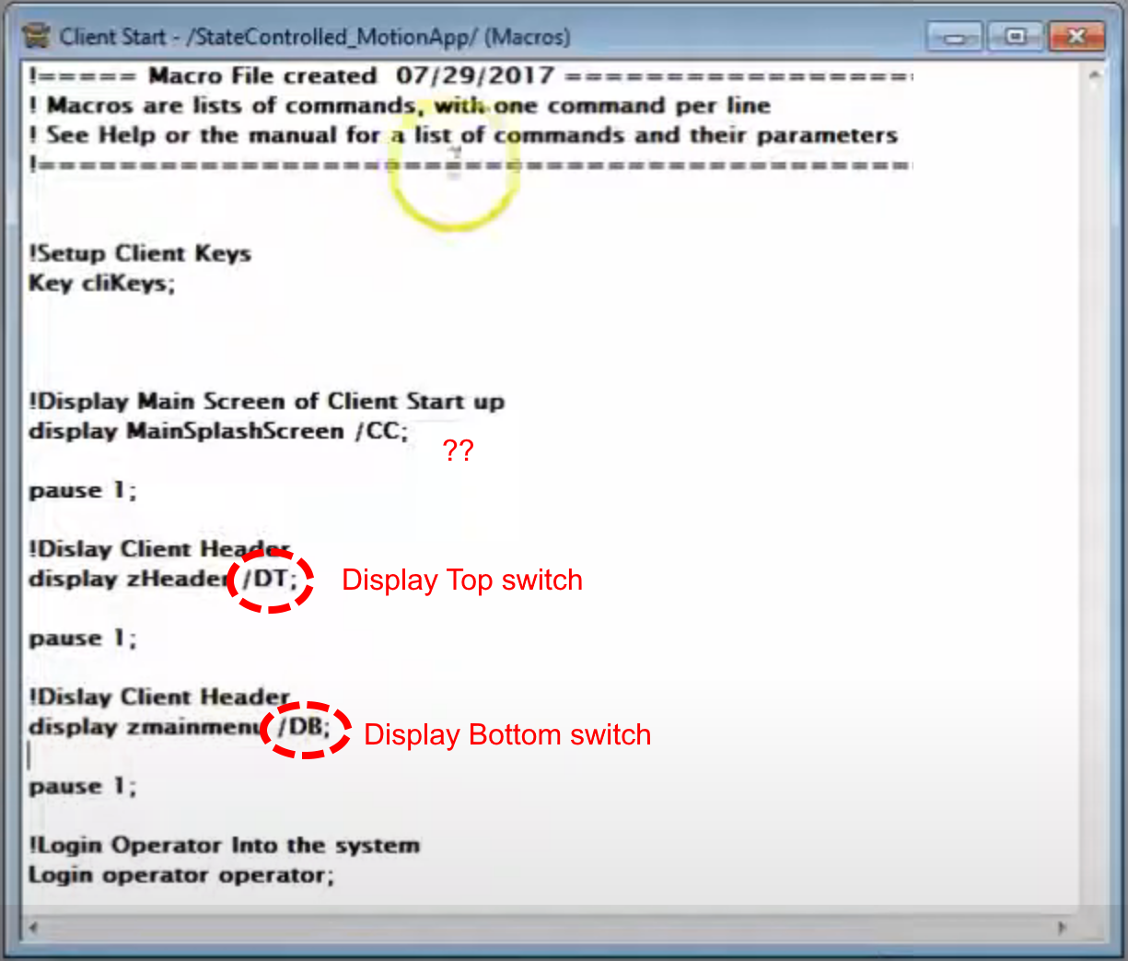

Now we will make some screens.

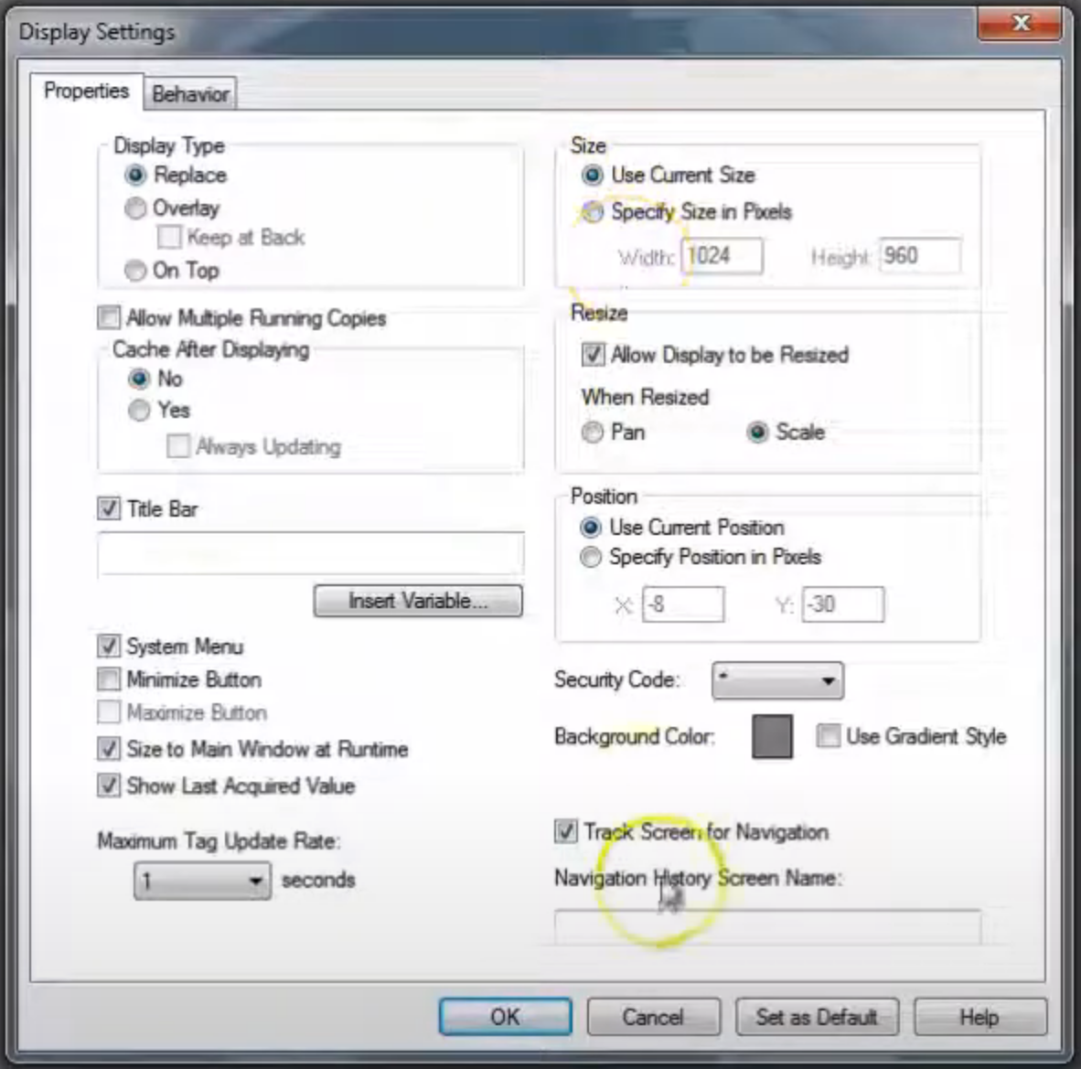

What we are doing here is showing our axis as a web and displaying the average velocity of each axis on its drum.

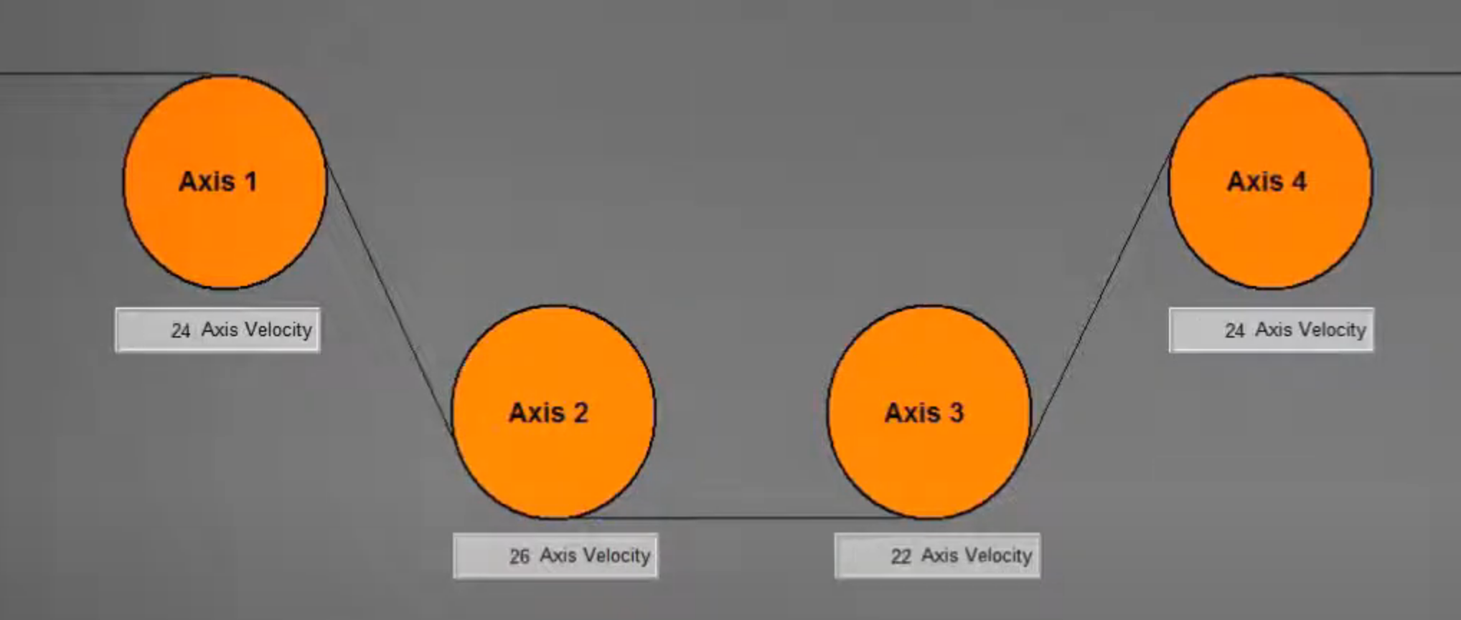
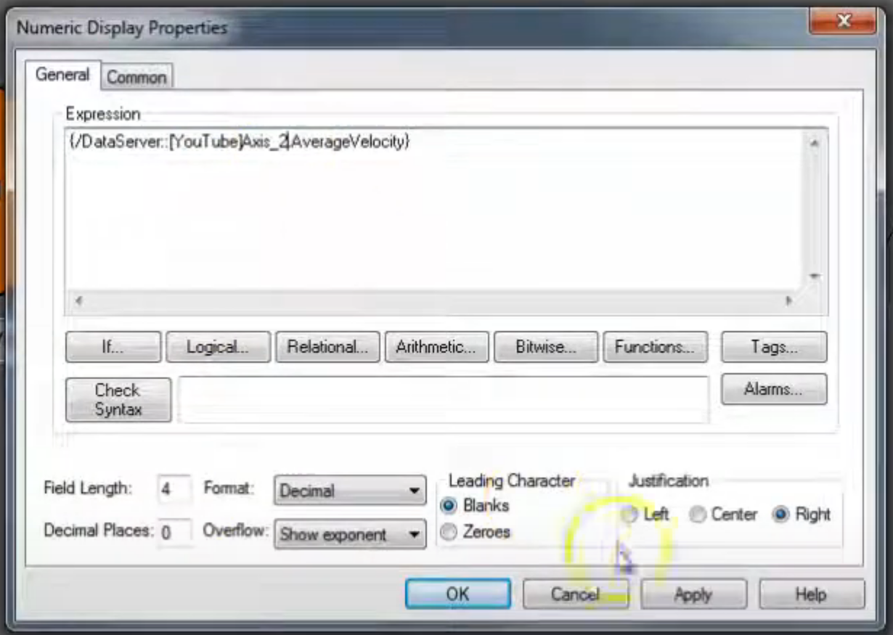

Now we want to add an axis start/stop button. This item is from StateMachine_Main | MachineState_Control.

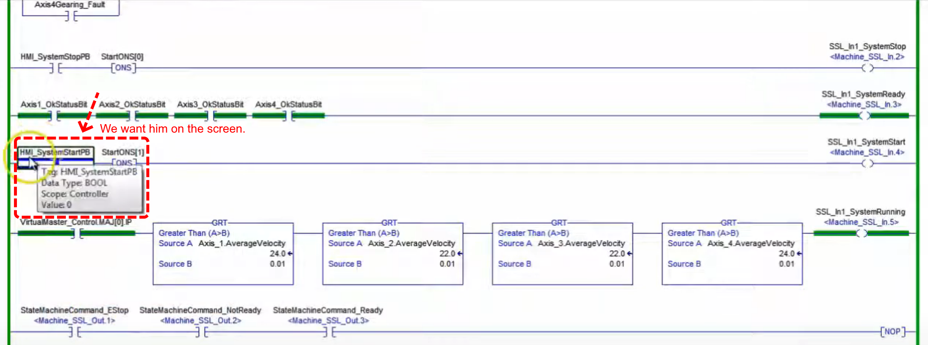

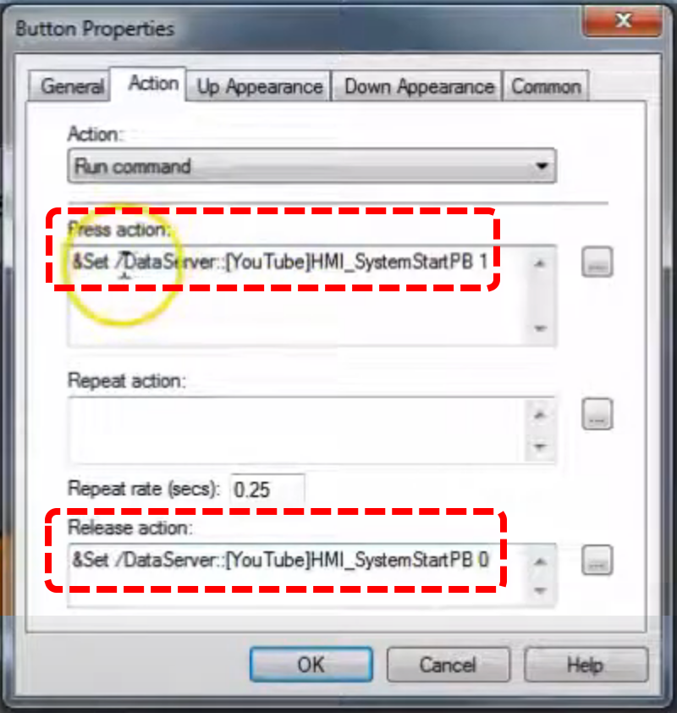

Let’s review the process for bringing up the tag select dialog.

Double click the button. Up Appearance tab, fill in Caption.
Select Action tab. Clear out Press action of any previous entry. Click ellipse.

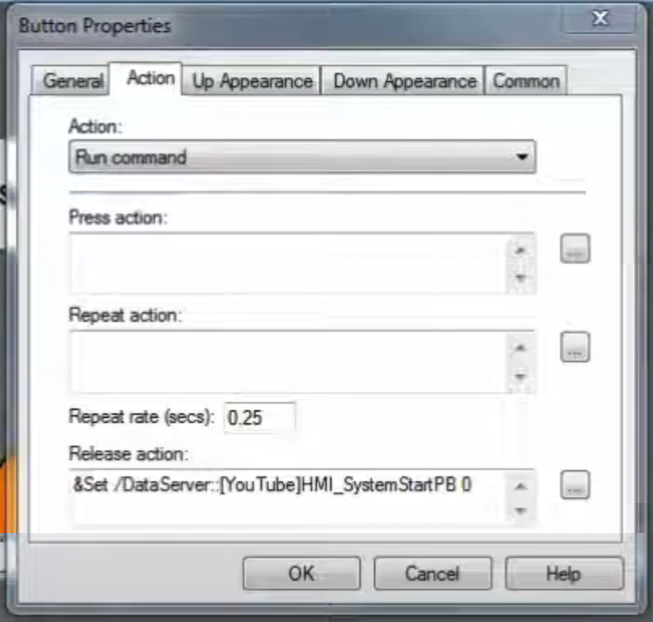
We want the SET command.

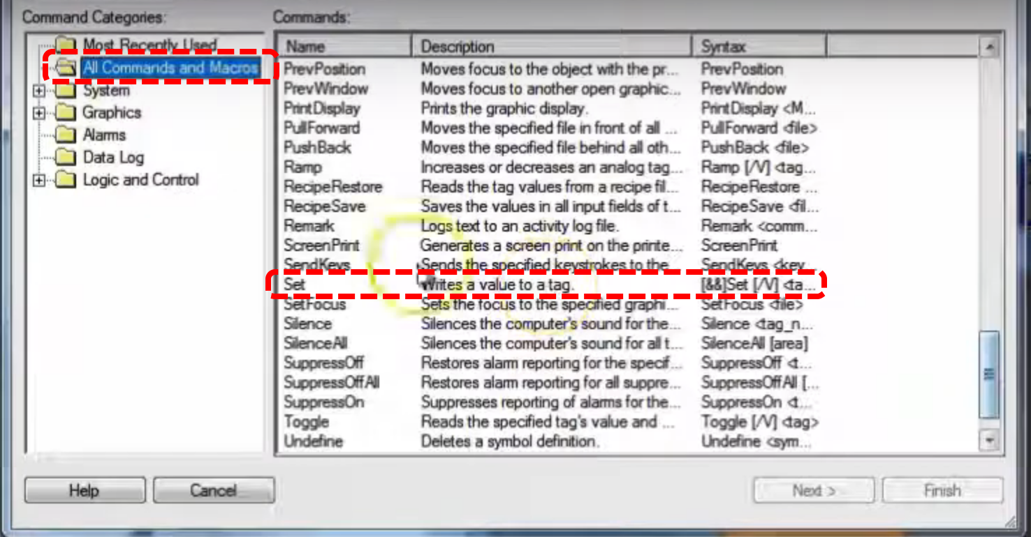

Click on ellipse.

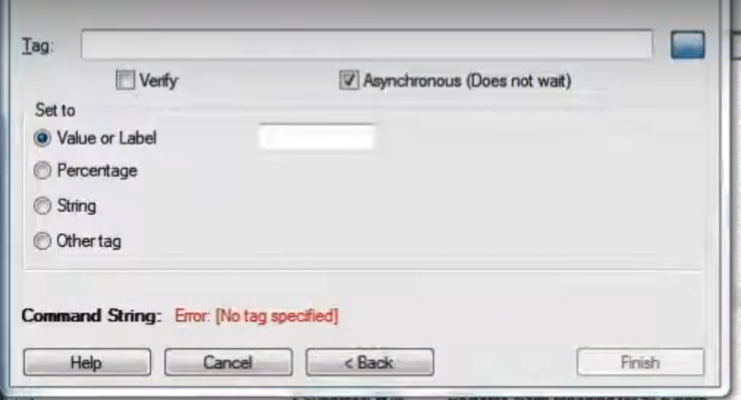

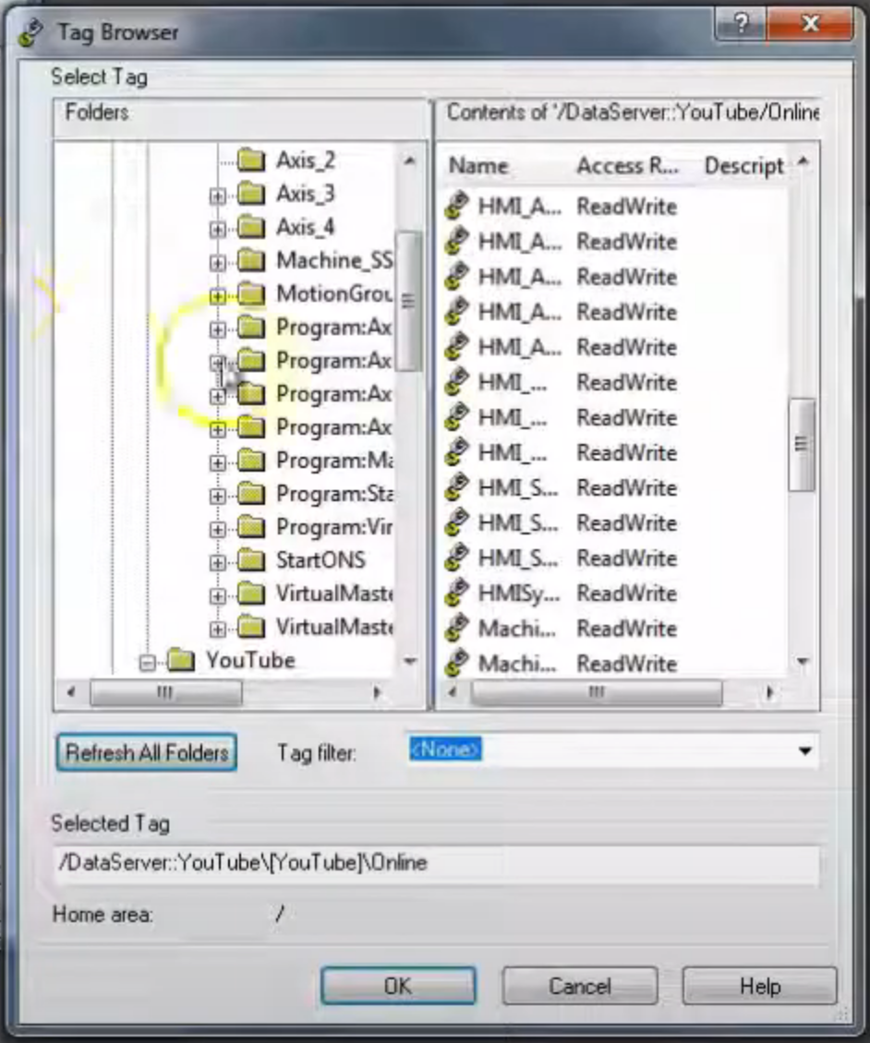

Select this tag

Press Action Command: this gives us a 1 second hold of the pushbutton effect.

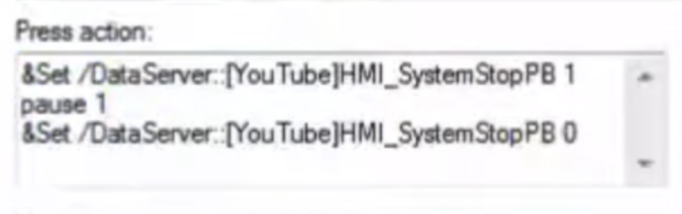
Release Action is blank.

Bottom number is gear draw.

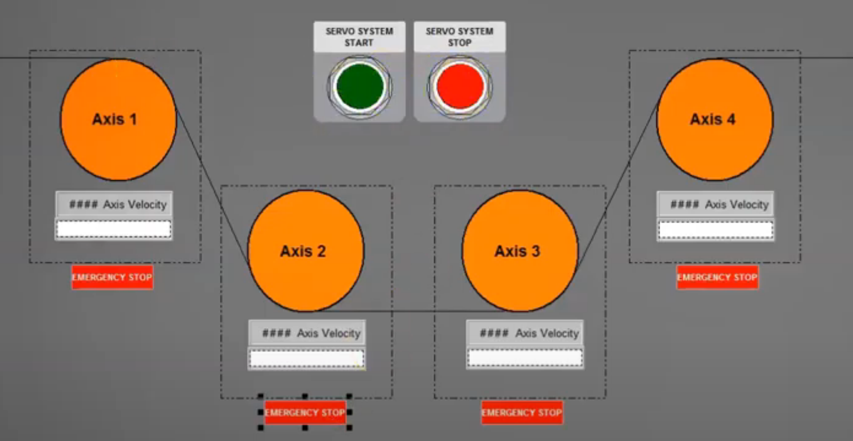

Adding an E-Stop button.

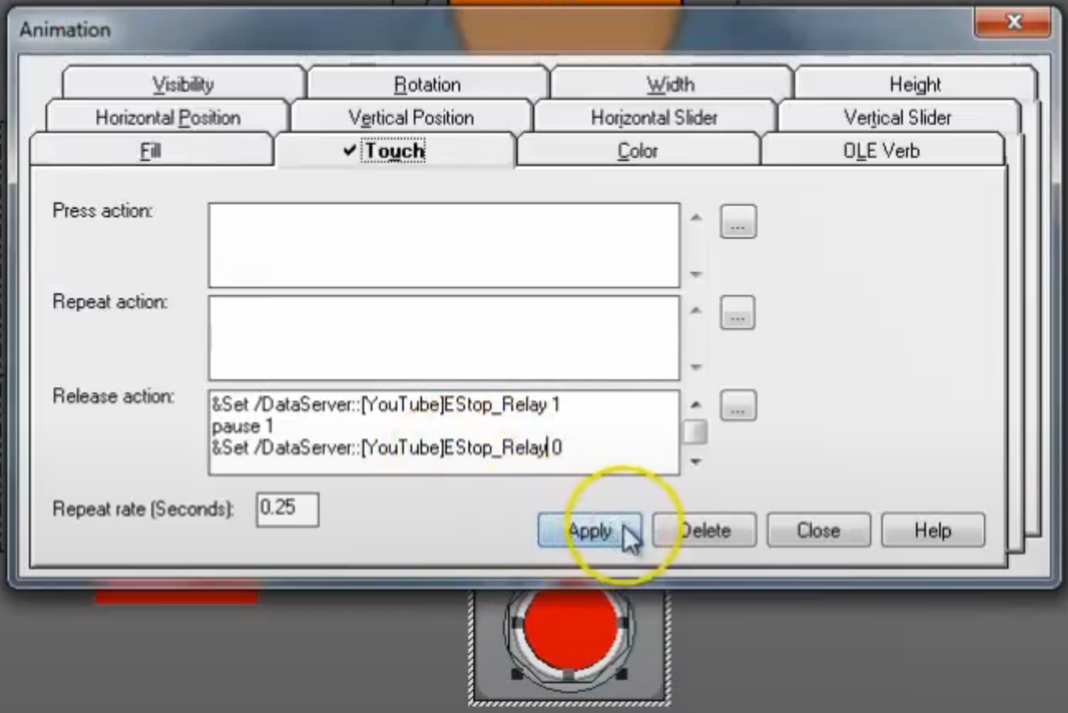
Want to add alarms and events. Recall our header screen has an A&E banner.

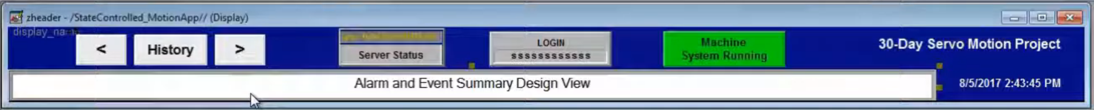

We want to use an ALMD instruction in ControlLogix. Create a new routine under MachineControl_47ms|MainProgram called SystemFault.

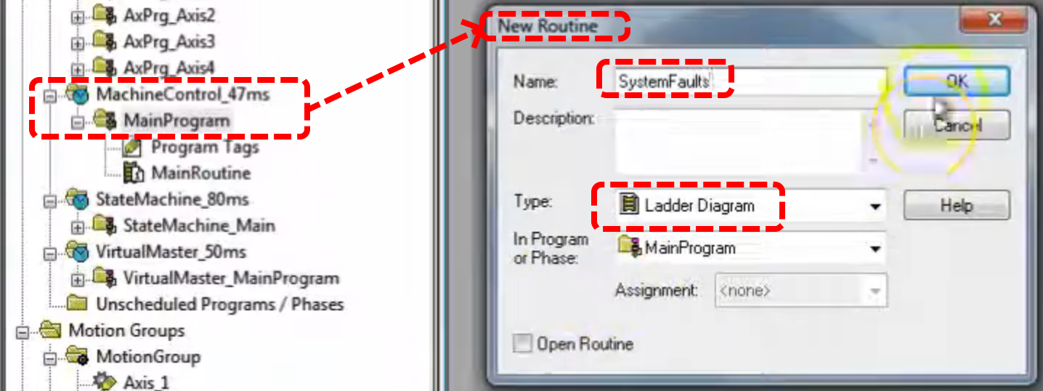

Remember to add a JSR in MainRoutine to call this function.

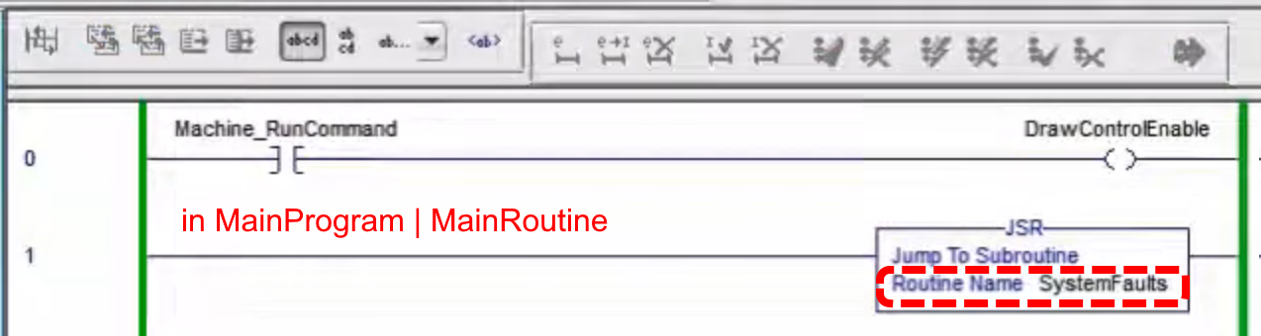

Now the idea is to make alarms for all the faults we capture. Two types of alarms, analog & digital.
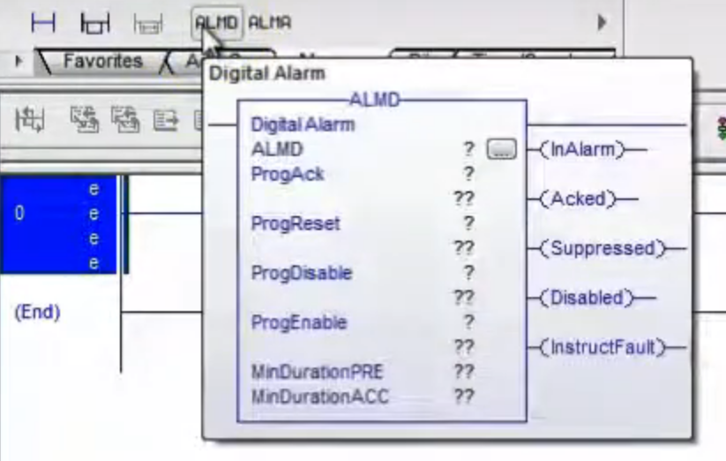
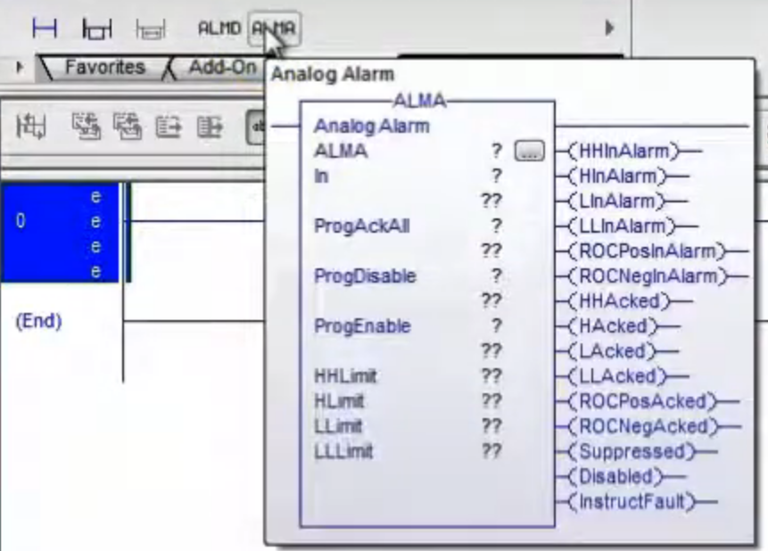
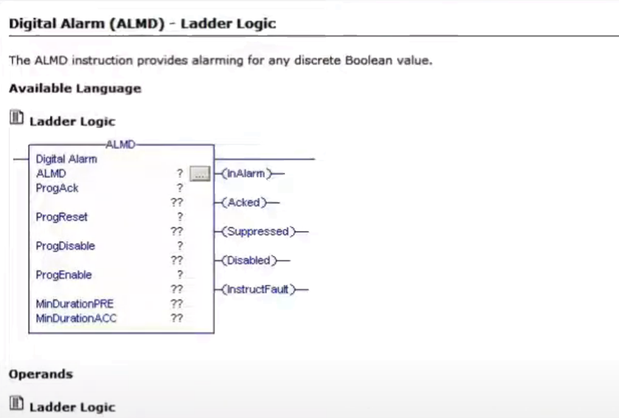
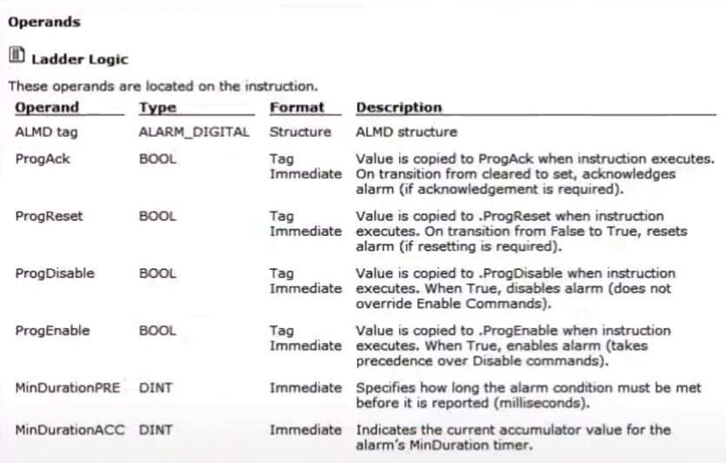
Need Alarms Enabled in RSLynx.

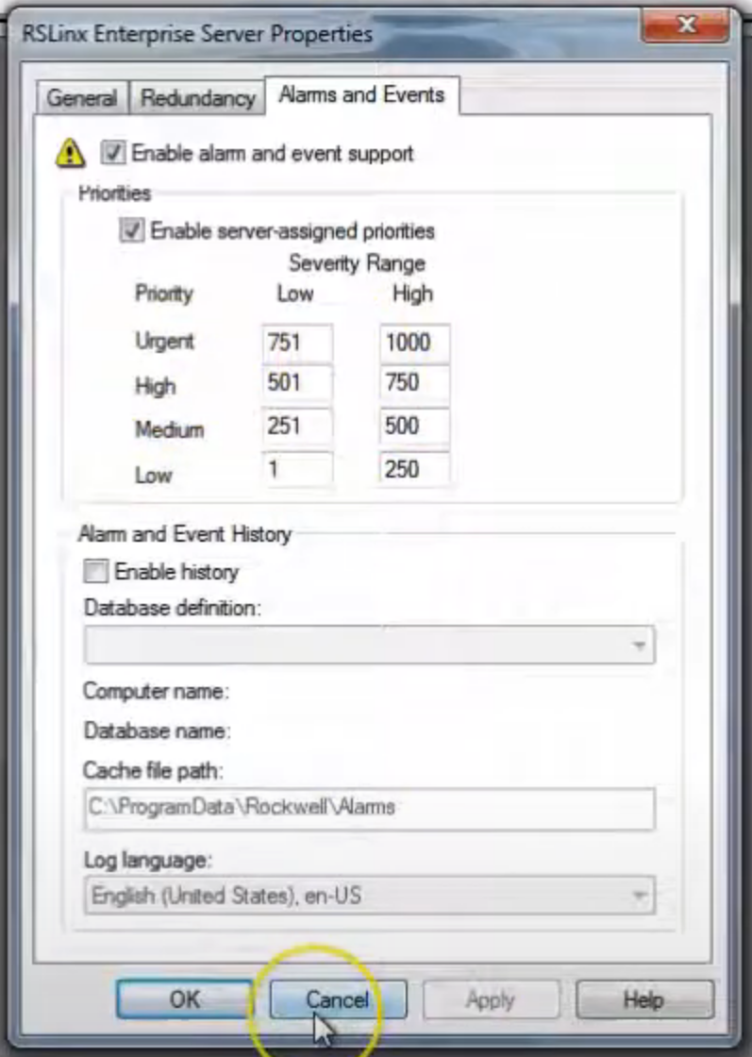

On the communications panel of FactoryTalk View you must also have alarms enabled.

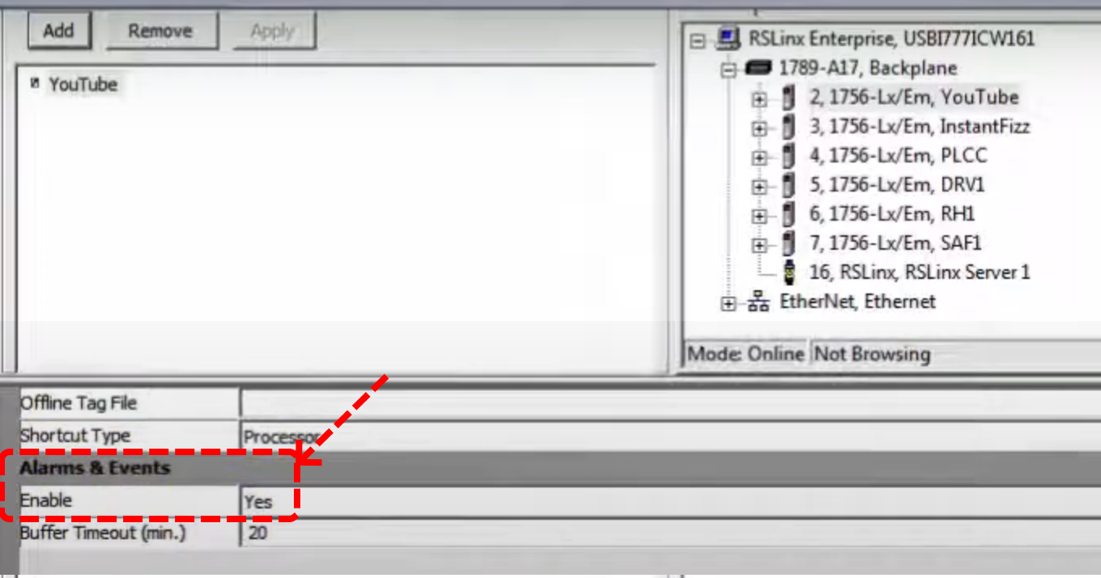

Now back in Logix Designer create a new tag for the first alarm, be sure to check “Open ALARM_DIGITAL Configuration” before clicking create. It is a controller scope tag.

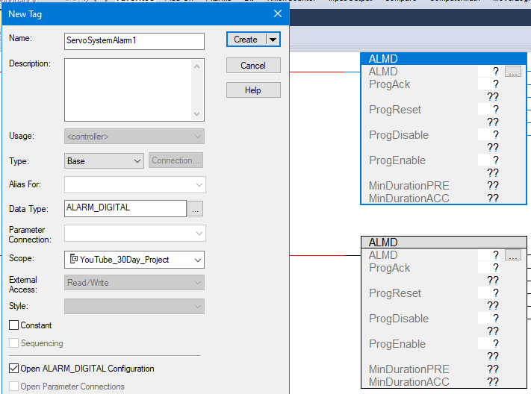
Enter the Severity, this is E-Stop so it will be 1000.

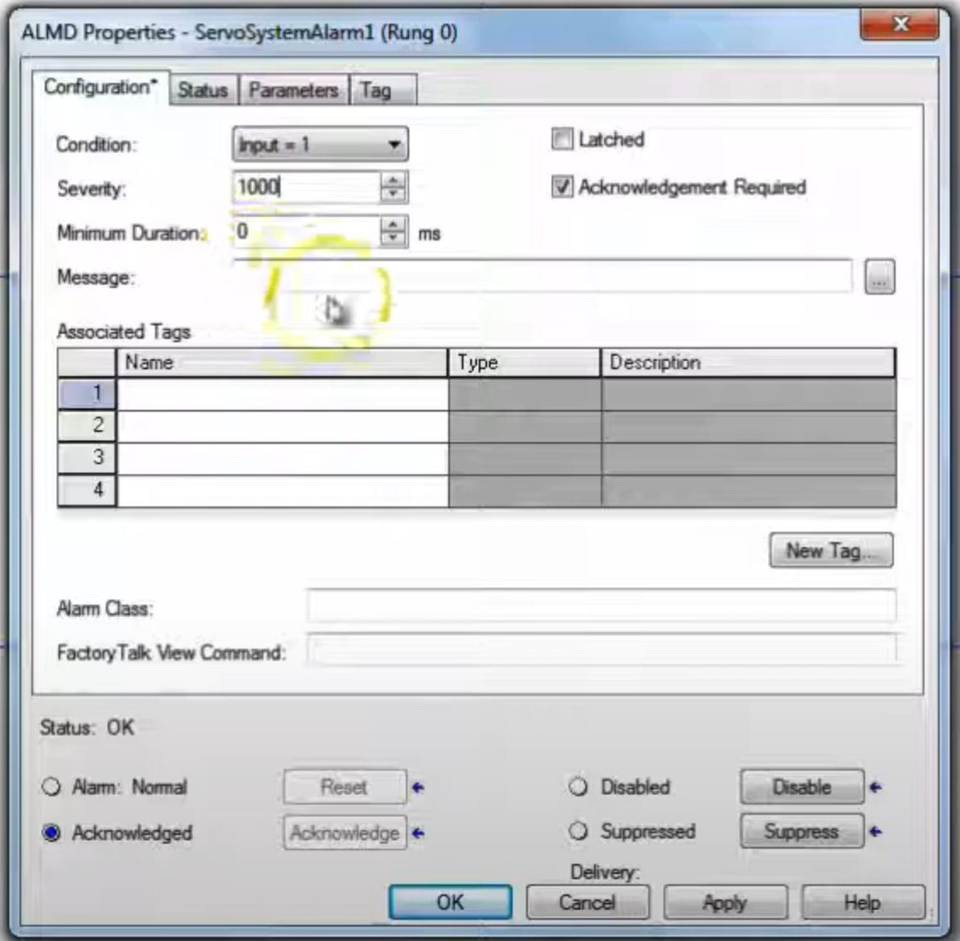

Click the Name field under Associated Tags and click New Tag, create as shown below.

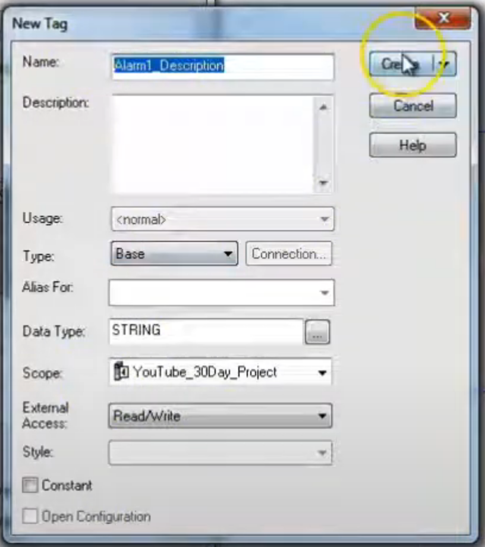
Click ellipse on Message.

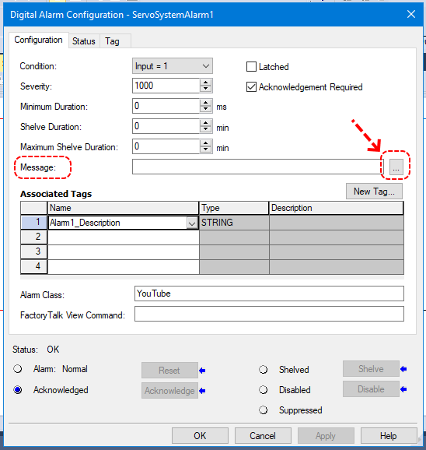

Select “Tag 1 (Alarm1_Description)” then click Add and then click OK.

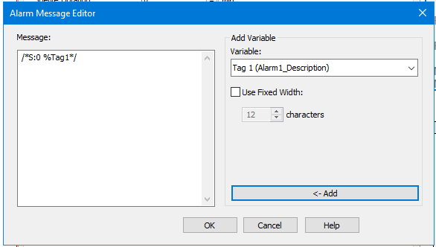

Must set Alarm Class equal to the shortcut created for comms in FT View.
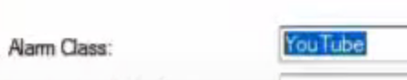

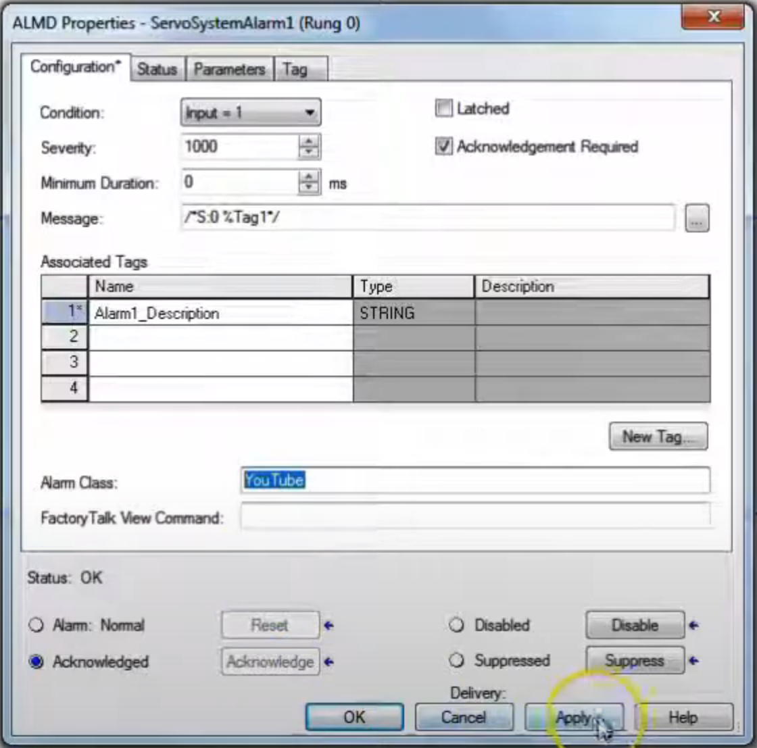

Do the same for remaining axis status bits. Use 750 severity for non E-Stop.

For now set all the ALMD fields equal to zero.

Add the contacts to each rung as shown below.
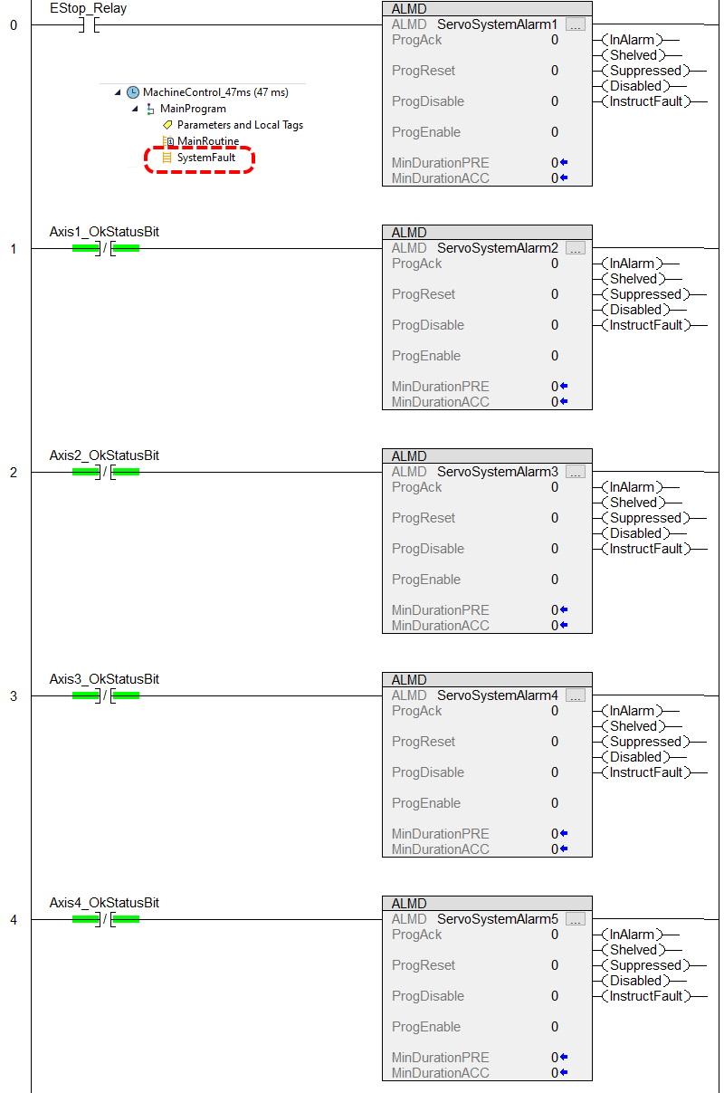
Now we will populate our alarm description tags with the data they need to describe (Value field). Look them up in controller tags and click the ellipse.

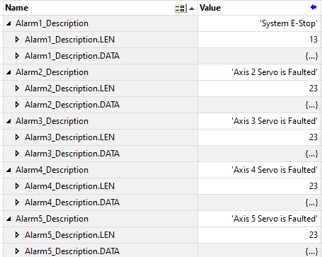

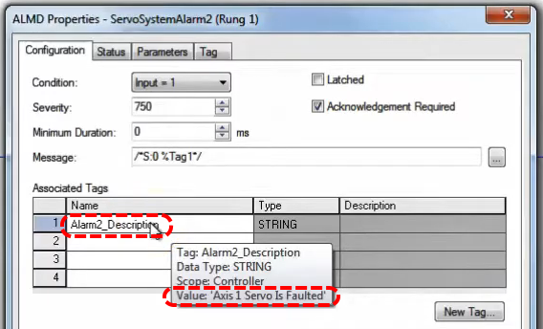

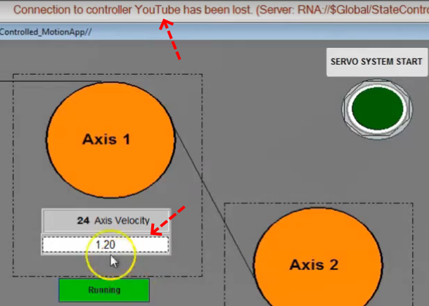

Now when we run our app we get a message up top saying the connection to the controller is broken even though we can see that we have comms. An adjustment needs to be made. We have an RSLynx problem (there exist a RW tech note on this problem). Go to control panel, click on Administrative Tools, double click on Component Services, then Services (Local), scroll down to RSLinx Enterprise, right click and Restart, do this while the system is active. Rebooting the computer will not fix this on non-server based systems. The status line should display faults now.

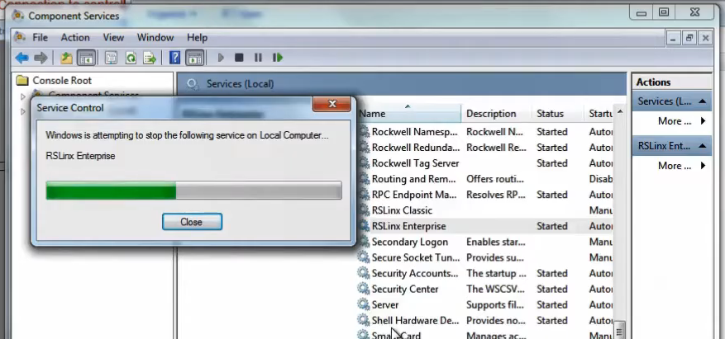

Now we want to make a fault screen active. Open our fault screen…

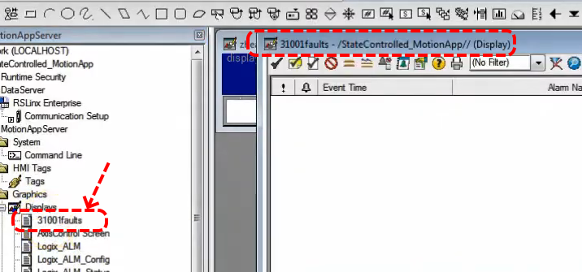

Right click and select Delete so we start from scratch. Now from menu bar select Objects|Alarms & Events|Summary. Draw out the control. Helpful to change icon size to medium. Can adjust font size. The settings you see below should work.

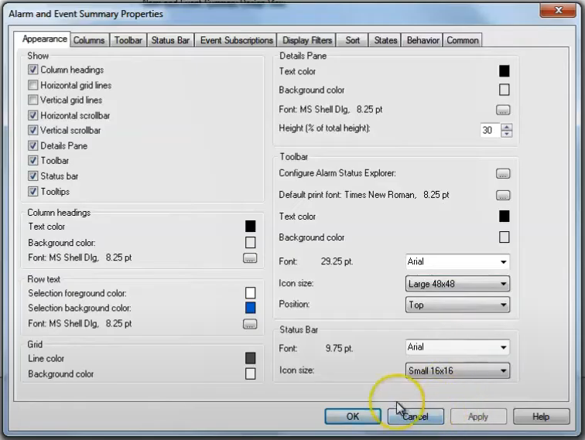

Do a quick test by clicking the run button on menu bar… 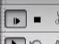

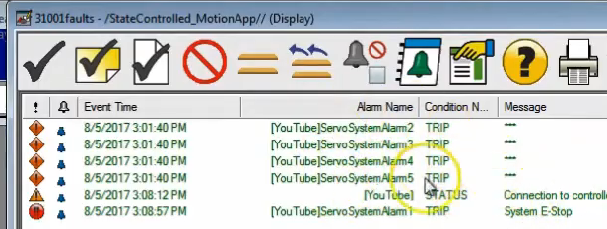

Close and save this screen. Open the Main Menu display, create a button to open the alarm screen.

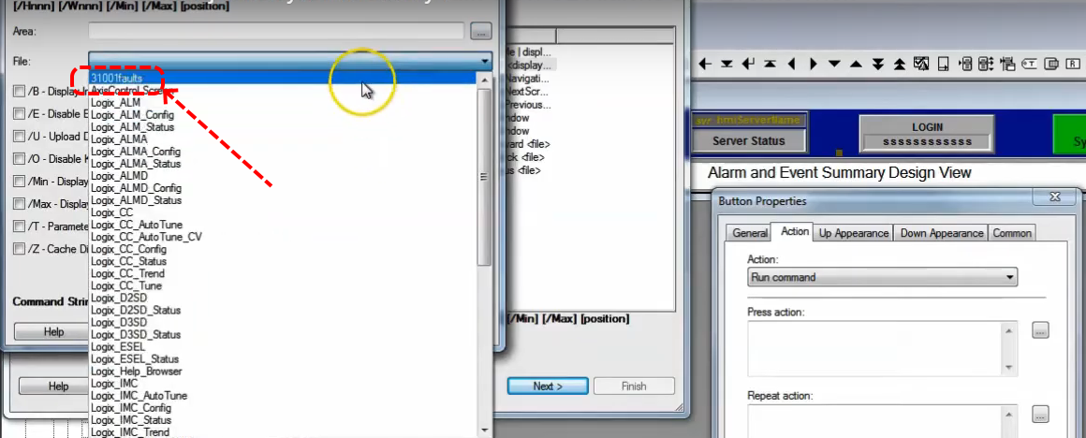

Now restart the client. Bring up the alarm screen. Click Acknowledge All (black check on white paper) and then refresh.

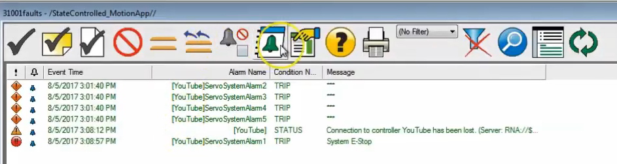

Now we see our status bar working. It seems that having an active alarm screen has allowed the status bar to access the alarms.

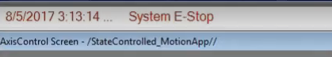
We can also see the condition on our alarms display. At this point we see all alarms working.

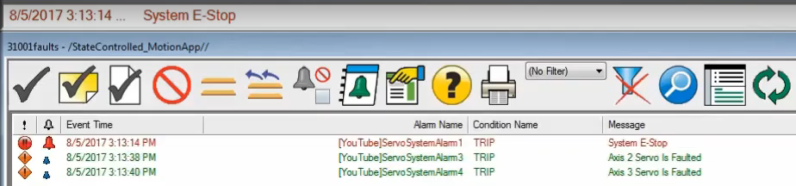

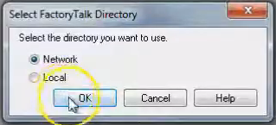
This is a basic demonstration of alarm capabilities

How to make a FactoryTalk View backup? Open the program FactoryTalk Administration Console. Select Network for the “directory you want to use”.

Select the application you wish to backup from the file tree.
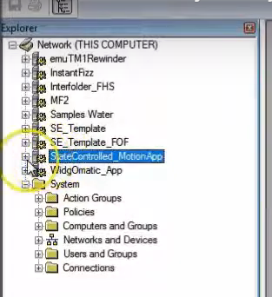

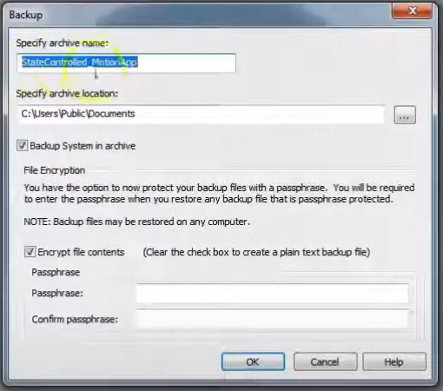
Right click and select Backup and click ellipse.
Here you select the archive location.

You can encrypt without entering a pass phrase.

Wait a moment for confirmation message.

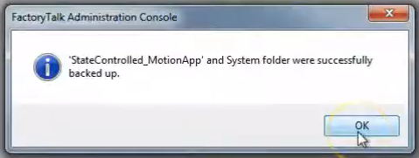
For a server backup (you’re application server) run the program HMI Server Backup & Restore.
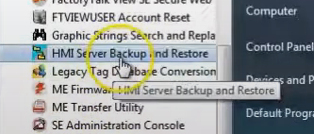

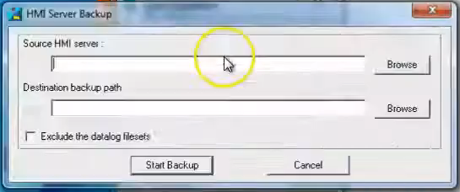

Select the source server and destination paths.
YOU MUST EXECUTE BOTH OF THESE PROCEDURES TO HAVE A COMPLETE BACKUP.

Now you must confirm your backup. Go to your destination and enter subdirectory according to the name of your server application (MotionAppServer).

Scroll to the bottom and inspect the size of file .sed, it must not be equal to 201, if it is you have a corrupt file/backup. There is a RW knowledge base article on this. If you have this problem close all programs and try again.

Also make sure you have files in your Gfx directory, those are the app screens.
Add a copy of your PLC application as well.
You also want to save a L5K version of the PLC application.

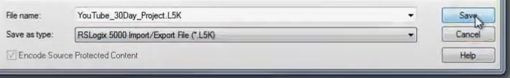

The L5K version gives you access to text based information such as version which you can change if you ever have to (risky).

Exporting to L5K and then importing has the effect of removing a lot of overhead associated with online edits. Also removes the cache files. Can be helpful.

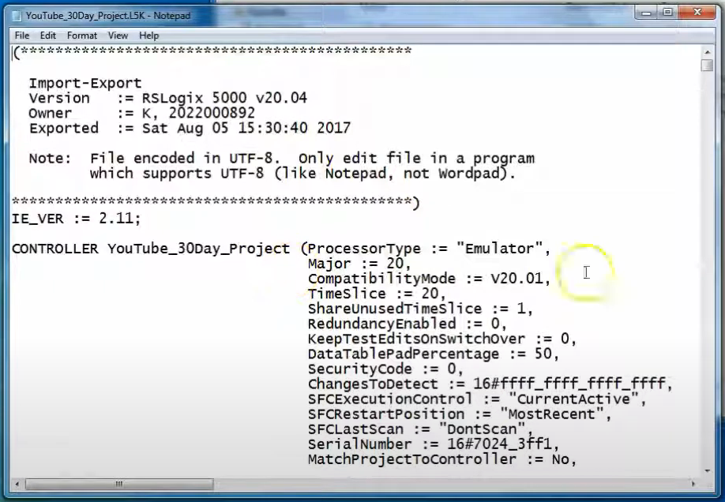
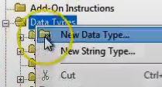
Now we will look at Produced & Consumed, aka, Peer to Peer Setup. We will produce/consume our start button from another processor. We begin by creating a user defined data type (UDT) which will handle the data exchanged.

We’ll just use a bunch of bools to demo.

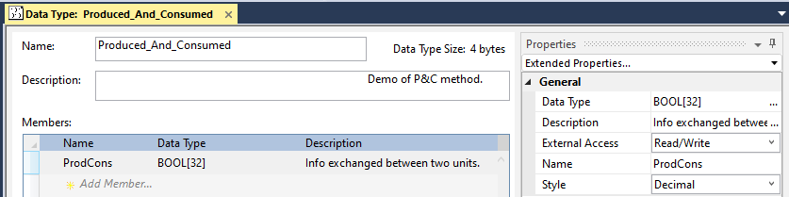

Now export the P&C data type and import it into the other processor. Then, on both machines, create a controller tag that has this UDT as its data type. This is NOT an array.

Now right click this variable and select properties.

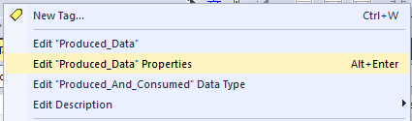

Set the data type to Produced.

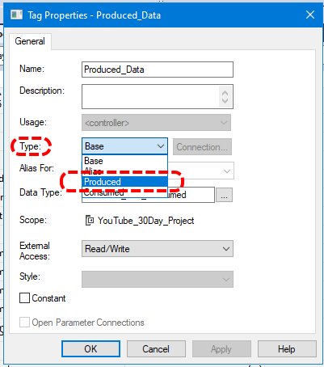
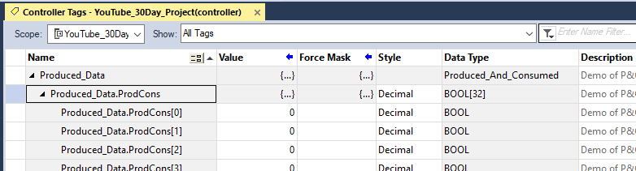
Top line has no index, only the data member has index due to it being an array.

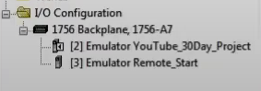
Now we do the similar operation for Consumed_Data then we create both of these in the other machine. Note that both processors are located in the I/O Configuration. Not clear how this plays out, where have we identified the other processor? What if we had 3 other processors, what is directing traffic?

It looks like we do not specify a controller until we are setting up the consumed tag(s). Then you have to click on the Connection button when in the properties of the consumed data tag. So it is necessary to set up that controller in your I/O Configuration tree.

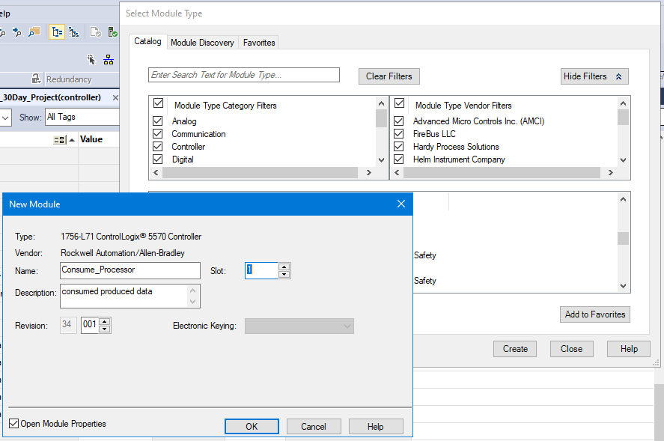

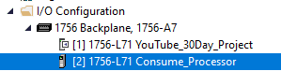

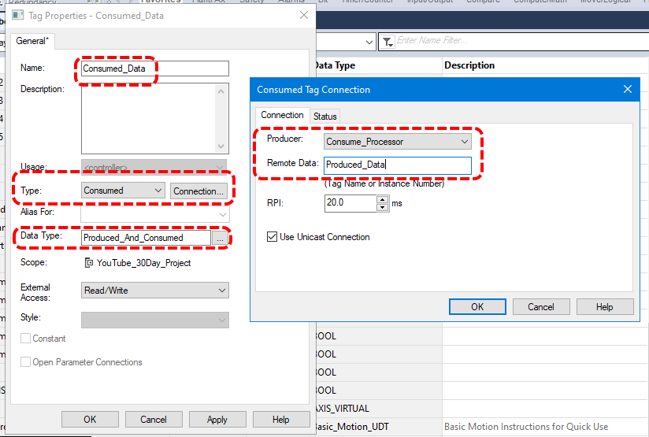
Consumed_Processor gets Produced_Data (from other processor).

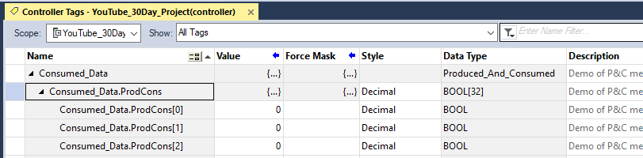
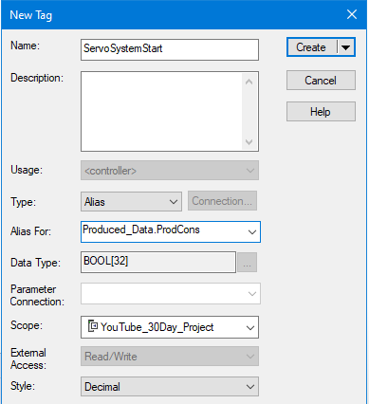
Now create a rung in PLC that will activate the remote tag (kind of assuming both machines require remote start of each other for demonstration purposes). Set up this button in MachineControl_47ms | MainProgram | MainRoutine.

Note that we select a specific instance of Produced_Data for this Bool.

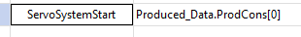

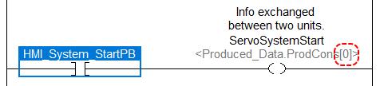

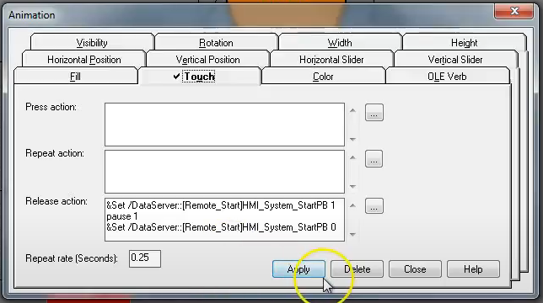

So now when we access data from the other processor via produce/consume we have to change the shortcut data path in the HMI as well.

The End

